A 1,000-metre lead with single-pair Ethernet switches

The new unmanaged switch from Weidmüller impresses with its long range and power transmission and meets the requirements of PROFINET conformance class A.

Weidmüller is introducing a new unmanaged switch with SPE connection. The switches raise the performance of industrial applications to a new level. While the SPE technology increases the range of the internet connection, the two-wire cables enable parallel power transmission.

For many industrial applications, the transmission of data over long distances and different levels represents a major challenge. In some cases, not only data, but also power must be transmitted from the switch to the sensor. Companies who need to meet this special requirement can now look to Weidmüller’s unmanaged switch 10Base-T1L SPE as a pioneering solution.
The 10Base-T1L SPE switch ensures reliable data transmission over distances of up to one kilometre. In comparison, conventional RJ45-based Ethernet only has a range of 100 metres. With a bandwidth of 10 Mbit/s, the performance is also significantly higher compared to the RS485 standard at a similar distance. Compared to other interfaces, therefore, Weidmüller’s 10Base-T1L SPE switch offers not only a reliable, but also a powerful network connection for industrial devices such as sensors. In addition, the mating face of the SPE connection is suitable for industrial applications, which prevents micro-interruptions in the transmission.

Data and power supply in a compact space

An outstanding characteristic of the 10Base-T1L SPE switch is its support of Power over Data Line (PoDL) up to class 14. This enables a power supply of up to 50 watts at the end device. Features such as SCCP and force mode simplify the set-up of the power supplies for new devices.
SPE technology is particularly advantageous in areas with limited space, as both data and power flow via a single pair of wires, so that only one cable needs to be laid. This also enables sensors to be connected cost-effectively in various industrial scenarios through the use of copper cables instead of expensive fibre optic technology. Compared to fibre optics, copper boasts larger bending radii and is easier to install, as no splicing is required.

PROFINET conformance class A

The Quality of Service (QoS) functionality of the 10Base-T1L SPE switch allows the distribution of resources in the network and the prioritisation of data traffic. This allows users to prioritise important applications and make optimum use of the bandwidth. This feature also achieves PROFINET conformance class A, which ensures a seamless connection to PROFINET-compatible networks.
The 10Base-T1L SPE unmanaged switch from Weidmüller is a cost-effective and space-saving solution to master the challenges of data transmission and power supply. The 10Base-T1L SPE unmanaged switch offers users an alternative to fibre optic technology.

Comprehensive SPE infrastructure

In addition to its SPE switches, Weidmüller is now presenting an extensive range of single-pair Ethernet components, comprising plug-in connectors for on-site installation and pre-made patch cables. For the various applications in the field, the company is offering the device connection technology in protection classes IP20 and IP67.

3294 characters including spaces

All images are freely available. You can download them from the following link:
https://www.picdrop.com/weidmueller/hMqveT1GC9

Image source: Weidmüller

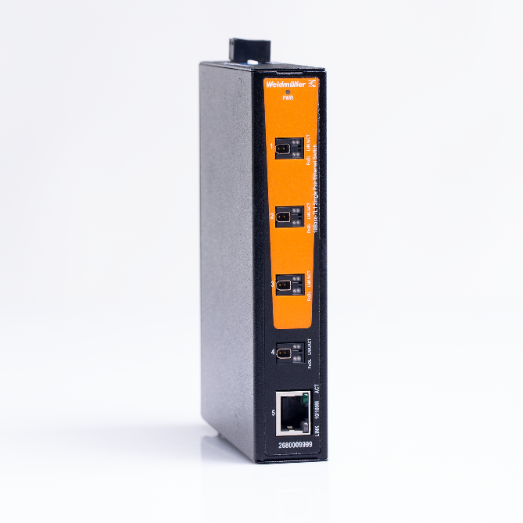
Image caption: The 10Base-T1L SPE switch transmits power and data over a distance of up to 1,000 metres

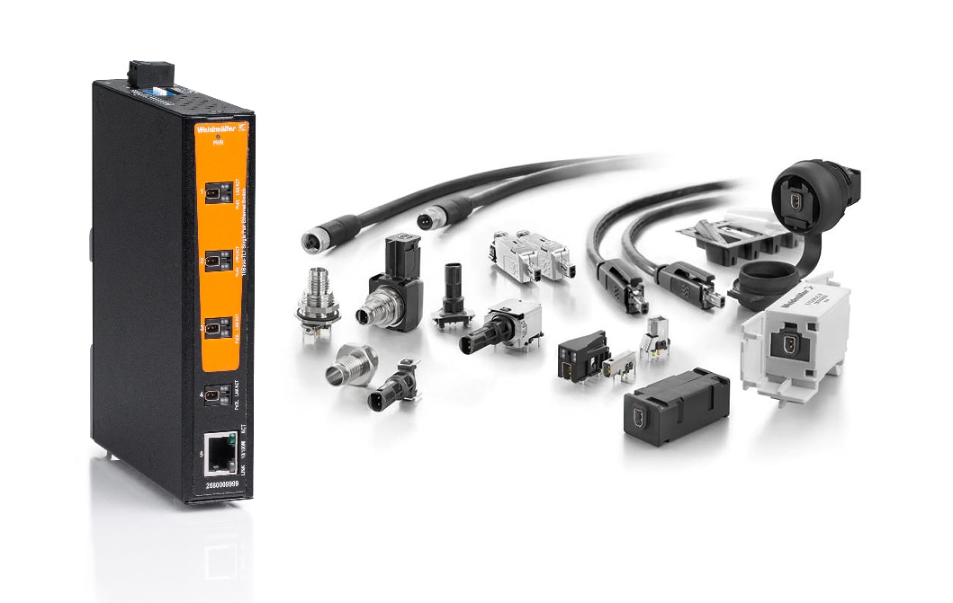
Image caption: Weidmüller offers a wide SPE product portfolio that includes field-attachable plug-in connectors and switches

The Weidmüller Group
Smart Industrial Connectivity: Electrification, automation, digitalisation, electrical connectivity, electromobility and renewable energies – markets in which Weidmüller feels right at home. The family-owned company established in 1850 has production facilities and sales companies in over 80 countries. As a global player in electric connection technology, Weidmüller achieved a turnover of more than one billion euros in the 2023 financial year with around 6,000 employees worldwide - around 2,000 of whom work at the company's headquarters in Detmold, in the heart of East Westphalia-Lippe, Germany. What Weidmüller lives by: Diversity with respect.
Technologies and engagement for a liveable future - Weidmüller demonstrates how it approaches the topic of sustainability in its interactive sustainability brochure.

Your contact person: Weidmüller Corporate Communications
Tel.: +49 5231 14-292322
Email: presse@weidmueller.com

