Weidmüller: Web-based control of wind turbines

The u-OS operating system from Weidmüller enables web-based engineering on Rengineers wind turbines

Weidmüller is equipping onshore wind turbines from Rengineers with the u-OS operating system, the PROCON-WEB web HMI and u-control control systems. Weidmüller’s systems facilitate the development of control and regulation technology for the wind turbines. They also simplify the commissioning of the turbines.

Rengineers turbines equipped with Weidmüller products are used all over Europe. Some of them can be found on the island of Fort Pampus. This is located in the inland lake IJmeer near Amsterdam. Originally a base for soldiers, the island is now a UNESCO World Heritage Site. As part of a building renovation project, an initiative was launched to make the island’s power supply completely self-sufficient. In addition to biogas plants, a battery management system and hydroelectric power have been installed. The island’s electricity is to be generated by photovoltaic and wind power plants. Rengineers manages the entire energy management system (EMS).

Weidmüller has proven to be an excellent partner for Rengineers when it comes to automation and digitalisation. Thanks to the open design of its portfolio, Weidmüller can readily integrate its products into the wind turbines. The u-control edge and control systems in particular were easy to set up and install in the wind turbines.

Rengineers also decided on the u-OS operating system from Weidmüller. “Each individual wind turbine is used in different application environments. In order to harmonise these environments and make them work as one, quite a few challenges had to be overcome. This has been standardised thanks to u-OS”, explains Leen van den Brink, Lead Engineer at Rengineers. The operating system offers even more advantages for the wind turbine manufacturer. The fact that u-OS supports native Codesys dramatically simplifies the programming process for engineers. In this regard, they benefit from the knowledge of the Codesys community, which can offer many examples of how to carry out a project. A further advantage for the company was that u-OS is web-based. This creates a lot more flexibility.

Rengineers chose PROCON-WEB fo onsite HMI control. Here too, the web capability of the software plays an important role. “We can now read the operating data of a wind turbine online. This allows us to perform remote fault diagnosis, for example. Our technicians no longer have to travel all the way to the site of the wind turbine, be it on an island or deep in the countryside.”, van den Brink continues. This is because technicians can check the electricity produced, operating data and wind speed via a mobile device. Similarly to this, customers use the Windup App developed by Rengineers to see how much electricity their system is producing and feeding into the power grid – using a smartphone when on the road.

The original intention was to equip only one batch of wind turbines with Weidmüller products. However, due to the broad range of functions, Rengineers decided to use Weidmüller solutions for the future production lines as well.

Thanks to the cooperation between the two companies, the island of Pampus was successfully equipped with the necessary wind turbines. The UNESCO World Heritage Site is now energy self-sufficient and fossil-free. “With our products and solutions for industrial IoT and automation, we are helping to shape the world of tomorrow. Moreover, we operate across a variety of sectors: from renewable energy to machine construction, from process optimisation to intralogistics. We accompany our customers on their path to the Industrial IoT”, explains Dr Thomas Bürger, Head of the Automation Products and Solutions Division at Weidmüller.

3799 characters including spaces

All images are freely available. You can download them from the following link:
https://www.picdrop.com/weidmueller/d2Xhv71HHv

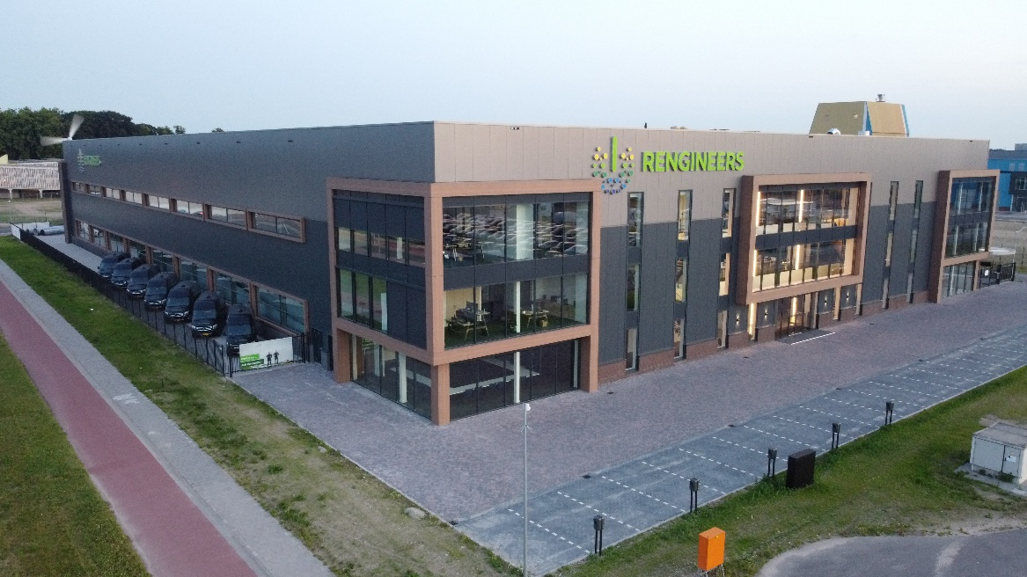
Image caption: Founded in 1997, Rengineers focuses on ensuring the availability of sustainable energy
Image Source: Rengineers

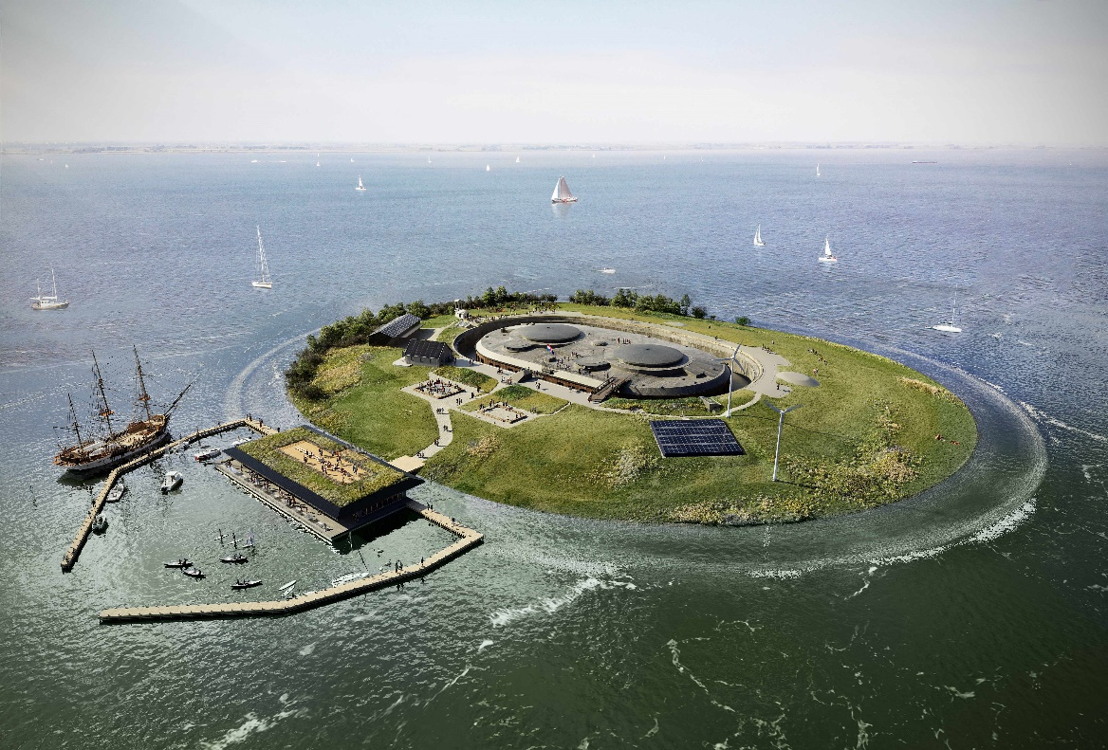
Image caption: Engineers do not have to travel all the way to a wind turbine, thanks to the availability of remote diagnostics
Image Source: Rengineers

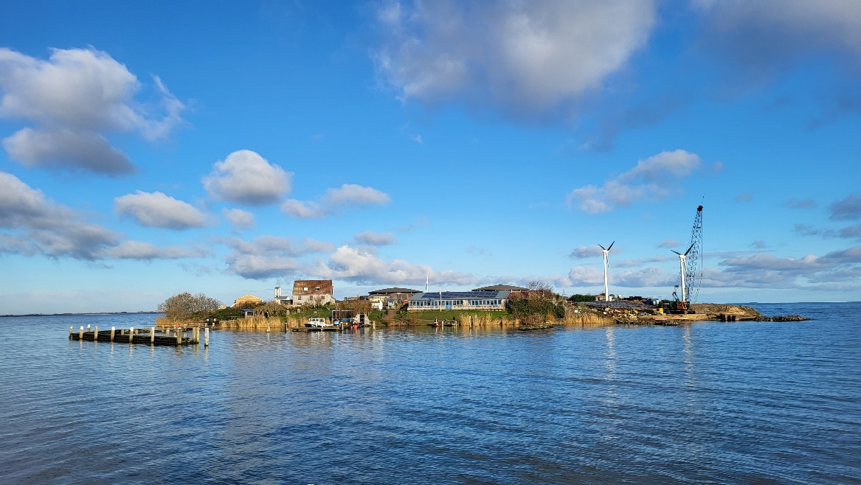Image caption: The UNESCO World Heritage Site Fort Pampus is self-sufficient in terms of energy
Image Source: Rengineers

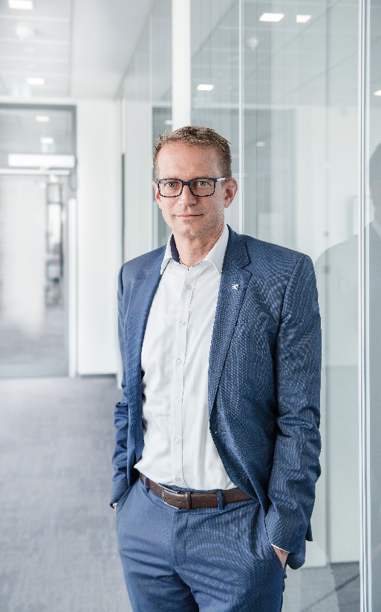
Image Caption: Dr Thomas Bürger, Head of the Automation Products and Solutions Division at Weidmüller
Image Source: Weidmüller

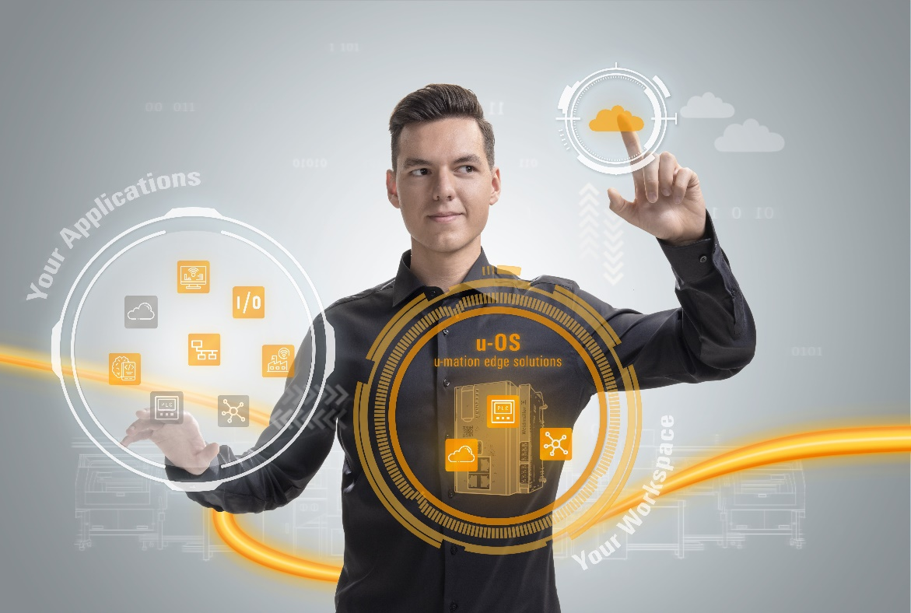Image Caption: u-OS combines customised software with industrial IoT and automation technology
Image Source: Weidmüller

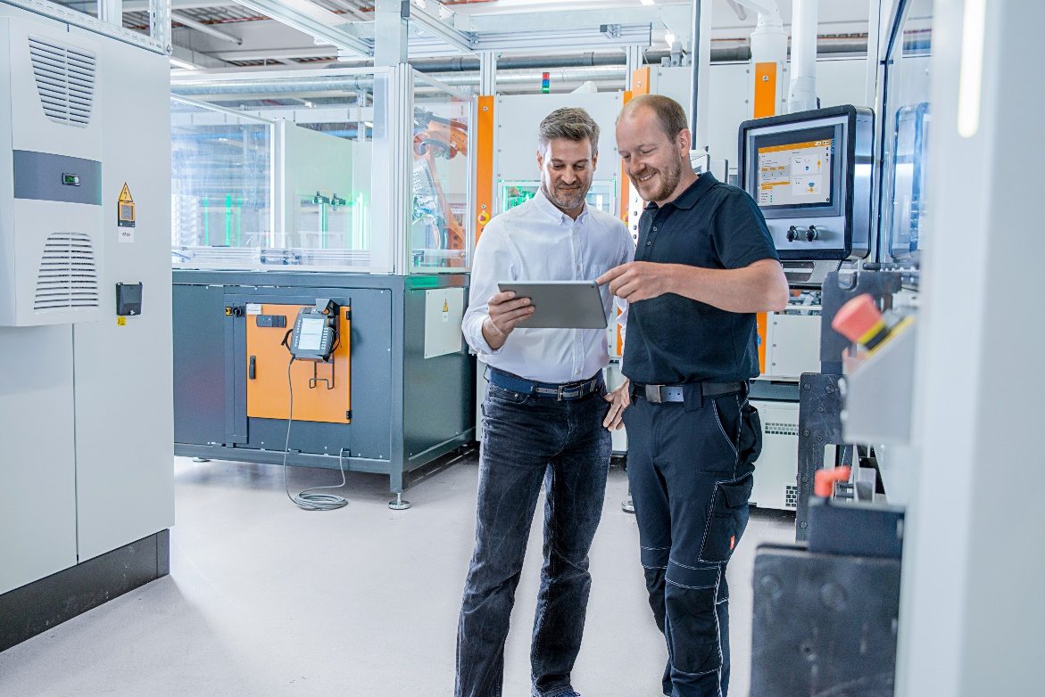Image Caption: The web-based visualisation solution PROCON-WEB allows configuration and parameterisation of user interfaces without programming knowledge
Image Source: Weidmüller

The Weidmüller Group
Smart Industrial Connectivity: Electrification, automation, digitalisation, electrical connectivity, electromobility and renewable energies – markets in which Weidmüller feels right at home. The family-owned company established in 1850 has production facilities and sales companies in over 80 countries. As a global player in electric connection technology, Weidmüller achieved a turnover of more than one billion euros in the 2023 financial year with around 6,000 employees worldwide - around 2,000 of whom work at the company's headquarters in Detmold, in the heart of East Westphalia-Lippe, Germany. What Weidmüller lives by: Diversity with respect.
Technologies and engagement for a liveable future - Weidmüller demonstrates how it approaches the topic of sustainability in its interactive sustainability brochure.

Responsible for the content: Weidmüller Corporate Communications
Corporate Spokesperson, Sybille Hilker

Your contact person: Weidmüller Corporate Communications
Tel.: +49 5231 14-292322
Email: presse@weidmueller.com

