Weidmüller supports the standardisation of Single Pair Ethernet
New SPE connector system offers standardised connector face

The automation community PROFIBUS & PROFINET International (PI), in which the electrical and connection technology company Weidmüller is involved as one of over 1,800 members, has implemented a uniform connector face for Single Pair Ethernet (SPE) based on key application requirements and submitted it for international standardisation. With its core technologies such as PROFIBUS and PROFINET, PI is responsible for the development of its market-leading, open standards for all fields of application in industrial production. By agreeing on a standardised connector face for Single Pair Ethernet, the industry is now taking a decisive step towards the future. The new SPE connector system offers a standardised mating face for applications in the control cabinet, in the field and also for hybrid installations. Numerous manufacturers have already announced that they will be implementing it in the near future. As a key driver of this technology, Weidmüller will also be expanding its product family to include connectors with the new face. Many functions of the new connector generation are already integrated into Weidmüller connectors. ‘As a pioneer in connection technology, Weidmüller is also a forerunner in Single Pair Ethernet technology. With its end-to-end communication from the sensor to the cloud, it offers real added value for the industry. This makes it all the more important that the industry has now agreed on a uniform connector face,’ explains Simon Seereiner, Business Development Manager at Weidmüller, and emphasises: ’The international standardisation now initiated by ISO/IEC and the acceptance of this interface by PROFINET will create clarity, security and unambiguity for manufacturers and users and thus accelerate the breakthrough of this technology.’

1.912 characters including spaces

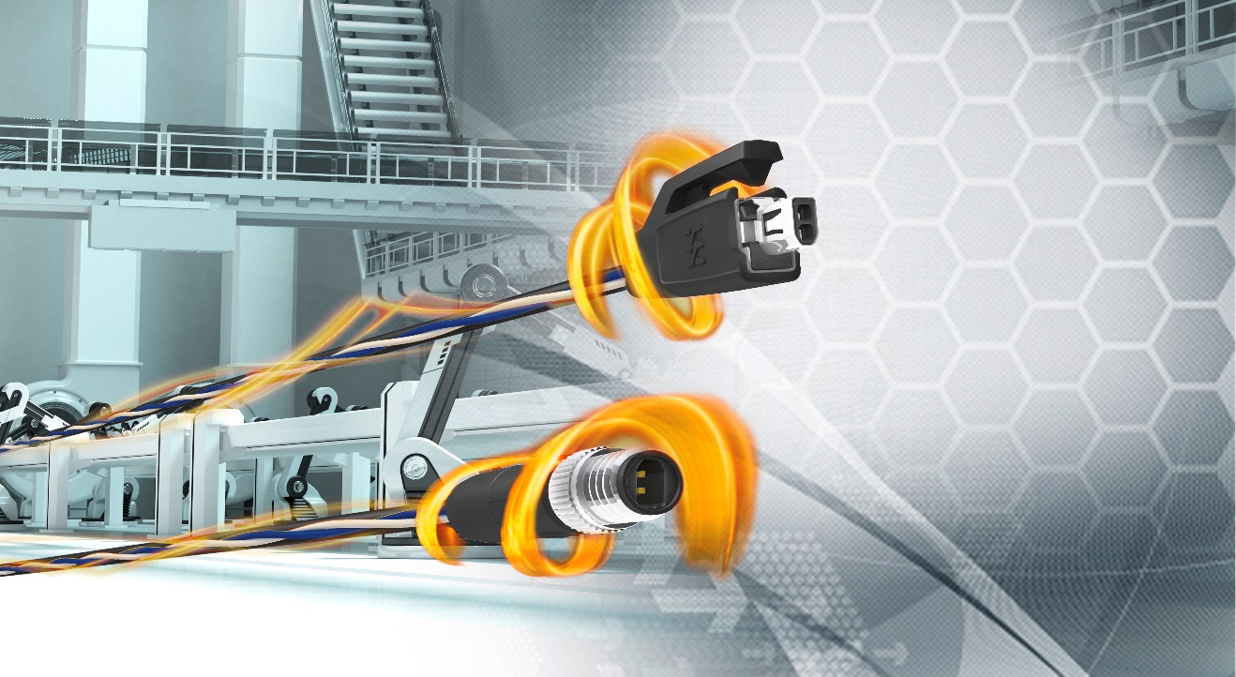
Image caption: Weidmüller will expand its product family to include connectors with the new face

The Weidmüller Group
Smart Industrial Connectivity: Electrification, automation, digitalisation, electrical connectivity, electromobility and renewable energies – these are markets in which Weidmüller feels right at home. The family-owned company established in 1850 has production facilities and distributors in over 80 countries. As a global player in electrical connectivity, in 2023 Weidmüller reported revenue in excess of one billion euros with around 6,000 employees worldwide – approx. 2,000 of whom are located at the headquarters in Detmold in the heart of Ostwestfalen-Lippe, Germany. Values Weidmüller lives by: Diversity with respect.

Technologies and engagement for a liveable future – Weidmüller demonstrates how it approaches the topic of sustainability in its interactive sustainability brochure.

Contact:
Weidmüller Corporate Communications
Company Spokesperson, Sybille Hilker
Phone: +49 (0)5231 / 14-292322
Email: presse@weidmueller.com

