With green hydrogen to a successful energy transition
Weidmüller founding member of the "AquaVentus" sponsoring association

Detmold, 12 March 2021. Weidmüller is strengthening its commitment to sustainability as a founding member of "AquaVentus". The sponsoring association, consisting of research institutions, organisations and companies, aims to decisively shape and advance the technology for the production of climate-neutral hydrogen from offshore wind energy. Green hydrogen, as an emission-free alternative to conventional energy sources, will be a central component of the energy transition and contribute towards the reduction of CO2 emissions.

AquaVentus wants to make a decisive contribution towards the German and European hydrogen strategy with ten gigawatts of generation capacity by 2035.

"Sustainability, whether in production, application or customer application, is both a responsibility and a matter of course for us. As a family-run medium-sized company, we are making our contribution towards achieving the goal set by the EU and Germany of climate neutrality by 2050. That is why we did not miss the opportunity to be a founding member of AquaVentus. In this way, we are actively promoting the topic of green hydrogen", explains Dr Timo Berger, Weidmüller's Chief Marketing and Sales Officer.

As a pioneer in industrial connectivity, Weidmüller is contributing its many years of expertise from wind energy, photovoltaics and its competence in explosion protection. This means that many years of experience from maritime applications, Power to X and DC technology complement the new way of generating energy. From this tradition, Weidmüller sees the connection to current topics such as digitalisation, Industrial IoT or artificial intelligence.

"The field of renewable energies is virtually predestined for forward-looking, data-driven business models, from plant construction and operation to state-of-the-art service concepts. We are happy to contribute our technological expertise for machine learning here", says Berger.

2,032 characters including spaces

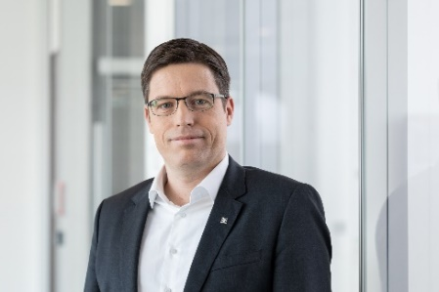

Image caption: Dr Timo Berger, Chief Marketing and Sales Officer of the Weidmüller Group
Image rights Weidmüller

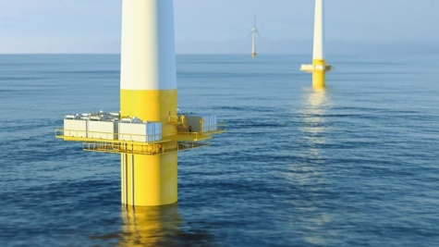
Image caption: AquaVenturs_Tower
AquaVentus aims to make a decisive contribution towards the German and European hydrogen strategy with ten gigawatts of generation capacity by 2035
Image rights: © AquaVentus

About AquaVentus: http://www.aquaventus.org

Weidmüller – Partner in Industrial Connectivity
The Weidmüller Group has production facilities, sales companies and representatives in more than 80 countries. Together with our customers, we shape the digital transformation – with products, solutions and services for Smart Industrial Connectivity and the Industrial Internet of Things. In the 2019 financial year, Weidmüller generated sales of €830 million with around 5,000 employees.

Contact: Weidmüller Corporate Communications
Corporate Spokesperson Hilker
Tel.: +49 5231/14-292322
E-mail: presse@weidmueller.com

