Precisely monitor power flows

Weidmüller presents new power measurement modules for the u-remote I/O system

Weidmüller, a leading provider of products and solutions for electrical connections and automation technology, announces the market launch of its latest power measurement modules for the u-remote I/O system. The four modules offer precise measurements, higher accuracy and seamless integration into existing automation systems.
The new power measurement series is composed of four different modules:

- 1-A current transformer measurement
- 5-A current transformer measurement
- Rogowski coil measurement
- 333 mV measurement

The power measurement modules were developed to meet growing requirements for precise measurement of power in industrial applications. Compared to their predecessors, they stand out for their speed and for the higher accuracy of the individual possible measurements.
The new power measurement modules offer all common electrical measured values. In addition to cyclical transmission of measured values, up to 128 other values can be transmitted via a mailbox system.
Thanks to the open interfaces, the new power measurement modules integrate seamlessly into existing automation systems. The eleven u-remote fieldbus protocols can serve even heterogeneous device landscapes. Configuration and monitoring via the web server ensure simple handling, quick installation and parameterisation.

“With our new power measurement modules, we make it possible for our customers to meet their requirements within the application not only via converter measurements, but also via Rogowski coil and mV measurement” says Sascha Lambauer, product manager at Weidmüller. “We developed the power measurement modules to give our customers and ourselves a clear overview of electrical data in the measured network. This is a major aid in monitoring power infrastructure, machines and systems” the expert adds.

The u-remote power measurement modules are part of the u-mation automation portfolio from Weidmüller. With software and hardware from sensors to the cloud, the company is helping its customers get started with automation and the industrial IoT.

2176 characters including spaces

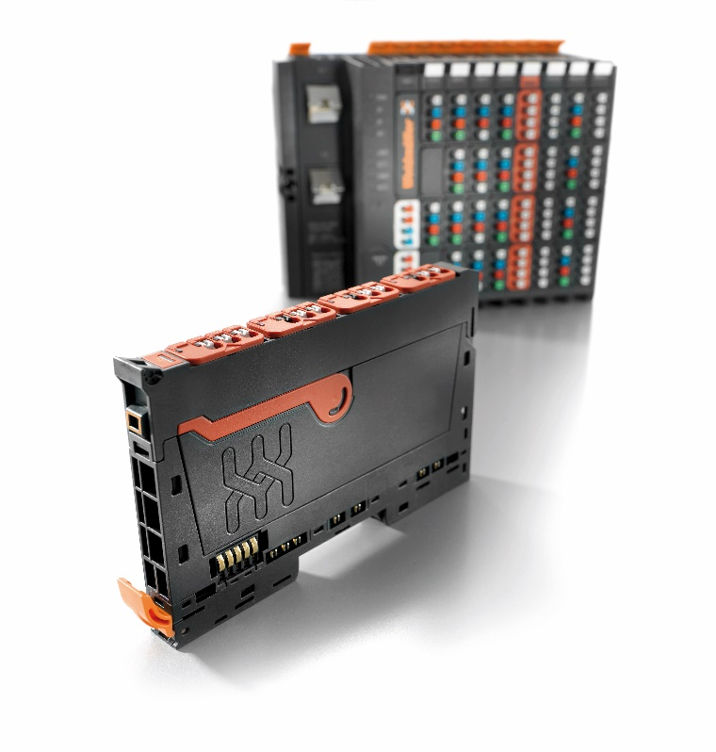
Caption: The new power measurement modules can transmit up to 128 values via a mailbox system.

The Weidmüller Group
Smart Industrial Connectivity: Electrification, automation, digitalisation, electrical connectivity, electromobility and renewable energies – markets in which Weidmüller feels right at home. The family-owned company established in 1850 has production facilities and sales companies in over 80 countries. As a global player in electric connection technology, Weidmüller achieved a turnover of more than one billion euros in the 2023 financial year with around 6,000 employees worldwide - around 2,000 of whom work at the company's headquarters in Detmold, in the heart of East Westphalia-Lippe, Germany. What Weidmüller lives by: Diversity with respect.
Technologies and engagement for a liveable future - Weidmüller demonstrates how it approaches the topic of sustainability in its interactive sustainability brochure.

Your contact person: Weidmüller Corporate Communications
Tel.: +49 5231 14-292322
Email: presse@weidmueller.com

