Install once for twice the safety
The compact PV Next fireman switch from Weidmüller

The number of rooftop photovoltaics systems is growing – and commercial properties and public buildings are no exception. According to a recent study, around a third of all businesses are planning to install a PV system over the next three years. There are a lot of regulations and recommendations to take into account when planning and installing this kind of system, including lightning and surge protection and the safety of firefighters in case of fire. Weidmüller is the first provider to develop an especially compact solution that combines these two requirements in one: the PV Next fireman switch. This clever box offers reliable protection while also making installation faster.

Prevent risk to firefighters
When generating electricity, the PV string cables in buildings are subject to high voltages of up to 1,100 volts. Even when a house fire occurs, electricity generation usually continues, putting firefighters at significant risk. This is particularly true when string cables are exposed due to fire destruction or the firefighters have to break through walls in which string cables are laid in order to rescue people. Given these risks, local and on-site fire services and insurance providers are calling for firefighters to be reliably protected during their work.

Automatic switch-off with reliable function
To ensure safety in case of fire, most PV systems installed on commercial buildings today are equipped with a fireman switch. Weidmüller offers the PV Next fireman switch for precisely this field. This compact box makes it possible to switch off the system’s DC lines. It is installed outside the building and as close as possible to the PV modules – at the lines’ entry point to the building as a minimum. When the fireman switch is activated, it automatically switches off the power to the string cables in the building via a switch disconnector so that the fire service can work safely. “The switch reacts automatically to a voltage of 230 volts,” says Pascal Niggemann, Head of PV Systems Home & Business at Weidmüller, explaining how it works. “If the voltage drops to zero because the fire service presses the emergency off switch, the box switches off automatically within 1.5 seconds. If the AC power supply is merely disrupted due to a power cut, however, the box automatically switches back on once a voltage of 230 volts is restored.”

Flexible integration options, depending on requirements
How the fireman switch is integrated into the building and which technical properties it has can be defined individually depending on the field of use. “Usually, the requirements are defined together with the fire service responsible and documented in detail, for example when developing emergency plans,” explains Pascal Niggemann. “After all, in an emergency, the firefighters need to know that there is a fireman switch, where the associated main switch is, and how to activate it. Integration into a fire alarm system is also possible on request. PV Next’s modular structure provides a great deal of freedom for installation.”

Unique combination of fireman switch and surge protection
Although many bodies recommend the installation of a fireman switch, it is not required by law. It is a different story for lightning and surge protection. This has been compulsory in all new buildings within the EU since 2019. Many customers therefore asked us whether functions like the fire switch can be combined with surge protection equipment, allowing them to reduce their installation work and costs,” says Pascal Niggemann. Weidmüller reacted to these enquiries and developed the new PV Next fireman switch in such a way that the two functions are combined in a single compact housing, saving space and costs. Thanks to this clever solution, the string connections only need to be connected once, saving a great deal of time. “There is currently only a handful of providers on the market offering similar solutions. Its circuit board design makes our device especially compact, clear and well-structured – the only one of its kind currently on the market,” says Pascal Niggemann. “That is another reason why our product family won the German Design Award in gold once again this year.”

Full service for the use of PV systems and renewable energies
As a partner of Smart Industrial Connectivity, Weidmüller develops innovative products and solutions in the fields of photovoltaics and renewable energies. The new PV Next fireman switch is just one example of how the company is reacting to the rapidly changing requirements of planners, installers and operators – both through continuous development of the range of components, tools, markers and plug connectors in the Weidmüller portfolio, and through innovative product developments like the new AC SMART wallbox family and the SMARTcharge intelligent load charging management solution. Both innovations will be showcased at Intersolar 2023. With its broad product range, Weidmüller offers planners and installers a series of sequential solutions for the use of renewable energies. The extensive range of services for selecting, ordering and installing the products provides the support needed in everyday operation. As a result, Weidmüller leaves nothing to be desired for its customers, knows Pascal Niggemann: “With us, they can jump straight into the future of renewable energies.”

5.525 characters including spaces

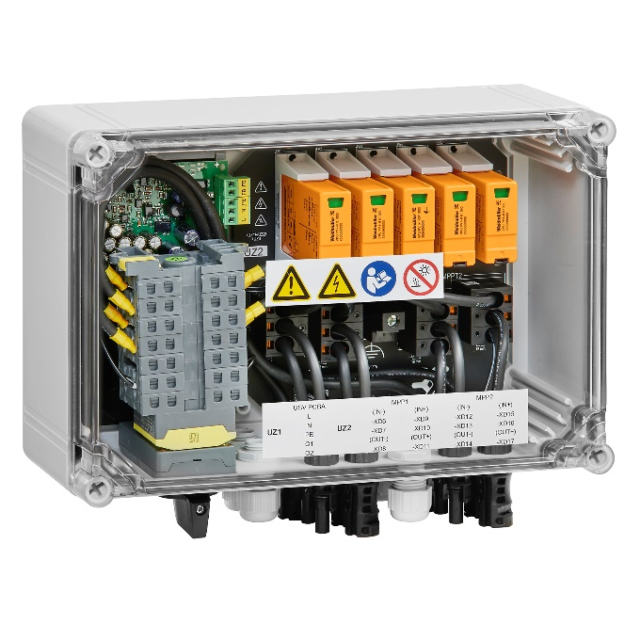
Image caption: The new PV Next fireman's switch offers safe emergency shutdown of PV systems in combination with overvoltage protection.

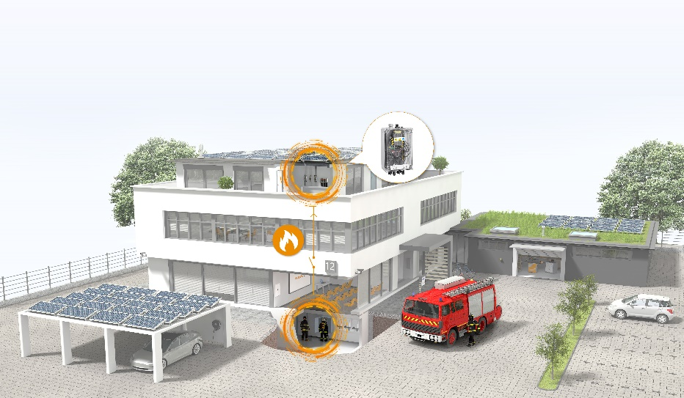

Image caption: The PV Next fireman's switch is installed outside the building and as close as possible to the PV modules. It is also available with integrated overvoltage protection.

Your contact person: Weidmüller Corporate Communications
Tel.: +49 5231 14-292322
Email: presse@weidmueller.com

Weidmüller – Partner of Smart Industrial Connectivity
The Weidmüller Group has production sites, sales companies and representatives in more than 80 countries. Together with its customers, the Detmold-based family business is shaping the digital transformation – with products, solutions and services for smart industrial connectivity and the Industrial Internet of Things. In the 2022 fiscal year, Weidmüller generated a turnover of more than one billion euros with about 6,000 employees around the world.

Responsible for the content: Weidmüller Corporate Communications
Corporate Spokesperson, Sybille Hilker

https://www.deutsche-handwerks-zeitung.de/wo-eine-solarpflicht-gilt-206871/

