Weidmüller at SPS 2025: Innovations for IIoT, Automation and Cabinet Building

- Weidmüller presents technologies for the Industrial Internet of Things (IIoT) and automation
- The family-owned company showcases efficient solutions for the cabinet building of the future – including SNAP IN connection technology
- Through targeted consulting in IIoT and automation, Weidmüller supports companies in optimising their processes

Detmold, 24 November 2025. From Tuesday, 25 November, to Thursday, 27 November 2025, the Weidmüller Group, headquartered in Detmold, will present new technologies for industrial automation as well as pioneering solutions for cabinet building at the leading trade fair SPS – Smart Production Solutions in Nuremberg.
“Automation, digitalisation and electrification are transforming industry. As a pioneer and innovation driver in Industrial Connectivity, Weidmüller is helping to shape this change. In dialogue with customers and partners, we are setting impulses at SPS and working together towards a sustainable future,” emphasises Dr Sebastian Durst, Chief Executive Officer of the Weidmüller Group.

Highlights from Industrial IoT & Automation
At the Weidmüller booth (Hall 9 / Booth 351), visitors will gain insights into modern concepts around Industrial IoT, software solutions and cybersecurity. Under the motto “The easy way to Industrial IoT and Automation”, the company demonstrates how openness, modularity and digital networking can increase efficiency in industry. With user-friendly tools, powerful software and practical consulting concepts, Weidmüller shows how automation can be designed holistically and sustainably.
“Only through openness can the requirements of industry be met. At SPS, we show how openness can be realised not only in software but also in hardware,” explains Dr Timo Berger, Chief Technology Officer of the Weidmüller Group.
One highlight is the u-software portfolio, which includes the u-OS operating system, the Industrial Service Platform easyConnect, and application software for energy management, HMI/SCADA and machine learning. In addition, special focus is placed on cybersecurity: certified products and partnerships enable Weidmüller customers to benefit from comprehensive protection mechanisms.
Cabinet Building of the Future
The SNAP IN connection technology developed by Weidmüller, also presented at SPS, is revolutionising cabinet building: the technology enables greater automation in industrial environments. It is ready-to-robot, ultra-fast, intuitive and absolutely reliable. Furthermore, Weidmüller’s Workplace Solutions help companies take the next step towards automated cabinet building.
“In cabinet building today, it’s all about speed, precision and automation. With technologies such as SNAP IN and our Workplace Solutions, we enable our customers to make the next leap in efficiency – from manual processes to smart manufacturing,” says Dr Berger.

Consulting & Collaboration
The company also presents its comprehensive consulting services. Whether in control cabinet building, energy management or Industrial IoT – Weidmüller’s experts support customers in finding solutions. The company’s broad partner network further expands its offering for customers.

3.235 characters including spaces

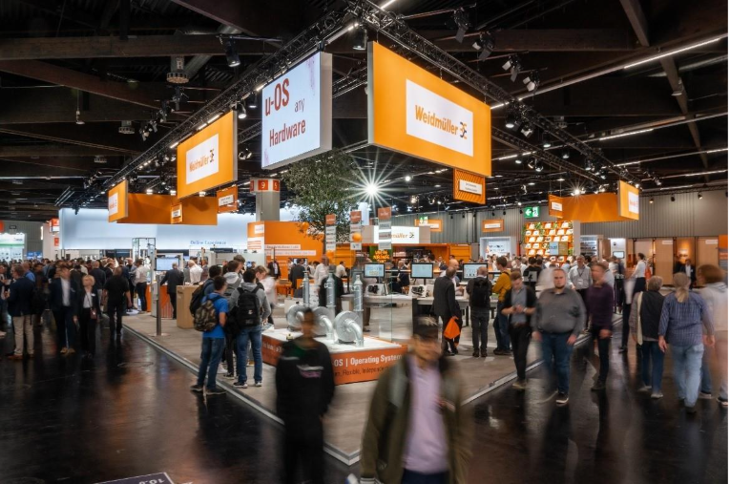
Caption: Weidmüller's exhibition booth at SPS 2025 is located in Hall 9, Booth 351.
(Image source: Weidmüller)

Caption: Dr Sebastian Durst, Chief Executive Officer of the Weidmüller Group
(Image source: Weidmüller)

Caption: Dr Timo Berger, Chief Technology Officer of the Weidmüller Group
(Image source: Weidmüller)

The Weidmüller Group
Industrial Connectivity: Electrification, automation, digitalisation, electrical connectivity and renewable energies – markets in which Weidmüller feels right at home. The family-owned company established in 1850 has production facilities and sales companies in over 80 countries. As a global player in electric connection technology, Weidmüller achieved a turnover of almost one billion euros in the 2024 financial year with around 5,700 employees worldwide - around 2,000 of whom work at the company's headquarters in Detmold, in the heart of East Westphalia-Lippe, Germany. What Weidmüller lives by: Diversity with respect.

