Weidmüller receives CC-Link certification for modular I/O system u-remote
With the new CC-Link Safety modules, Weidmüller expands the application range of its u-remote I/O system.
Weidmüller has received certification from the CC-Link Partner Association (CLPA) for its modular I/O system u-remote. This makes u-remote the first modular I/O system to obtain official CC-Link IE Safety certification for CC-Link IE TSN. The interface opens up new possibilities for machine manufacturers and automation engineers to integrate systems into networks based on the CC-Link IE TSN standard.
CC-Link IE TSN is an open fieldbus system based on Gigabit Ethernet technology that meets the demands of modern industrial communication. By supporting Time-Sensitive Networking (TSN), CC-Link IE TSN enables deterministic data transmission and promotes the convergence of different networks within a system.
The integration of CC-Link IE TSN technology into u-remote allows modular, fine-grained system architectures to be implemented easily. Users benefit from the flexible integration of distributed I/O modules into existing automation networks – without compromising performance or safety.
Another advantage lies in its use for functionally safe applications: for example, if a light barrier is interrupted, u-remote transmits the signal via a “Black Channel” directly to the safety controller. The controller responds immediately, for instance by stopping a process or initiating predefined safety measures. The system thereby ensures compliance with key safety requirements under modern machinery directives and safety standards.
The certified communication technology guarantees the safety-compliant operation of the system. The modular I/O architecture makes it easier to set up complex systems and simplifies their commissioning and maintenance. Due to the global adoption of CC-Link, Weidmüller also offers machine manufacturers greater planning reliability for export projects.
With the CC-Link IE Safety certification, Weidmüller strengthens the global connectivity of its u-remote I/O system. The company thereby supports users who rely on seamless, convergent communication solutions and who want to design their automation systems to be future-proof and based on the latest technological capabilities.
2297 characters including spaces
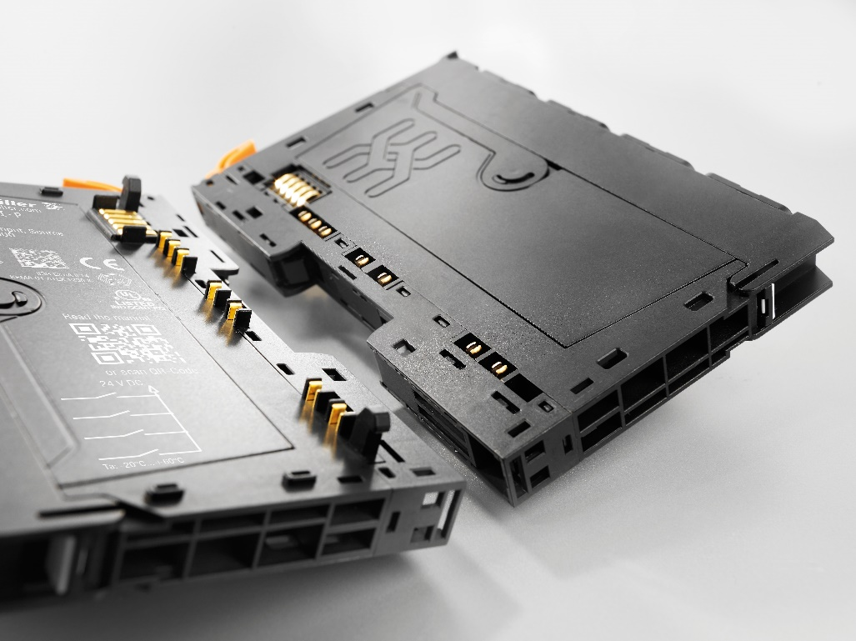
Image caption: u-remote is the first modular I/O system to obtain official CC-Link IE Safety certification for CC-Link IE TSN. This now also enables the implementation of fine-grained system architectures.

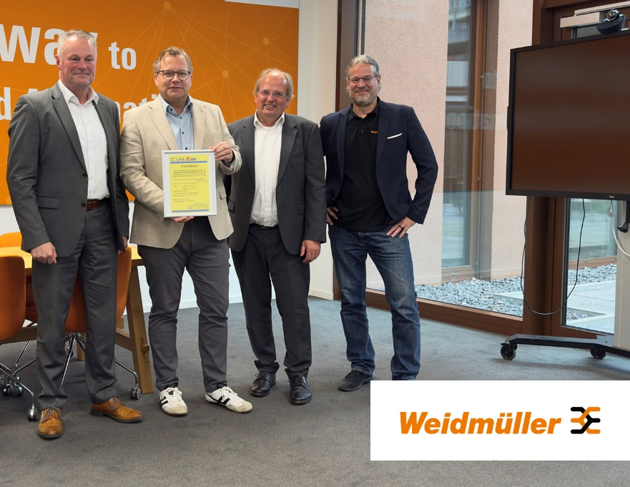
Image caption: From left to right: Christoph Behler (CC-Link Partner Association), Andreas Hoffmann (Weidmüller), Peter Dabringhaus (CC-Link Partner Association) and Sascha Lambauer (Weidmüller) at the certificate presentation in Paderborn

The Weidmüller Group
Smart Industrial Connectivity: Electrification, automation, digitalisation, electrical connectivity and renewable energies – markets in which Weidmüller feels right at home. The family-owned company established in 1850 has production facilities and sales companies in over 80 countries. As a global player in electric connection technology, Weidmüller achieved a turnover of almost one billion euros in the 2024 financial year with around 5,700 employees worldwide - around 2,000 of whom work at the company's headquarters in Detmold, in the heart of East Westphalia-Lippe, Germany. What Weidmüller lives by: Diversity with respect.
Technologies and engagement for a liveable future - Weidmüller demonstrates how it approaches the topic of sustainability in its interactive sustainability brochure.

Your contact person: Weidmüller Corporate Communications
Marc Ladermann, Head of Corporate Communication
Tel.: +49 5231 14-292322
Email: presse@weidmueller.com

