Fast, simple and intuitive labelling and assembly of components in panel building with Eplan Smart Mounting and Weidmüller’s LPC
Together, the digital assembly assistant Smart Mounting from Eplan and Weidmüller’s LPC make it possible to combine intuitive workflows for everything from the planning phase to the shopfloor in a new way.

Precision and time savings through digital support
Eplan Smart Mounting simplifies the manual assembly of mechanical and electrical components in control cabinets through the use of smart, browser-based software operated directly at the workplace, shopfloor or production hall. With the help of clearly organised checklists containing precise step-by-step work instructions and integrated 3D visualisation, users can fit the components efficiently and error-free in their intended positions in the control cabinet after just a short training session. This functionality is based on the digital twin generated in Eplan Pro Panel, which provides precise data for assembly. Thanks to this digital support, control cabinets can be assembled with high speed and reliability, reducing assembly times by up to 30%.
Weidmüller’s Labeling Processing Center (LPC) employs automatic component labelling to streamline the time-consuming physical labelling of components. A laser is used to project the label outline onto the product surface without distortion to enable the correct alignment of the component. The printing and application process is then started via a foot switch. Equipment IDs are correctly positioned, printed and applied in just a few seconds, and the components are precisely labelled. In addition to Eplan Smart Mounting, the time-consuming process of component labelling is automated in order to perform all equipment identification steps in production with software control. One key advantage: users only need a brief instruction, so no specialist training is required.
The use of intuitive assistance systems such as Eplan Smart Mounting and Weidmüller’s LPC reduces the workload of skilled workers, allowing them to focus on the demanding installation of the control cabinet. The optimal integration of digital systems increases productivity by up to 80% along the entire value chain.
Thanks to the enhanced data consistency it provides, the new solution from the two partner companies ultimately reduces process times and minimises errors. The digital assembly assistants efficiently support workers in the execution of their tasks by offering them cognitive guidance. They increase quality while helping to combat the shortage of skilled workers, as no specialist knowledge is required for the mechanical assembly. Personnel with less experience can be deployed to complete a control cabinet at high speed and a high degree of accuracy. Moreover, paperless digital documentation also offers high transparency, flexibility and improved monitoring. As a result, new standards are being set in cabinet building efficiency.
Eplan Smart Mounting in combination with Weidmüller’s LPC can be experienced from 12 to 14 November 2024 at the Eplan/Rittal stand at the SPS in Nuremberg, Hall 3C, Stand 321.
3,142 characters including spaces
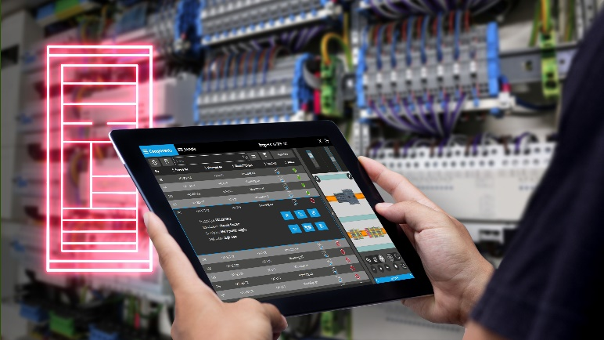
©Eplan

Image caption: Thanks to an intelligent, browser-based software employed directly at the workstation, Eplan Smart Mounting facilitates the rapid and exact placement of components in control cabinets

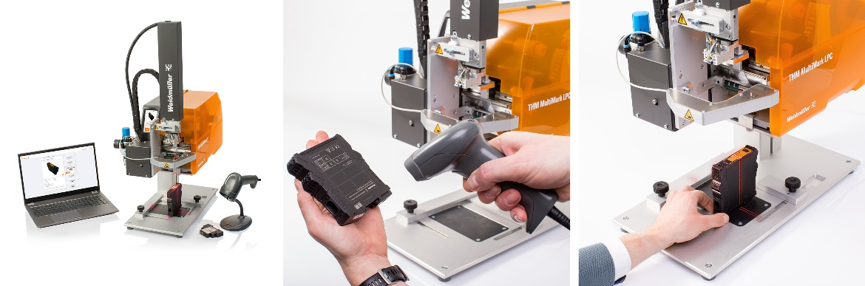Image caption: Weidmüller’s Labeling Processing Center (LPC) is used to position, print and apply equipment IDs in a few seconds

You are free to use all images. We request that you cite the image source.

The Weidmüller Group
Smart Industrial Connectivity: Electrification, automation, digitalisation, electrical connectivity, electromobility and renewable energies – these are markets in which Weidmüller feels right at home. The family-owned company established in 1850 has production facilities and distributors in over 80 countries. As a global player in electrical connectivity, in 2023 Weidmüller reported revenue in excess of one billion euros with around 6,000 employees worldwide – approx. 2,000 of whom are located at the headquarters in Detmold in the heart of Ostwestfalen-Lippe, Germany. Values Weidmüller lives by: Diversity with respect.

Technologies and engagement for a liveable future – Weidmüller demonstrates how it approaches the topic of sustainability in its interactive sustainability brochure.

Contact:
Weidmüller Corporate Communications
Company Spokesperson, Sybille Hilker
Phone: +49 (0)5231 / 14-292322
Email: presse@weidmueller.com

