Weidmüller acquires shares in ORing Industrial Networking
Acquisition of shares in the Taiwanese family-owned company strengthens
Weidmüller’s competence in network infrastructures and solutions for the Industrial Internet of Things (IIoT)

Detmold, Germany / New Taipei City, Taiwan, 12. June 2019. The
Weidmüller Group, an international market leader in Industrial Connectivity and automation with headquarters in Detmold, Germany, acquired a minority stake in ORing Industrial Networking Corporation (abbr: ORing) on May 31, 2019. With the minority interest, Weidmüller strengthens its strategic partnership with ORing and enables a deepening of the technological cooperation. The parties have agreed not to disclose the purchase price.

Volker Bibelhausen, Chief Technology Officer of Weidmüller Group commented on the conclusion of the agreement: "We are strengthening Weidmüller’s position to become a recognized player in the Industrial Internet of Things space – with this acquisition we are taking an important step in this direction. In addition, we are complementing our presence in Asia and will benefit from
ORing's strong development expertise."

Angus Shih, founder, Chief Technology Officer and Sales & Technical Leader at ORing added: „ORing will continue to exist as an independent company, but with Weidmüller's know-how and global positioning we will work even more consistently and successfully on joint IIoT solutions for our global markets. By adopting German working attitude into ORing family, we are thrilled to cultivate the same spirit of excellency to enhance ourselves to the next level in high quality product development and company management system. I am looking forward to the entry of Weidmüller and to the intensified cooperation that is now beginning.“

As a result of the share acquisition, which employs 150 developers and technicians worldwide, ORing will, among other things, put together a dedicated development team for Weidmüller and relocate its European headquarters from Poland to Paderborn, Germany, at the newly established Weidmüller location Zukunftsmeile 2.

1.865 characters including spaces

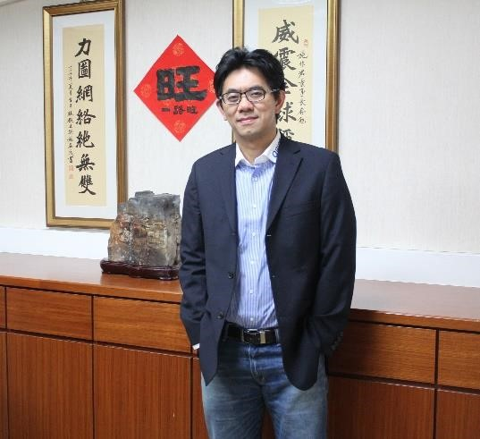
Image caption 1: Angus Shih, Founder, Chief Technology Officer and Sales & Technical Leader at ORing.

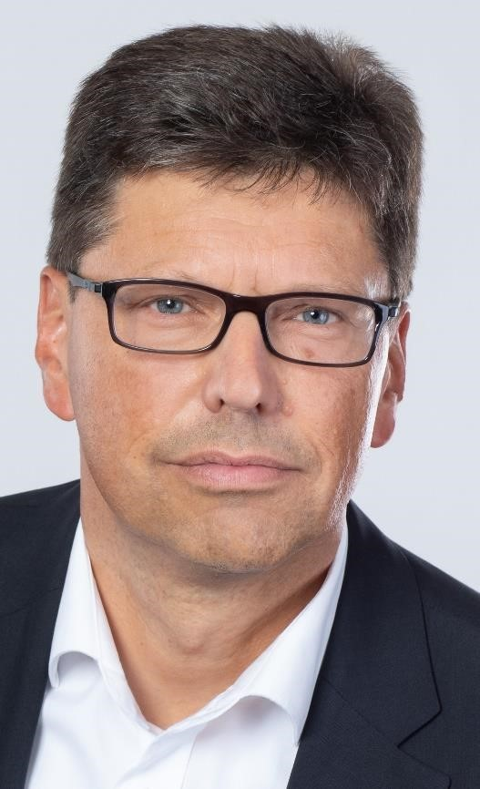
Image caption 2: Volker Bibelhausen, Chief Technology Officer of Weidmüller Group.

Weidmüller – your partner in industrial connectivity.
As experienced experts we support our customers and partners around the world with products, solutions and services in the industrial environment of power, signal and data. We are at home in their industries and markets and know the technological challenges of tomorrow. We are therefore continuously developing innovative, sustainable and useful solutions for their individual needs.
Together we set standards in Industrial Connectivity. The Weidmüller Group owns manufacturing plants, sales companies and representatives in more than 80 countries. In its fiscal year 2018 Weidmüller reached sales of 823 million euro with 4,900 employees.

ORing Industrial Networking Corp – Get connected, anytime, anywhere
Founded in Taiwan in 2005, in just 14 years, ORing has established four overseas branch offices for North America, Europe, India and China markets; and overall 200 employees worldwide. ORing not only specializes in developing innovative own-branded products for industrial settings but also experiences in IIoT new technologies for automation and smart city applications.
Furthermore, based on ORing‘s strong experiences of developing industrial communication technology, ORing has incorporated its technological strength within product lines –Industrial Ethernet (PoE) switch, Industrial wireless AP/Router, IoT gateways, remote I/O modules, IIoT cloud service platform and APP to provide a total End to End IIoT solution.

Contact: | Carsten Nagel
 | Weidmüller Gruppe
 | Corporate Communications
 | Fon.: +49 (0)5231 / 14-291010
 | E-Mail: carsten.nagel@weidmueller.com
Contact: | Elva Lee
 | ORing Industrial Networking Corp
 | Corporate Communications
 | Fon: +886-2-22181066 ext: 284
 | E-Mail: elvalee@oringnet.com

