Industrial routers from Schwabach to the world
The Niehoff Group relies on Weidmüller routers for its wire drawing lines

Routers in control cabinets have become essential in modern automation technology. They allow the networking of machines and production lines as well as the exchange of data between these and the higher-level system. The growing importance of Industry 4.0 and IoT technologies makes reliable and secure communication within the production network indispensable. Because of this, the use of routers in control cabinets is an effective solution for optimising the performance and efficiency of machines and production lines while ensuring both safety and data security.

IIoT-enabled machines for Industry 4.0

The Niehoff Group is a leading supplier of wire drawing machines and drawing lines for the wire and cable industry. Whether galvanic coating, braiding or annealing, the Niehoff Group builds individual machines and even entire lines for wire production. With headquarters in Schwabach, the family-owned company with a workforce of 960 employees generated a turnover of 248 million euros in the 2020/2021 financial year. With twelve locations worldwide, the company is an important international supplier of machines for wire production.
In order to drive the automation of production forward, Niehoff is committed to providing its customers with IIoT-enabled machines. To make this possible, the company relies on industrial routers from automation and electronics company Weidmüller.

Industrial routers for efficient data communication

Niehoff machines and systems are equipped with industrial routers to ensure smooth data communication between production lines and IIoT applications. The routers assign data packets to the individual machines and forward data streams from the machines to the servers. “We opted for Weidmüller routers because they have proven themselves to be highly reliable and efficient”, explains Markus Raab, Head of Electrical Engineering, adding: “Weidmüller IE-SR-4TX routers are used as standard in the control cabinets of the Niehoff production lines.”
Weidmüller IE-SR-4TX industrial routers boast an extensive range of functions for protecting networks. In addition to network segmentation, the industrial security router features an integrated stateful packet inspection firewall that protects the machine network and applications against unauthorised access. “We install the Weidmüller routers in the machines we produce for delivery to our customers worldwide. The feedback we have received has been 100% positive”, emphasises Markus Raab.

Comprehensive portfolio for industrial IoT and automation

As an enabler, Weidmüller is committed to supporting its customers on their path to industrial IoT and automation. With its industrial security routers, the company enables Niehoff to upgrade its machinery to meet automation standards. Weidmüller’s expertise is all they need to achieve this. “As an ‘enabler from data to value’, we empower our customers to easily digitalise their systems”, explains Dr Thomas Bürger, Head of the Automation Products and Solutions Division at Weidmüller. Weidmüller provides innovative concepts for data collection, pre-processing, analysis and visualisation.
3246 characters including spaces

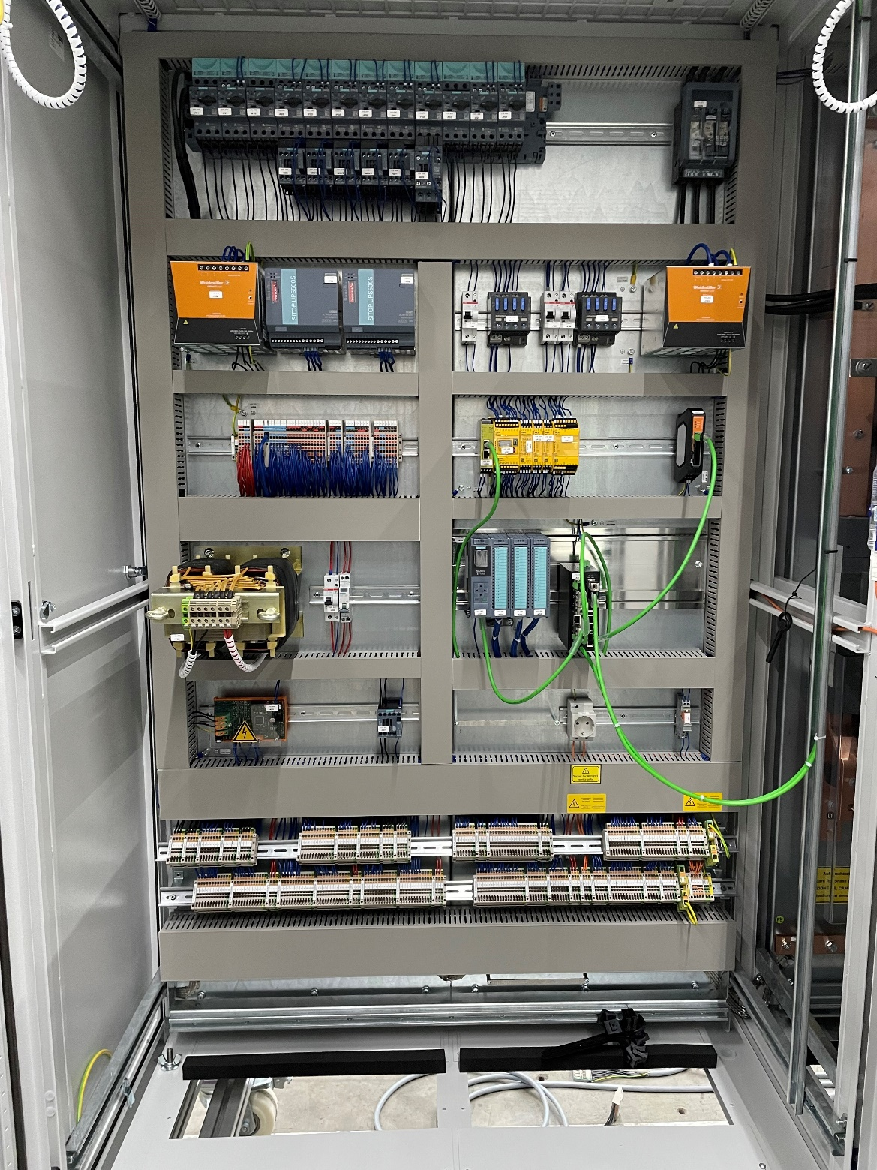image caption: The routers segment the networks and protect Niehoff’s machines

Image rights: Weidmüller
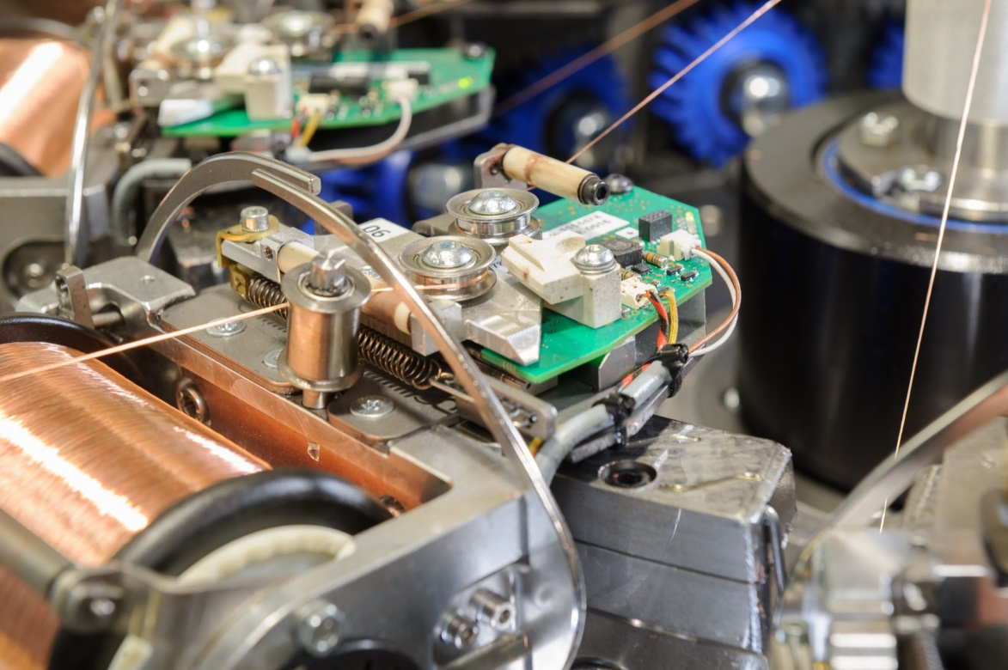
Image caption: Niehoff is the world’s leading supplier of machines and lines for the wire and cable industry

Image rights: Niehoff

Your contact person: Weidmüller Corporate Communications
Tel.: +49 5231 14-292322
Email: presse@weidmueller.com

Weidmüller - Your Partner in Industrial Connectivity
The Weidmüller Group has production facilities, marketing companies and representative offices in more than 80 countries. Together with our customers, we shape the digital transformation – with products, solutions and services for Smart Industrial Connectivity and the Industrial Internet of Things. In the fiscal year of 2021, Weidmüller reached sales of 960 million euros with around 5,300 employees.

Responsible for the content: Weidmüller Corporate Communications
Corporate Spokesperson, Sybille Hilker

