PrintJet CONNECT Impresses Right Down the Line

The high-performance PrintJet CONNECT inkjet printer from Weidmüller impresses with fast and flexible solutions and offers its users high-quality results. Focusing on the changing needs of industry and panel building, it combines maximum process and cost efficiency with intelligent networking and complete data consistency.

Perfectly centred prints that inspire, without manual adjustment
Advantages that impress – just ask Börger GmbH. The international company, which is headquartered in Borken-Weseke, currently employs over 340 workers worldwide, and offers a comprehensive range of products. Börger manufactures rotary pumps, mobile pumps, shredding technology, separation technology, and stainless-steel containers. As a forward-thinking company, it is essential to optimise work processes and take advantage of the new possibilities offered by digitalisation.
That is why the family-owned company decided to integrate the PrintJet CONNECT into its production processes. These processes are very diverse at the Börger company, as well as cross-sector. The product portfolio includes products for industrial applications, environmental and municipal technology, the food industry, marine and offshore, as well as biogas. That was why it was so important to find a flexible solution that can be adapted to individual needs. The PrintJet CONNECT fulfils these requirements. The broad range of applications and the Windows-based M-Print® PRO labelling software allow for customised marking. Available data from ePLAN, WS-CAD, Zuken e3 or Microsoft Excel can be used for the marking. The advantages of the PrintJet CONNECT allow the company to improve efficiency and minimise their error rate.
With automatic adjustment to the size tolerances of the markers, the PrintJet CONNECT ensures the print is perfectly centred. This saves time and improves processes and sequences. An integrated sensor ensures high quality by recording the exact size of the marker and adjusting the print values accordingly. The mobile pump from Börger especially requires precise marking to ensure correct operation. Börger is impressed, as it can use the PrintJet CONNECT to print both warning symbols as well as QR codes and type plates with company logos and more, and can choose between coloured or black and white prints. The simple plug & play design and solid cost-benefit analysis were two features that won over the company.

All in one: marker, printer, and software
The PrintJet CONNECT has another delighted user in the Wesermarsch district, Janssen electrical engineering. The company works both in the areas of crane and industrial service as well as in planning and designing switchgears. Janssen trusts the PrintJet CONNECT with optimal marking of the switchgears, and uses two of the printers, one permanently installed at the location in Nordenham, and one mobile printer for construction sites. This means Janssen can choose from a comprehensive marker portfolio from Weidmüller including over 800 MultiCards and additional metal and stainless-steel markers for special applications. Correct and complete marking is essential for service, maintenance, and successful troubleshooting. For Janssen, the ability to achieve results quickly is very important, since it manufactures switchgears in series production for machines and systems, as well as custom switchgears according to customer specifications.

“We are very satisfied with the PrintJet CONNECT. It fulfils our requirements and offers simple operation. The high speed the printer works at, in particular, makes our everyday work easier” says Jan Heinen, electrical engineer at Elektrotechnik Janssen GmbH. The PrintJet CONNECT workflow is highly automated; separating, labelling the MultiCard and then curing the ink. In addition, pre-heating is integrated for the marker, ensuring optimisation of ink flow control while also improving print quality. Not least due to the use of the multi-stage fusing unit consisting of an infrared emitter, ventilation, thermal separation and a sophisticated heat dissipation system, the PrintJet CONNECT is also suitable for printing large quantities of markers.
“We offer switchgears that are either custom designed to the customer's needs, or in series production for machines and systems. The PrintJet CONNECT allows us to be notably flexible, since we can process different MultiCard formats in one print order. We can then use the markers right away” says Jan Heinen, praising the advantages of the printer. This means that there is no need to complete the complex process to change the print media even with different markers in a single print job. Up to 50 MultiCards can be held in the input magazine for each order, then output via the integrated output magazine. Due to the ingenious design of the printer, it is also capable of printing half MultiCards. This allows that even the smallest quantities can be produced economically and sustainably.

Print results with good durability for extreme applications
The company HERMES Systems from Wildeshausen is also benefiting from the advantages of the high-performance printer. As a forward-thinking company that develops innovative solutions for different, custom profiles of requirements in the areas of I&C and automation technology, HERMES chose to work with the winner of the “German Innovation Award“. The PrintJet CONNECT is the perfect choice for the cross-sector services of HERMES Systems, which include technical building facilities, industrial automation, hydraulic engineering, waste treatment technology, refrigeration technology, central control technology, and information technology. Refrigeration technology in particular, which is used for freezing foods, requires special high-quality and durable marking. Weidmüller also offers detectable MultiCards for custom marking.
The PrintJet CONNECT guarantees brilliant print results with high durability on all media, from graphics to full-surface printing. HERMES Systems are mainly impressed by the refined inkjet technology. “We have razor-sharp print quality, high wipe and scratch resistance and unique colour printing. That kind of quality is especially important in the food industry” concludes Eckard Oltmann, electrical engineer at HERMES Systeme GmbH. These results are all laboratory-tested.

Unique networking opportunities
Another advantage of the printer are the comprehensive monitoring functions it offers, ensuring reliable operation. Through intelligent networking and complete data consistency, the PrintJet CONNECT records and stores operation-relevant parameters such as power supply, ink consumption, service life, air humidity, room temperature, etc., and warns users quickly of errors and deviations. The PrintJet CONNECT is connected to the network either in the traditional manner via LAN or wirelessly via WiFi. Hermes is delighted by the optimal printing results and easy operation of the PrintJet CONNECT.
A range of positive feedback from customers proves that the PrintJet CONNECT earned the coveted “German Innovation Award” and is perfectly tailored to the diverse requirements in industry and panel building. This is a positive confirmation for Weidmüller that it has created a unique product that can be individually adapted to the requirements of companies, while impressing users with its simple operation.

7,399 characters including spaces

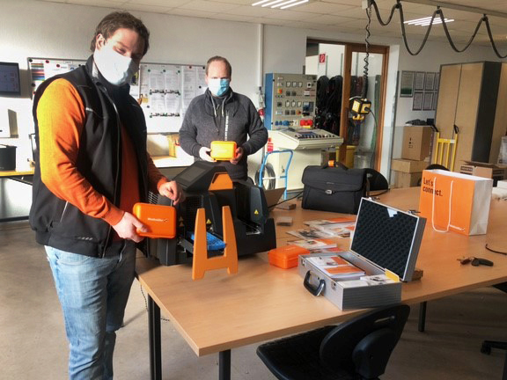
Image caption:
Successful integration of the Weidmüller PrintJet CONNECT into the work of Janssen electrical engineering.

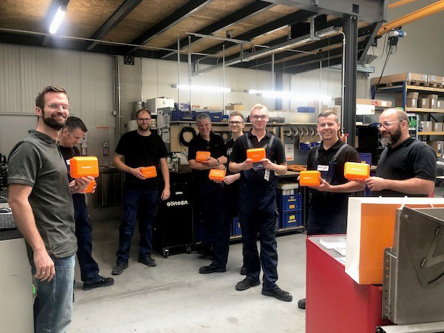
Image caption:
Employees at the family-owned company Börger GmbH are glad to begin operation of the PrintJet CONNECT.

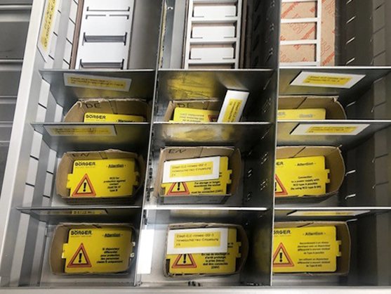
Image caption:
The PrintJet CONNECT allows Börger to print out both warning symbols and Data Matrix codes.

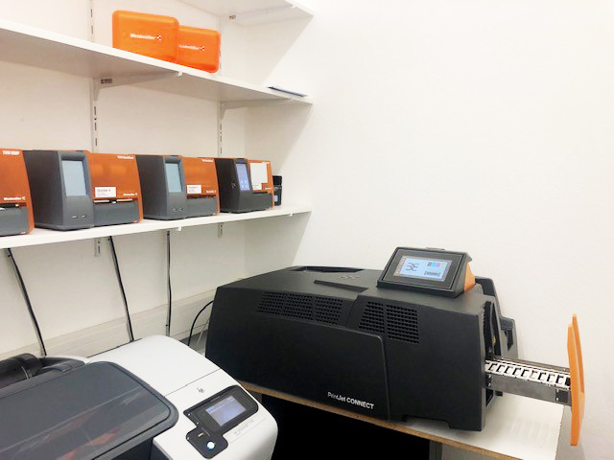
Image caption:
The company Hermes Systems benefits from the high wipe and scratch-resistance of high-quality print results from the PrintJet CONNECT.

Your contact: Dipl.-Ing. Silke Lödige
Press consultant
Tel. +49 (0) 5231 / 14-292322
Email: presse@weidmueller.com

Weidmüller – your partner in industrial connectivity.
The Weidmüller Group has production facilities, marketing companies and representative offices in more than 80 countries. Together with our customers, we shape the digital transformation – with products, solutions and services for Smart Industrial Connectivity and the Industrial Internet of Things. In the fiscal year of 2020, Weidmüller reached sales of 792 million euros with around 5,000 employees.

Responsible for content: Weidmüller Corporate Communications
Corporate Spokesperson, Sybille Hilker

