Weidmüller receives Top Employer award again
Top Employer Engineers 2020 – the family-owned company receives the award from the Top Employers Institute for the twelfth time

Detmold, 7 February 2020. Committed human resources management, excellent employee conditions and a harmonious work environment: The Top Employers Institute presented the Detmold-based electrical engineering firm
Weidmüller with the ‘Top Employer Engineers 2020’ award for the twelfth time.

Employees are at the heart of business operations
“We're delighted to have been presented with the ‘Top Employer Engineers
2020’ award for the twelfth time,” says Andreas Grieger, Executive Vice President Global Human Resources at Weidmüller. After all, the award demonstrates that the family-owned company puts its employees at the heart of its business operations and continues to create an employee-friendly working environment. “We can only achieve our business goals if our employees are satisfied and motivated in the workplace,” adds Grieger.

Human resources planning and leadership development
Weidmüller won over the independent jury this year in particular in the areas of human resources planning and leadership development. What's more, the group company had grown in various areas compared with the previous year, especially in terms of its talent strategy. “The award confirms that at Weidmüller the combination of growth, challenges in digitalisation and new workplace design is always shaped in a way that is focused upon the employees,” continues Grieger.

Employee needs are a priority
A guiding principle applies at Weidmüller: Understand the employees' needs and create good working conditions. To grow employees' skills, the Weidmüller Academy offers many further and advanced training opportunities. What's more, employees also enjoy a range of health management initiatives: with various opportunities for sport, health and work-life balance.

“For a better world of work”
To be recognised as a Top Employer, as part of a multi-stage evaluation process, a company must prove that the implementation of its human resources strategy enriches the working lives of its employees. Weidmüller convinced the objective and independent jury of its attractiveness to engineers. “Certified companies are a great example of committed human resources management, ongoing improvement and the promise: ‘For a better world of work’,” emphasises David Plink, CEO of the Top Employers Institute.

About the Top Employers Institute
The Top Employers Institute was founded more than 28 years ago and has been examining employers around the world who have outstanding staff management and strategies in place. It focuses on various areas of practice, including talent strategy, human resources planning, talent acquisition, onboarding, training & development, performance management, leadership development, career and succession planning, compensation & benefits and corporate culture.

3.451 Zeichen inklusive Leerzeichen
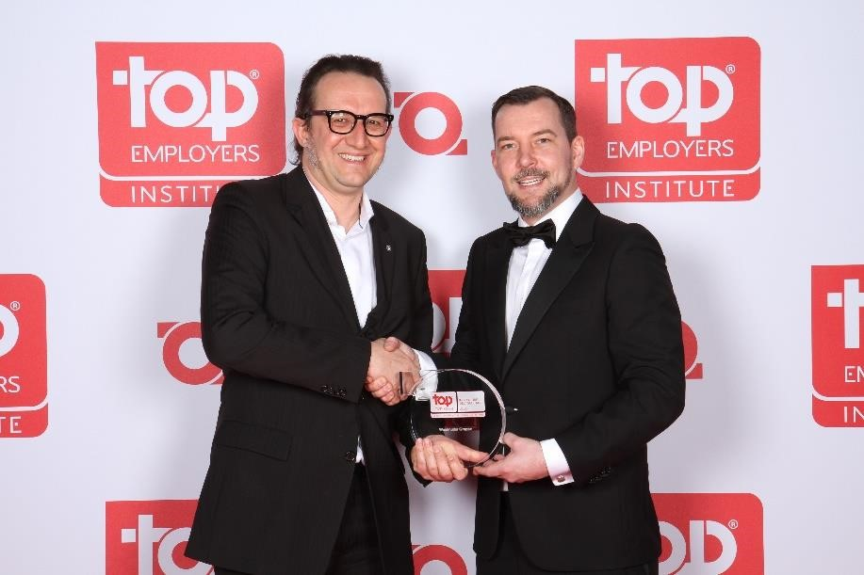
Image caption: Bernd Konschak, Senior HR Manager Marketing (l), accepted the award from Steffen Neefe, Country Manager DACH at the Top Employers Institute (r). (Copyright: Florian Grob)

Weidmüller – your partner in industrial connectivity.
As experienced experts we support our customers and partners around the world with products, solutions and services in the industrial environment of power, signal and data. We are at home in their industries and markets and know the technological challenges of tomorrow. We are therefore continuously developing innovative, sustainable and useful solutions for their individual needs. Together we set standards in Industrial Connectivity.
The Weidmüller Group owns manufacturing plants, sales companies and representatives in more than 80 countries.
In its fiscal year 2018 Weidmüller achieved sales of EUR 823 million with around 4,900 employees.

Contact: Carsten Nagel
Corporate Communications
Tel.: +49 (0)5231 14-291010
E-mail: carsten.nagel@weidmueller.com

