Weidmüller BLADEcontrol® - Leading condition monitoring system for wind turbines
BLADEcontrol® enables early detection of damage to the rotor blade and increases system availability

Damage to wind turbines can quickly become expensive - this applies to both onshore and offshore turbines. While onshore turbines are usually relatively easy to reach for repairs, offshore turbines often require costly boat or helicopter missions for maintenance and servicing. Whether on land or at sea, it becomes particularly expensive when damage occurs unexpectedly and urgent action is required. To prevent unexpected defects, the electronics and connection technology company Weidmüller offers highly efficient systems for the remote monitoring of rotor blades.

Many operators and service providers want to sustainably increase the cost efficiency and system safety of wind turbines. They are faced with the challenge of meeting increasing demands on profitability: Modern and future-proof turbines must become ever more cost-effective and reliable. As a solution provider and specialist in smart industrial connectivity, Weidmüller meets this demand from the wind industry with customised products, solutions and services. The international technology company offers both individual components and complete packages for the individual requirements of its customers in the wind industry. As part of the Weidmüller Group, Dresden-based Weidmüller Monitoring Systems GmbH specialises in the vibration-based condition monitoring of rotor blades - and has been doing so for around 20 years.

‘The demand for technologies that reliably visualise anomalies in critical and expensive components such as rotor blades is increasing noticeably,’ explains Hans Schlingmann, Head of IIoT & Automation Consulting at Weidmüller, adding: ’This is not surprising, however, as the wind energy sector is one of the fastest growing energy sources for power generation worldwide.’ The number of wind turbines has been increasing continuously for years. Nevertheless, even the most modern turbines are not protected against damage.

Sensors and cloud solutions go hand in hand

With its digitalisation solutions, Weidmüller supports many branches of industry, including the wind industry. To detect damage before it becomes a critical issue, Weidmüller provides solutions ranging from sensors to cloud-based software. The company uses its many years of experience in the field of industrial IoT to offer software applications for data acquisition, storage, analysis, evaluation and visualisation. Important added value can be generated from the processed data. This is particularly essential when it comes to maintaining and further optimising the operation of systems.

Rotor blade monitoring with BLADEcontrol®

In 2004, Weidmüller's experts developed and launched BLADEcontrol®, an innovative condition monitoring system (CMS) that detects even the smallest anomalies in rotor blades and their structure. BLADEcontrol® permanently monitors the rotor blades for changes and recognises damage to the rotors of wind turbines as soon as it occurs. BLADEcontrol® reliably detects cost-intensive damage, such as blade tip damage caused by lightning strikes, trailing edge cracks, web separation, bonding defects or blade bearing damage. This enables service technicians to intervene at an early stage before major damage to the blade structure or even loss of the rotor blade occurs. This is a real added value, as planned repairs are generally much cheaper than spontaneous ones.

For operators, sudden damage to offshore wind turbines in particular represents a major economic risk. In an emergency, they have to reckon with a prolonged outage of the entire turbine, including yield losses, as repair work on the high seas is associated with high costs and considerable effort.

Web-based visualisation with expert support: WebVis for BLADEcontrol®

With BLADEcontrol® WebVis, Weidmüller offers a user-friendly dashboard that provides a quick overview of the entire turbine portfolio. Filter functions, direct switching to other turbines and a flexible time range selection make status monitoring efficient and user-friendly. Operators can find out about the turbine status at any time via the Internet and call up detailed information for each turbine. The monitoring experts can be contacted directly if questions arise.

All detected damage is transmitted to the Weidmüller Monitoring Center, where experts analyse the data and provide specific recommendations for action for the operators. Online monitoring with WebVis enables continuous condition monitoring of the rotor blades.

Reliable condition monitoring of wind turbines

Weidmüller's condition monitoring solutions such as the BLADEcontrol® CMS for rotor blades, the BOLTcontrol® bolt breakage detection system and the TwinCap® condition monitoring system for blade bearings increase turbine safety and reduce unexpected failures. With its LED systems, Weidmüller also offers ready-to-install solutions for lighting and emergency lighting in the tower and nacelle. Customised solutions such as individually assembled housing solutions and control cabinet components complete the product portfolio of the electrical engineering and connection technology company for the wind industry.

5,298 characters including spaces

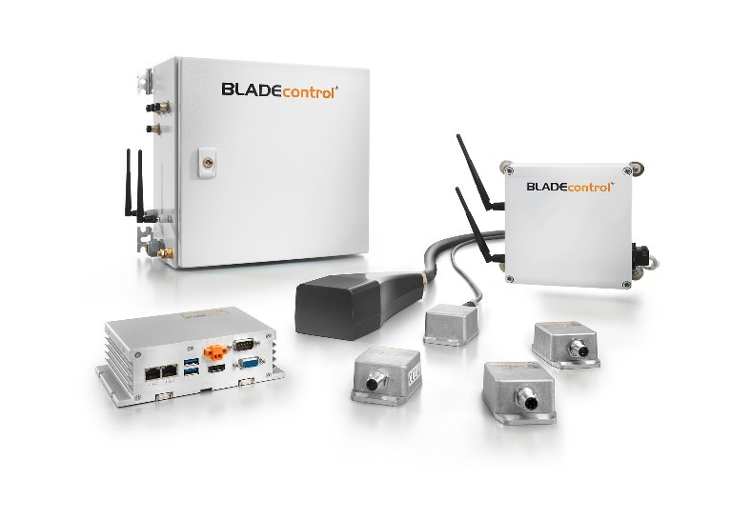
Image caption: BLADEcontrol® permanently monitors the rotor blades for changes
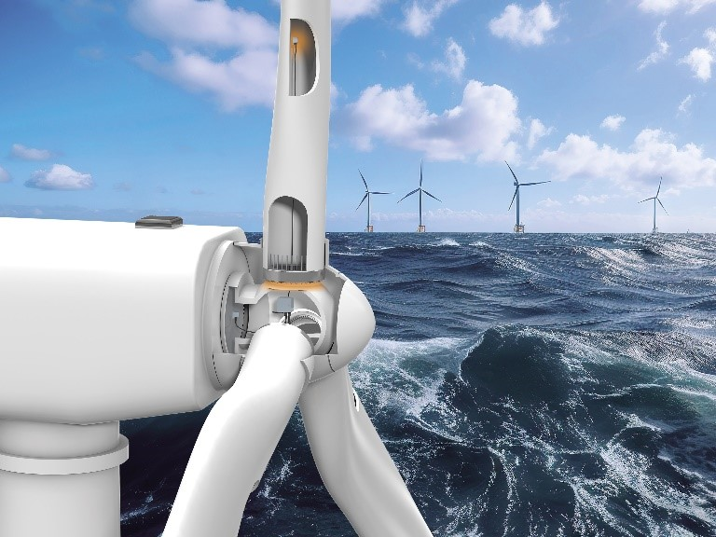
Image caption: The condition monitoring system BLADEcontrol® is suitable for onshore and offshore wind turbines

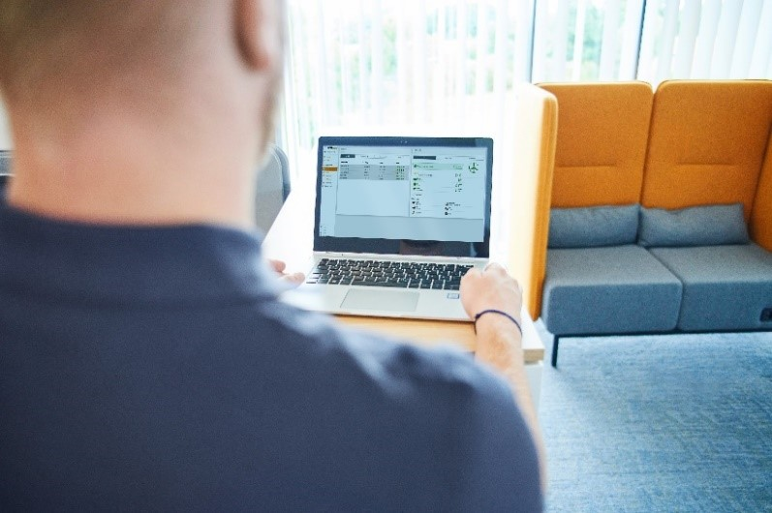
Image caption: BLADEcontrol® WebVis makes important information about the condition of the rotor blades available at any time

You are free to use all images. We request that you cite the image source Weidmüller.

The Weidmüller Group
Smart Industrial Connectivity: Electrification, automation, digitalisation, electrical connectivity, electromobility and renewable energies – markets in which Weidmüller feels right at home. The family-owned company established in 1850 has production facilities and sales companies in over 80 countries. As a global player in electric connection technology, Weidmüller achieved a turnover of more than one billion euros in the 2023 financial year with around 6,000 employees worldwide - around 2,000 of whom work at the company's headquarters in Detmold, in the heart of East Westphalia-Lippe, Germany. What Weidmüller lives by: Diversity with respect
Technologies and engagement for a liveable future - Weidmüller demonstrates how it approaches the topic of sustainability in its interactive sustainability brochure.

Your contact person: Weidmüller Corporate Communications
Tel.: +49 5231 14-292322
Email: presse@weidmueller.com

