Weidmüller at the SPS 2023 trade fair: Into the future with innovative power

- With u-OS, Weidmüller presents an open operating system for automation and digitalisation
- SNAP IN connection technology enables automated wiring processes
- Products and solutions for renewable energies and greater sustainability

Detmold, 14 November 2023. The Weidmüller Group, headquartered in Detmold, will be presenting its solutions in the field of electrical automation technology at the SPS – Smart Production Solutions trade fair in Nuremberg (14 to 16 November 2023). The focus will be on a new operating system, an innovative connection technology and solutions that the family-owned company is developing for renewable energies. “Electrification, automation and digitalisation are important areas for the future. We develop systems to address these issues, and our innovations make an important contribution to a sustainable and more liveable world. For this reason, we are optimistic about the future, even in geopolitically and economically challenging times – after all, we’re located in the right markets,” emphasises Volker Bibelhausen, Chief Technology Officer and Speaker of the Executive Board at Weidmüller.

Developed for the future: Innovations from Weidmüller

The SPS in Nuremberg is one of the world’s largest trade fairs for electrical automation technology. At its stand (Hall 9 / Stand 351), Weidmüller will be demonstrating the easy way to the Industrial Internet of Things (IIoT) and automation with a wide range of products designed for this purpose. The company's presentation will focus in particular on the new u-OS operating system for industrial plants and machines. Compared to other real-time operating systems, the Weidmüller solution has an open design and enables users to integrate software, hardware and cloud connections from third-party providers in a flexible way. “With u-OS, we have developed an edge operating system based on open source technologies that automation specialists can expand with their own software - a unique concept that allows our customers to remain independent and flexible. In this way, u-OS contributes to the simple and effective realisation of industrial solutions on a wide variety of platforms,” says Volker Bibelhausen.

Another focus topic for Weidmüller at SPS 2023 is the SNAP IN connection technology. Volker Bibelhausen is well aware of Weidmüller's pioneering position in this technology: “With SNAP IN, we have invented the most innovative connection technology. It not only makes wiring processes in cabinet building simpler and faster, but is also ready-to-robot.” In other words, the technology can even be used for wiring by robot. “This means that SNAP IN is ready today for the automated cabinet building of tomorrow.”

Weidmüller will also be showcasing products and solutions that have applications in the field of renewable energies, in particular digital solutions for wind energy, hydrogen production and energy storage.

2,985 characters including spaces

You are free to use all images.
Image source: Weidmüller

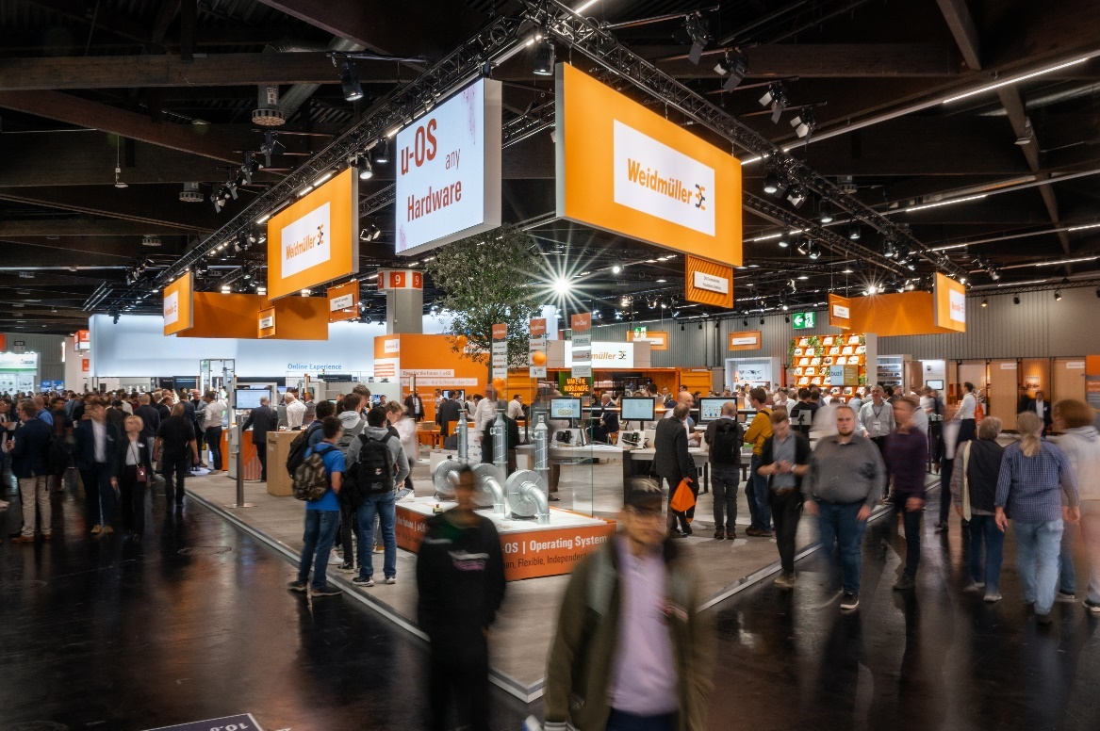
Image caption: Find Weidmüller at the SPS 2023 trade fair in Hall 9, Stand 351

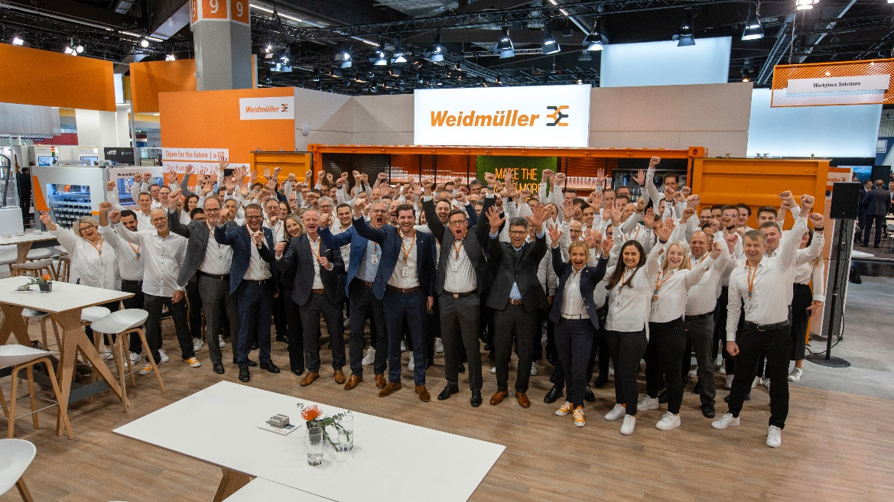
Image caption: The Weidmüller team is looking forward to interesting discussions at the trade fair stand

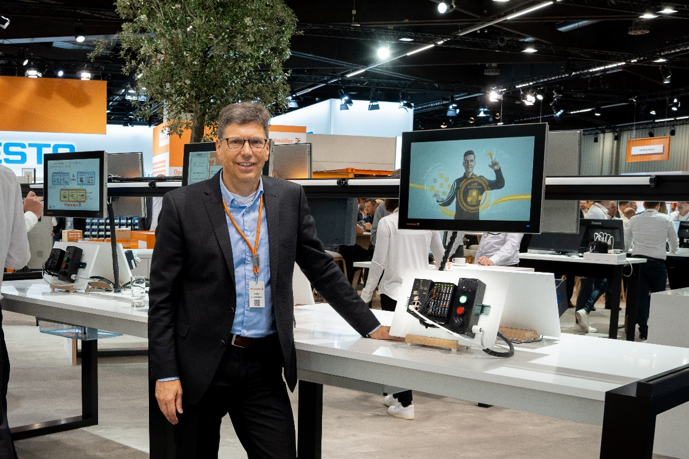
Image caption: Volker Bibelhausen (Chief Technology Officer and Speaker of the Executive Board at Weidmüller) presents the open operating system u-OS from Weidmüller

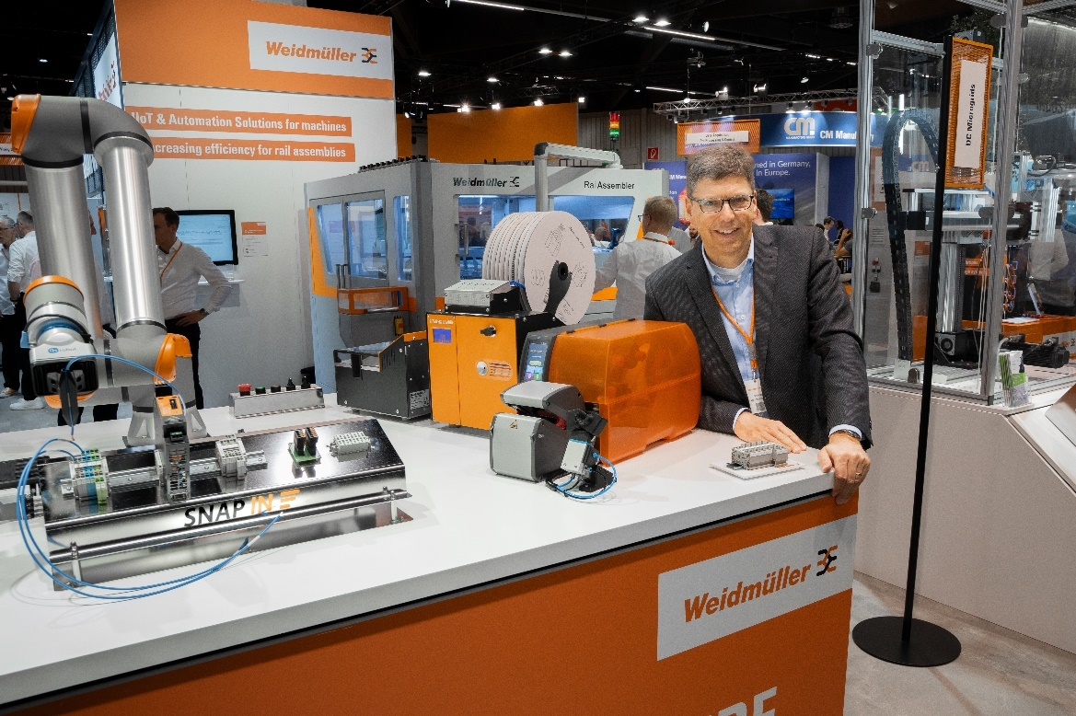
Image caption: With SNAP IN, Weidmüller has invented a connection technology that enables automated wiring processes

The Weidmüller Group

Smart Industrial Connectivity: Electrification, automation, digitalisation, electric connectivity, electromobility and renewable energies - markets in which Weidmüller is at home. Founded in 1850, the family-owned company is represented in over 80 countries with production facilities and sales companies. As a global player in electric connection technology, Weidmüller achieved a turnover of more than one billion euros in the 2022 financial year with around 6,000 employees worldwide - around 2,000 of whom work at the company's headquarters in Detmold, in the heart of East Westphalia-Lippe.
Responsible for content:
Weidmüller Corporate Communications
Company Spokesperson, Sybille Hilker
Contact:
Weidmüller Corporate Communications
Tel.: +49 (0)5231 / 14-292322
Email: presse@weidmueller.com

