Efficient Retrofitting: String Monitoring for Utility Scale PV Systems
PV Retrofit Combiner Boxes with String Monitoring from Weidmüller Ensure Better Measurability and Higher Performance Ratio

Photovoltaic systems are assets that unleash their full potential when they are aligned for optimal performance. To achieve this, the productivity and efficiency of the systems must be monitored, along with seamless integration into the network, ensuring constant feed-in capacity and maximizing their economic success and profitability.

Zone Monitoring Leads to Misconceptions
In past years and decades, numerous design and construction approaches were implemented where string monitoring was not considered mandatory. A simple zone monitoring, which only encompassed monitoring at the input of the central inverter, was deemed sufficient to evaluate the performance of the systems.

However, it is now clear that sole reliance on zone monitoring is no longer adequate. Relying exclusively on data from zone monitoring led to many operators and maintenance companies overlooking failures, issues, and insufficient energy generation, resulting in numerous systems operating below efficiency.

Maximizing Photovoltaic Efficiency through (Retrofit) String Monitoring
A growing trend indicates that operators, asset owners and maintenance companies of photovoltaic systems are having the actual performance of their systems evaluated by technical consulting firms. Especially for existing PV combiner boxes lacking string monitoring, the primary recommendation from these consultants is to implement or retrofit string monitoring, as it significantly increases the Performance Ratio (PR). In these cases, we refer to retrofit string monitoring solutions.

Weidmüller responds to these demands with various tailored solutions for retrofitting photovoltaic systems with string monitoring. Firstly, with the standalone component PV String Monitoring System, which allows users to choose between modules with 8 or 12 inputs, ranging from 25 ADC to 50 ADC. These modules can also be combined in existing PV DC Combiner Boxes, allowing solutions with up to 32 inputs. The retrofit string monitoring communicates wirelessly via LoRaWAN® protocol as a plug-and-play solution, simplifying installation and preventing additional costs or maintenance work on communication cables. Thanks to these features, the system enables the localization and isolation of any problem on-site within minutes.

Secondly, there is the ready-to-use cabinet, the PV Retrofit Combiner Box, which allows installers to choose between twelve different boxes with varying inputs (12-16-24) with communications wired (RS485) or wireless (LoRaWAN) and connections (multi-via cable glands or PV connectors). Thanks to its optimized and reduced space requirement, this solution can be installed very quickly and close to existing PV DC combiner boxes.

Data Acquisition Even Without SCADA Solution
Weidmüller's string monitoring components can operate with two protocols: the standard Modbus/RTU protocol or Modbus/TCP. This flexibility allows users to easily integrate all data into their existing SCADA system.

However, with the PV Communication Box, Weidmüller also offers a communication module that allows users to manage all data independently of the SCADA system and thus without additional costs. With the PV Communication Box, users can also monitor all data, such as voltages and currents of each string, online. Thus, any performance deficiencies can be automatically detected, and those responsible can be notified to solve the problem.

PV Communication Box with Many Advantages
In addition to online monitoring, the PV Communication Box meets the requirements of IEC 61724-1-ed2.0 for data acquisition and storage. Thus, it provides a normative and verifiable way to access all data.

The solution can be operated in parallel with the existing SCADA system: The SCADA system in the plant can retrieve data from the new retrofit components. With the Weidmüller PV Communication Box, this data can be stored in a cloud and even forwarded at regular intervals for further analysis.

Many asset owners, operators and maintenance companies prefer a cloud service that allows them to access data at any time without having to pay for a specific SaaS (Software as a Service) for a SCADA system. These cloud services and/or data mining software in the cloud make it possible to process (parallel to the specific SCADA of the plant) big amounts of data. This independence of the SCADA system can be achieved with the PV Communication Box from Weidmüller.

Cloud services enable the maintenance of large databases that can be used for many activities at a very low cost. As a result, solutions for plant owners or operators and maintenance companies for predictive maintenance, energy forecasts, and many other functions are possible. This is ideal for increasing the performance of existing photovoltaic systems, optimizing the return on investment, and reducing the overall operating costs of the site.

Increasing Efficiency and PR in PV Systems through PV Retrofit Combiner Boxes
The installation of PV Retrofit Combiner Boxes enables precise monitoring at the string level in existing PV systems without extensive work such as trenching and additional wiring (with the wireless models). This solution offers reliable online detection of string faults and facilitates early identification and resolution of issues for operations and maintenance personnel. Due to its easy commissioning and compact design, integration into any PV system is facilitated. Customers can monitor and control the parameters of DC strings in detail, ensuring cost-effective and robust wireless communication. This makes PV Retrofit Combiner Boxes a reliable and economical option for optimizing existing PV systems.

5,837 characters including spaces

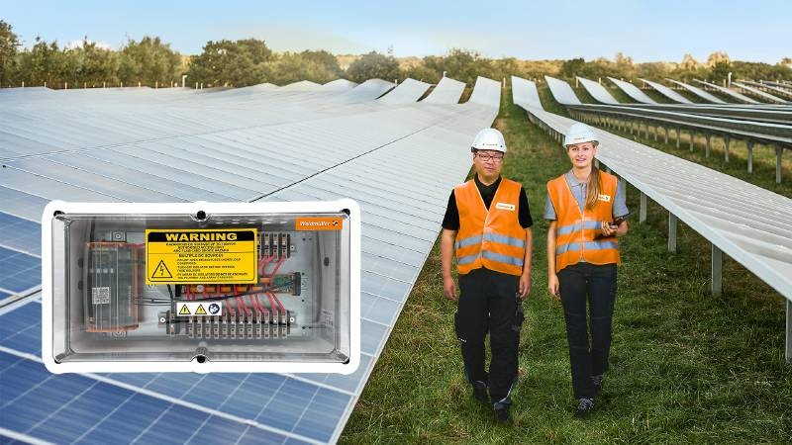
Image caption: PV Retrofit Combiner Boxes with PV String Monitoring System from Weidmüller ensure better measurability and higher performance ratio

The Weidmüller Group
Smart Industrial Connectivity: Electrification, automation, digitalisation, electrical connectivity, electromobility and renewable energies – markets in which Weidmüller feels right at home. The family-owned company established in 1850 has production facilities and sales companies in over 80 countries. As a global player in electric connection technology, Weidmüller achieved a turnover of more than one billion euros in the 2023 financial year with around 6,000 employees worldwide - around 2,000 of whom work at the company's headquarters in Detmold, in the heart of East Westphalia-Lippe, Germany. What Weidmüller lives by: Diversity with respect
Technologies and engagement for a liveable future - Weidmüller demonstrates how it approaches the topic of sustainability in its interactive sustainability brochure.

Your contact person: Weidmüller Corporate Communications
Tel.: +49 5231 14-292322
Email: presse@weidmueller.com

