Uninterruptible power supply for 24 V applications
The new DURAmax DC UPS from Weidmüller monitors power supplies across multiple industries
With the new DURAmax DC UPS, Weidmüller presents a compact solution for the uninterruptible power supply of 24 V applications. The DC UPS impresses with ease of use, robust design and maximum reliability, making it ideal for demanding environments, such as shipbuilding and industrial automation.
Weidmüller is expanding its portfolio with the DURAmax uninterruptible power supply. The UPS monitors the power supply of a system: if an interruption in voltage is detected, it switches to an external battery, preventing system downtime as a result of short-term voltage fluctuations. This ensures a continuous power supply. Once the power supply has been restored, DURAmax redirects part of the current to recharge the external battery until it is fully charged.
As one of the first DC UPS systems, DURAmax already meets all the requirements of the Cyber Resilience Act (CRA). This enables users to position themselves for the future. Free software is available for configuration, allowing users to flexibly adjust operating parameters and optimally integrate the system into their applications.
The DURAmax DC UPS is both UL- and DNV-approved, fulfilling international standards for use in demanding environments, such as shipbuilding and industrial automation.
Its compact design saves valuable space in the control cabinet. Robust and reliable, the UPS is ideal for continuous industrial operation. Users benefit from a comprehensive system consisting of installation software, certifications and CRA compliance. Together, these features make the DURAmax DC UPS from Weidmüller a future-proof and flexible solution for safeguarding 24 V systems.
1784 characters including spaces

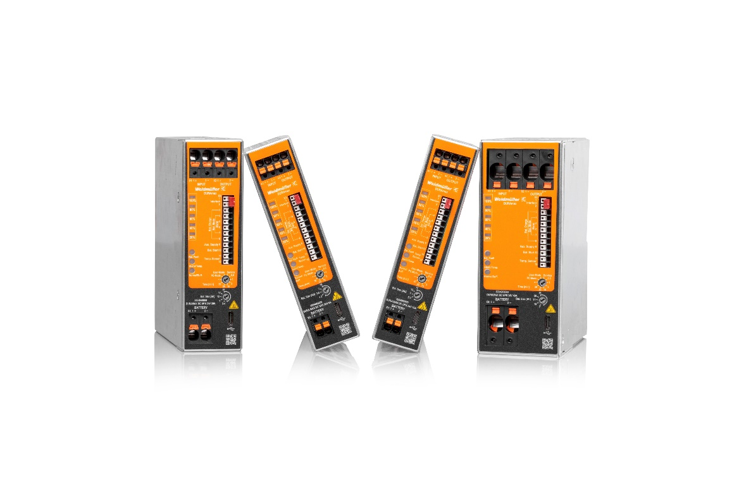
Image caption: The DURAmax DC device family comes in four compact designs

The Weidmüller Group
Smart Industrial Connectivity: Electrification, automation, digitalisation, electrical connectivity and renewable energies – markets in which Weidmüller feels right at home. The family-owned company established in 1850 has production facilities and sales companies in over 80 countries. As a global player in electric connection technology, Weidmüller achieved a turnover of almost one billion euros in the 2024 financial year with around 5,700 employees worldwide - around 2,000 of whom work at the company's headquarters in Detmold, in the heart of East Westphalia-Lippe, Germany. What Weidmüller lives by: Diversity with respect.
Technologies and engagement for a liveable future - Weidmüller demonstrates how it approaches the topic of sustainability in its interactive sustainability brochure.
Your contact person: Weidmüller Corporate Communications
Marc Ladermann, Head of Corporate Communication
Tel.: +49 5231 14-292322
Email: presse@weidmueller.com

