EN 54-4 approval for power supply equipment

Weidmüller supplies power to fire alarm systems in buildings

Weidmüller’s PROtop and PROmax power supplies and PRO DM diode modules have been approved according to DIN EN 54-4. This means that they may now be used as power supply units for building fire alarm systems – making them a key factor in fire protection.
The devices in the PROtop, PROmax and PRO DM series are suitable for a wide range of applications in a variety of industries, including machine construction, shipbuilding and building installation. Buildings in particular contain safety areas that must function in a reliable, fail-safe way at all times. Fire alarm systems are one of these areas. The new approval according to DIN EN 54-4 ensures that fire alarm systems are supplied with power even in the event of a power failure.
Devices in some series have also been approved according to IEC/EN as well as UL 61010-1 and 61010-2-201. They have also been approved in accordance with UL HazLoc Class 1, Division 2 for potentially explosive atmospheres. Moreover, thanks to receiving DNV approval, the devices can also be used in maritime applications.

1161 characters including spaces
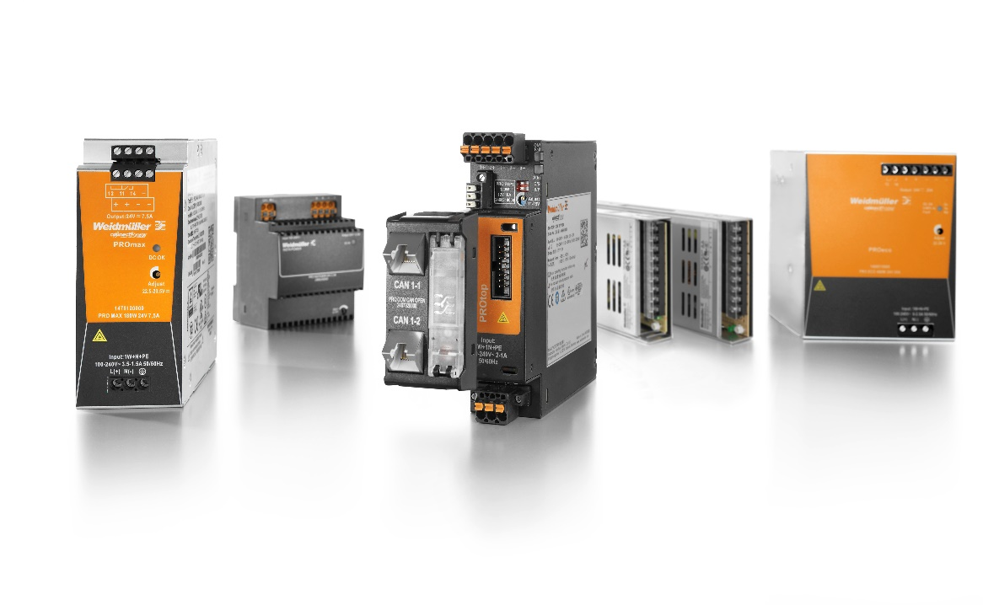
Image caption: The power supplies PROtop, PROmax and the diode modules PRO DM may be used as a supply unit for fire alarm systems in buildings

Your contact person: Weidmüller Corporate Communications
Tel.: +49 5231 14-292322
Email: presse@weidmueller.com

The Weidmüller Group
Smart Industrial Connectivity: Electrification, automation, digitalisation, electric connectivity, electromobility and renewable energies - markets in which Weidmüller is at home. Founded in 1850, the family-owned company is represented in over 80 countries with production facilities and sales companies. As a global player in electric connection technology, Weidmüller achieved a turnover of more than one billion euros in the 2022 financial year with around 6,000 employees worldwide - around 2,000 of whom work at the company's headquarters in Detmold, in the heart of East Westphalia-Lippe.

Responsible for the content: Weidmüller Corporate Communications
Corporate Spokesperson, Sybille Hilker

