Multi-stripax® – the stripping tool for PV conductors
Stripping PV conductors up to 10 mm²
The new multi-stripax® from Weidmüller masters the stripping challenges that arise in the photovoltaic industry. The stripping tool enables the precise and effortless removal of insulation from 4 to 10 mm² and guarantees zero damage to the conductors and insulation. With these capabilities, multi-stripax® makes all the difference. After all, the cross-section of a PV conductor has a direct impact on the output of the PV system. In order to minimise power loss, it is essential for a conductor to have the largest possible wire cross-section. This is why our 10 mm² PV conductor is becoming an increasingly important solution.

Robust, durable, reliable
The shaped blades of the multi-stripax® ensure precise stripping in a variety of applications. Thanks to their ingenious design, they are a reliable and accurate tool for removing insulation from wires and cables – thereby offering high repeat accuracy in the stripping result. The integrated guide plates are essential, as they not only facilitate the positioning of the conductors, but also provide effective protection against damage. A further advantage is the tool’s extreme sturdiness, guaranteeing reliable, long-term use. This is an extremely important quality for demanding working conditions. Thanks to its durability and reliability, the multi-stripax® is a universal problem solver that boasts a robust design and high technical precision.
Overall, the multi-stripax® impresses with its stripping precision, its guide plates for easy conductor positioning and its excellent sturdiness for reliable long-term use. The ergonomic design of the multi-stripax®, which enables fatigue-free work, is a unique bonus feature.

1,772 characters including spaces
Image caption: The new multi-stripax® from Weidmüller masters the stripping challenges that arise in the photovoltaic industry

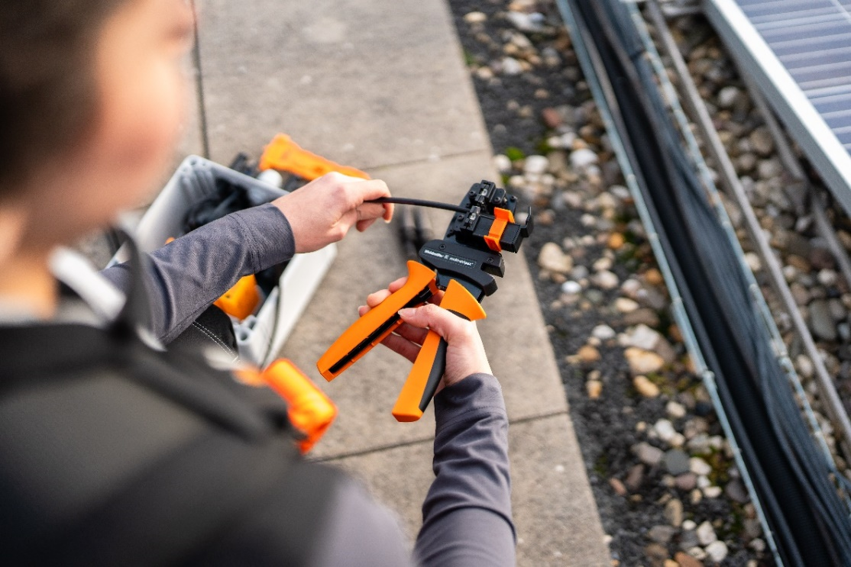
Image caption: The multi-stripax® PV enables precise conductor processing in the photovoltaic industry
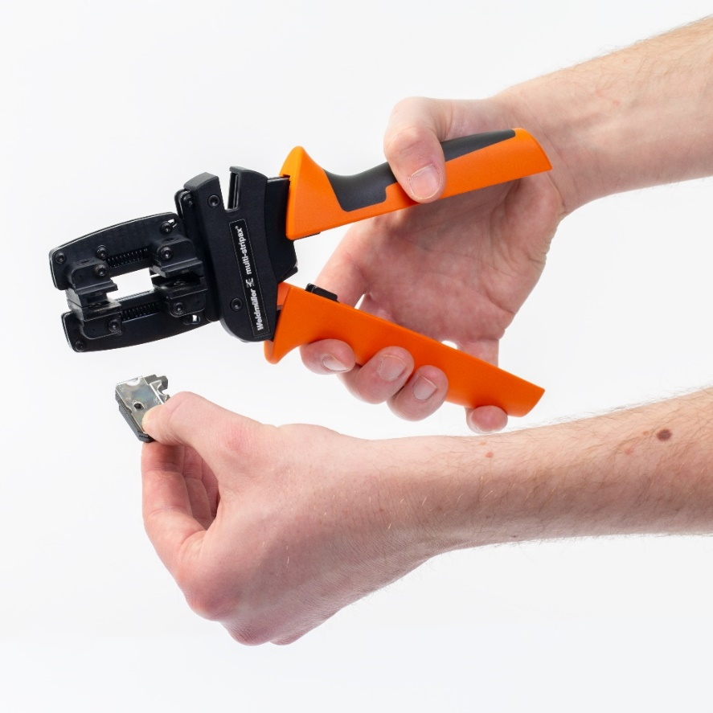
Image caption: The multi-stripax® enables the effortless removal of insulation of up to 10 mm²

You are free to use all images. We request that you cite the image source.

The Weidmüller Group
Smart Industrial Connectivity: Electrification, automation, digitalisation, electrical connectivity, electromobility and renewable energies – these are markets in which Weidmüller feels right at home. The family-owned company established in 1850 has production facilities and distributors in over 80 countries. As a global player in electrical connectivity, in 2023 Weidmüller reported revenue in excess of one billion euros with around 6,000 employees worldwide – approx. 2,000 of whom are located at the headquarters in Detmold in the heart of Ostwestfalen-Lippe, Germany. Values Weidmüller lives by: Diversity with respect.

Technologies and engagement for a liveable future – Weidmüller demonstrates how it approaches the topic of sustainability in its interactive sustainability brochure.

Contact:
Weidmüller Corporate Communications
Company Spokesperson, Sybille Hilker
Phone: +49 (0)5231 / 14-292322
Email: presse@weidmueller.com

