Weidmüller enables electronic load management for up to 18 amps

The maxGUARD electronic load monitoring system now features additional module variants: the ELM-18 and ELM-1 LIM CL2 EX.

Weidmüller developed the maxGUARD ELM-18 electronic load monitoring module (ELM) for particularly demanding loads in industrial 24 V DC power supply applications. Capable of load protection for up to 18 amps, it is one of the most powerful modules on the market. The module’s standout features include its space-saving design and operating temperature of up to +70 degrees Celsius. Thanks to a variant with ATEX certification and a protective coating, the module is suitable for even the most demanding applications – such as in the process industry, where the new electronic load monitoring system is already in use.

Moreover, a number of different applications require protection by a group switch, including control outputs, valves and lamps. The maxGUARD ELM-18 is the perfect solution to handle such challenges. With an adjustable tripping current of up to 18 amps, the module is also suitable for large loads, e.g. DC motors.

The ELM-1 LIM CL2 EX variant is used to protect small loads with high input capacitances, such as sensors. Load protection is also guaranteed for cable cross-sections less than 0.25 mm2. Both modules are approved for surge current protection in accordance with the UL 2367 semiconductor standard, and can also be used as group fuses for the simultaneous protection of multiple sensors.
The maxGUARD electronic system combines load monitoring and potential distribution in a single, space-saving component. On the mounting rail, this translates into a space savings of up to 50 %. Moreover, the closed, modular housing concept opens up a wide range of possible installation positions.

Weidmüller also supports its customers in configuring the load monitoring modules: in the Weidmüller Configurator, a client for digital engineering, customers can choose from all Weidmüller components to assemble their DIN rail according to their individual requirements – either by themselves or with the help of their regional sales contact. This opens up all new assembly options – ranging from paperless production to automated manufacturing. The Weidmüller Configurator provides all the necessary engineering data.

2316 characters including spaces

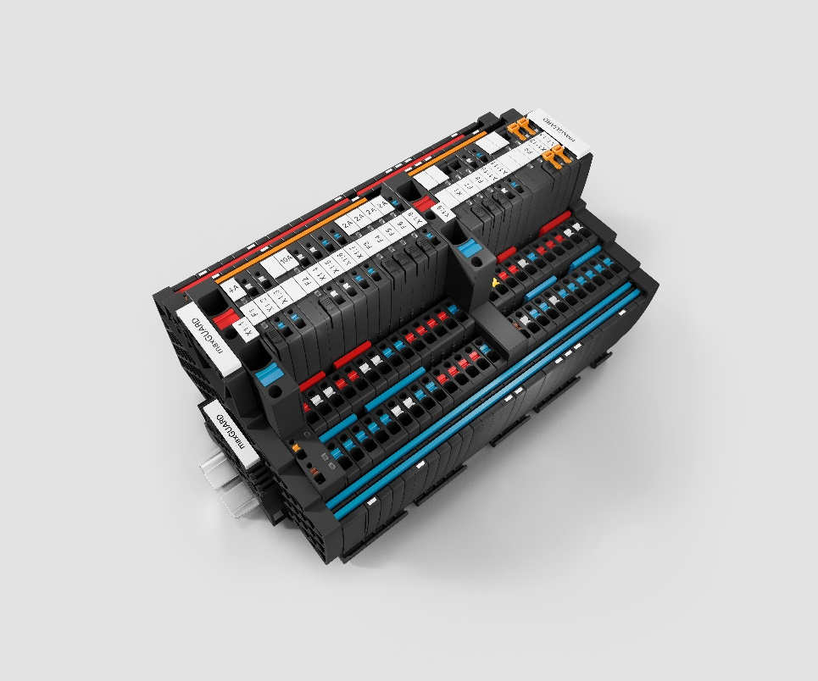
Image caption: The new maxGUARD modules control the potential distribution for sensors as well as for heavy loads

The Weidmüller Group
Smart Industrial Connectivity: Electrification, automation, digitalisation, electrical connectivity, electromobility and renewable energies – markets in which Weidmüller feels right at home. The family-owned company established in 1850 has production facilities and sales companies in over 80 countries. As a global player in electric connection technology, Weidmüller achieved a turnover of more than one billion euros in the 2023 financial year with around 6,000 employees worldwide - around 2,000 of whom work at the company's headquarters in Detmold, in the heart of East Westphalia-Lippe, Germany. What Weidmüller lives by: Diversity with respect.
Technologies and engagement for a liveable future - Weidmüller demonstrates how it approaches the topic of sustainability in its interactive sustainability brochure.

Your contact person: Weidmüller Corporate Communications
Tel.: +49 5231 14-292322
Email: presse@weidmueller.com

