JUMO and Weidmüller make greenhouses IoT-capable

Data monitoring and control with sensors and Single Pair Ethernet – from the greenhouse directly to the cloud

Technological innovations are revolutionising agriculture by increasing efficiency and yield. Greenhouses, in particular, can benefit from advanced sensor and automation solutions like Single Pair Ethernet technology.

Efficiency is crucial not only in industry – it is also becoming increasingly important in horticulture and agriculture as well. After all, no other economic sector is as dependent on external factors as horticulture and agriculture are. A cold spring can have just as negative an impact on a harvest as a dry summer. Wind, rain and sun can help make months of work pay off – or completely destroy a harvest.
Greenhouses can be used as protection against the effects of weather. This has major advantages for tomatoes, cucumbers or peppers: greenhouse cultivation can be combined with highly advanced technology to create optimal conditions for growing plants.

Sensors with Single Pair Ethernet help crops thrive
Sensors from JUMO are essential for making this technology work. The company, which specialises in sensor and automation solutions, offers a wide range of technologies used in greenhouses worldwide. These now also include sensors with Single Pair Ethernet technology (SPE).
The hydroTRANS SPE sensor records key parameters that contribute to plant growth. These include temperature and humidity, as well as CO₂ levels in the greenhouse. This helps greenhouse operators to fertilise as needed, ensuring that the plants receive the right CO₂ levels (CO₂ enrichment). An additional electromagnetic flowmeter with an SPE interface from JUMO can also be used to monitor the liquid fertiliser applied to the plants. The live sensor data collected is transmitted to the cloud using SPE technology from electronics and connection technology company Weidmüller. In addition to cable and plug-in connectors, Weidmüller also offers Single Pair Ethernet switches.
Weidmüller’s unmanaged switch has a range of up to 1,000 metres over a single copper wire pair, thanks to the SPE technology it uses. This makes it perfect for use in greenhouses, where the 100-meter limit of standard Ethernet is not sufficient. “Single Pair Ethernet technology is a real step forward for applications like greenhouses”, explains Manfred Walter, Product Manager at JUMO: “On the one hand, greenhouses benefit directly from the considerable range of SPE. Standard Ethernet using copper wire cannot extend past 100 meters. But in a greenhouse, the required distances can easily exceed that. In addition, data can be transmitted without complex intermediate steps. The data goes directly from the sensor to the JUMO cloud via the SPE switch, without the need for any additional edge gateway.”

SPE technology helps horticulture and agriculture flourish
Weidmüller’s unmanaged SPE switches transmit data essential for plant growth to JUMO’s cloud – directly and without detours via an I/O system or a controller. The data is then processed and visualised in the cloud. This method is much more user-friendly for greenhouse operators who are not experts in automation.
The PoDL (Power over Data Line) function of the SPE switches offers added advantages for users: the SPE cable not only transmits data from the sensor to the switch, but can also supply the sensor with power. This offers major economic and safety advantages, as fewer power cables need to be installed in warm, humid greenhouse environments. “Applications like these show that IIoT and automation not only deliver a huge increase in productivity, but also enable the precise utilisation of resources such as water and fertilizer. This intelligent automation results in higher yields and a more sustainable use of resources. At the same time, thanks to the focus on customer benefits of technology companies such as JUMO and Weidmüller, industrial IoT is becoming accessible to everyone. This is the only way we can create a sustainable world that is worth living in both now and in the future, and tackle the challenges of our time head-on”, says Dr Thomas Bürger, Head of the Automation Products and Solutions Division at Weidmüller.

If plants lack water, the supply can be adjusted directly – drop by drop, precisely tailored to demand. In this way, gardeners and farmers can ensure that plants get exactly the right amount of nutrients. This has a direct impact on harvests. The results are clear: plants produce higher yields in high-tech greenhouses.

4577 characters including spaces

All images are freely available to you. You can download them under the following link:
https://www.picdrop.com/weidmueller/MnWDGRUwt3

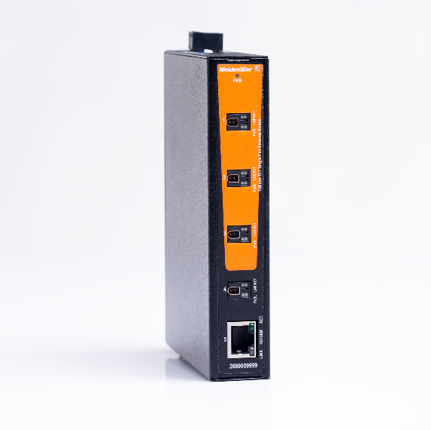
Image caption: The SPE switch connects SPE sensors over distances of up to 1,000 metres and enables Ethernet-based transmission of sensor values to the cloud

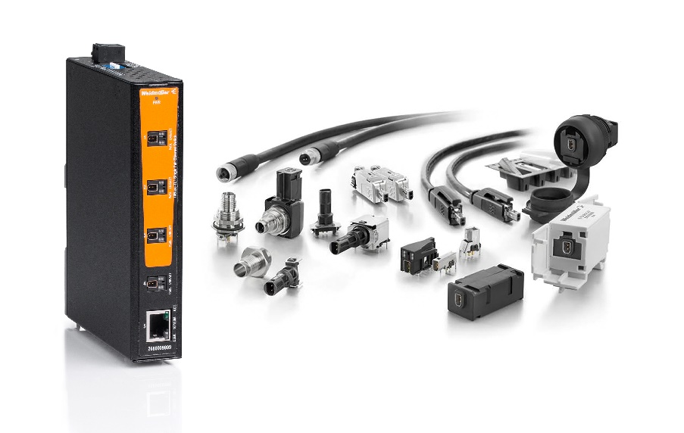
Image caption: Weidmüller offers a wide portfolio of SPE products that includes field-attachable plug-in connectors and switches

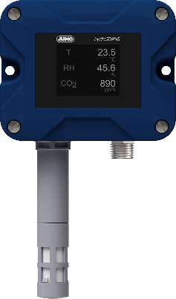
Image caption: JUMO hydroTRANS S20 intelligent SPE sensor for temperature, humidity and CO₂
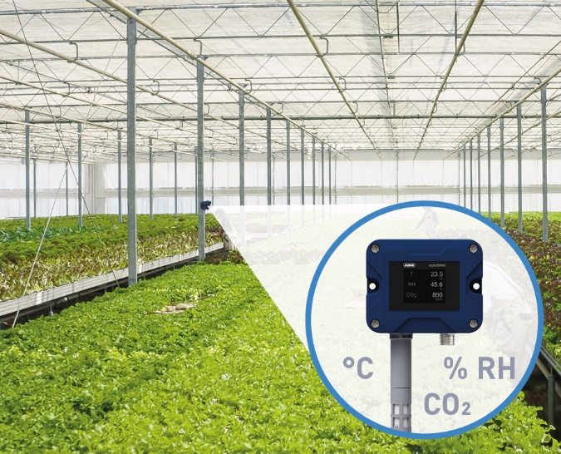
Image caption: The JUMO hydroTRANS S20 measures temperature, humidity and CO₂ values directly where plants are growing in the greenhouse.

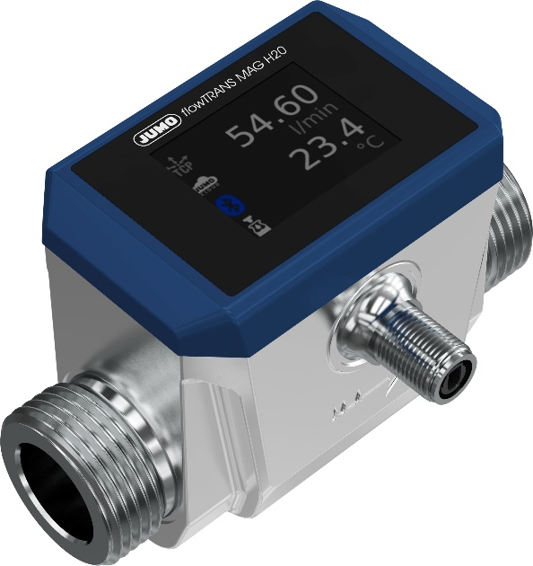
Image caption: JUMO flowTRANS MAG H20 electromagnetic flowmeter with SPE interface

The Weidmüller Group

Smart Industrial Connectivity: Electrification, automation, digitalisation, electrical connectivity and renewable energies – markets in which Weidmüller feels right at home. The family-owned company established in 1850 has production facilities and sales companies in over 80 countries. As a global player in electric connection technology, Weidmüller achieved a turnover of more than one billion euros in the 2023 financial year with around 6,000 employees worldwide - around 2,000 of whom work at the company's headquarters in Detmold, in the heart of East Westphalia-Lippe, Germany. What Weidmüller lives by: Diversity with respect.

Technologies and engagement for a liveable future - Weidmüller demonstrates how it approaches the topic of sustainability in its interactive sustainability brochure.

Your contact person: Weidmüller Corporate Communications
Marc Ladermann, Head of Corporate Communication
Tel.: +49 5231 14-292322
Email: presse@weidmueller.com

