PV Inline: The Compact Solution Against Major Damage
Weidmüller's Space-Saving Surge Protection for Photovoltaic Systems

In 2023, lightning and surge damage in Germany reached record levels: insurers paid out around 330 million euros for approximately 220,000 claims. This marks an increase of 80 million euros in total damages compared to the previous year. These alarming figures highlight the importance of relying on dependable surge protection solutions in the photovoltaic sector — such as Weidmüller's PV Inline.

Photovoltaic systems are particularly vulnerable to lightning strikes and power surges, which can result in costly repairs. Therefore, compliant protective measures are essential to safeguard these systems against such risks. Standard DIN 51643-32:2020 requires the use of Type I+II or Type II surge protection devices, while DIN 62305-3 Bbl.5 specifies that these devices must be installed directly where the string cables enter the building. However, space is often limited in exactly these locations. This is where Weidmüller's new PV Inline protection solution comes in, offering maximum safety with minimal space requirements.

Space-Saving Design with Maximum Functionality
Compared to conventional surge protection boxes, PV Inline is significantly more compact. Its handy size makes installation particularly easy, as the device can be mounted with just one hand. Integrated MC4 connectors ensure quick and secure wiring, significantly reducing installation time. With an IP65 protection rating, PV Inline is particularly resistant to environmental influences, making it ideal for use in demanding environments.

Another advantage is its flexible mounting options. The device can be installed inside cable ducts, directly on walls, or behind PV modules, allowing it to adapt perfectly to various installation conditions. An installation kit with brackets and mounting materials is included, further simplifying the process and offering installers an efficient solution.

Versatile Mounting Options for Every Application

PV Inline has been specially designed for integration into 60x40-mm cable ducts and is compatible with common systems such as Hager TEHALIT LF4006009016 and Würth PLF 4060. Installation can take place directly on or between cable ducts, allowing the device to blend discreetly into the existing system. Alternatively, it can be mounted on the wall using screws and brackets. For particularly space-saving setups, PV Inline can also be installed behind PV modules — a practical solution, especially for large systems where long distances between the inverter and PV modules are common.

Plug & Play – for Time-Saving Installation
PV Inline impresses with its well-thought-out Plug & Play functionality, enabling particularly fast and error-free installation. Thanks to the pre-installed MC4 connectors, there is no need to open the housing, saving valuable time and minimising potential sources of error. Another practical feature is the compact potential equalisation terminal with three screw connections, enabling quick and secure earthing.

Sustainable Solution with Standards-Compliant Safety
In addition to easy installation, Weidmüller focuses on a resource-efficient design. Thanks to optimised construction, material usage has been reduced by more than 50% without compromising on safety. PV Inline complies with all relevant standards and regulations, including EN IEC 61643-31:2019, EN IEC 61439-2:2021, the Low Voltage Directive 2014/35/EU, and the RoHS Directive 2011/65/EU.

With PV Inline, Weidmüller presents an innovative and high-performance solution for surge protection in photovoltaic systems. Thanks to its compact design, flexible installation options, and quick setup, it is particularly well-suited to installations where space is limited, ensuring reliable protection against surge damage.

3,844 characters including spaces

You are free to use all images. You can download them via the following link: https://www.picdrop.com/weidmueller/pmfiFbiF5V
We request that you cite the image source Weidmüller.

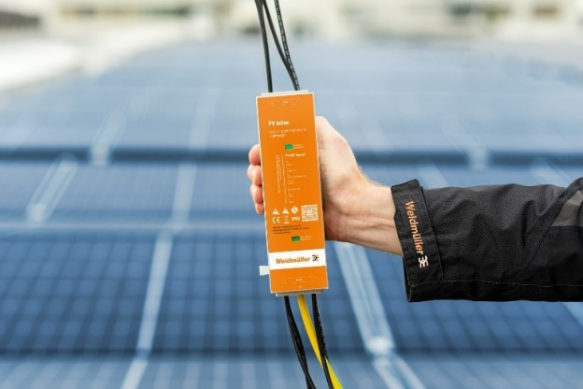
Image caption: A standards-compliant protection solution — such as PV Inline — is essential to prevent damage caused by lightning and surges

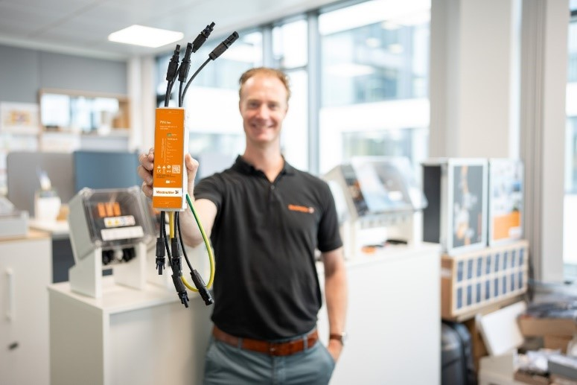
Image caption: PV Inline is revolutionising surge protection with a new concept

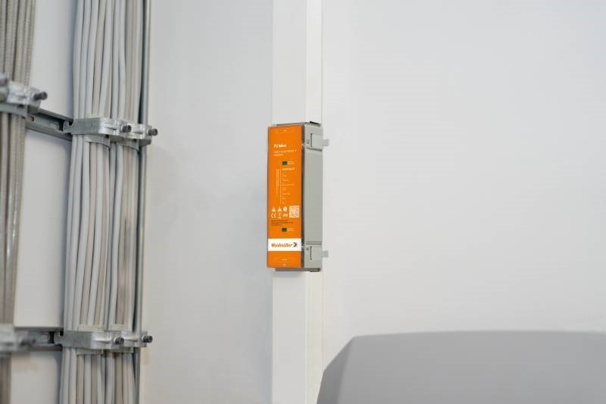
Image caption: Wall mounting between two cable ducts is one of the most common applications for PV Inline
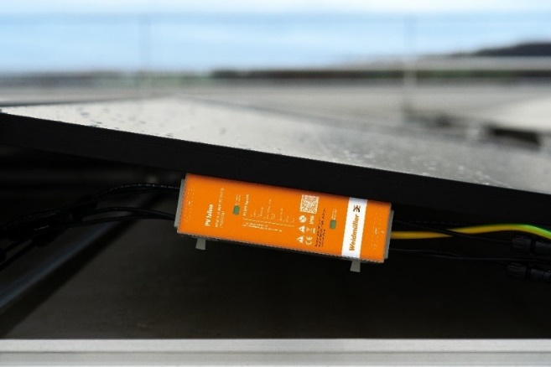
Image caption: For an especially space-saving installation, PV Inline can be mounted behind the PV system’s modules — an ideal solution for large systems with more than 10 metres between the inverter and the PV modules

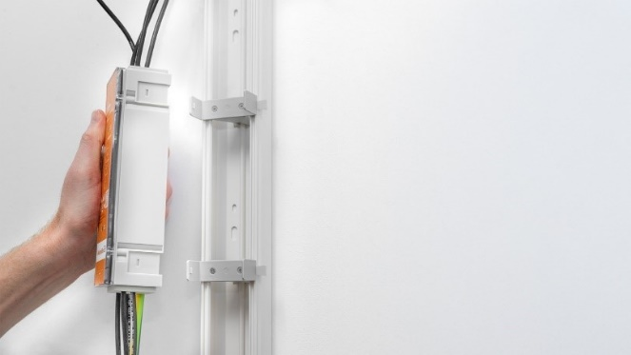
Image caption: The compact design of PV Inline allows for easy one-handed installation.

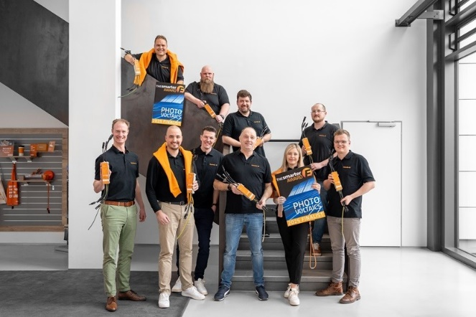
Image caption: PV Inline is a finalist for The smarter E AWARD — the team is proud

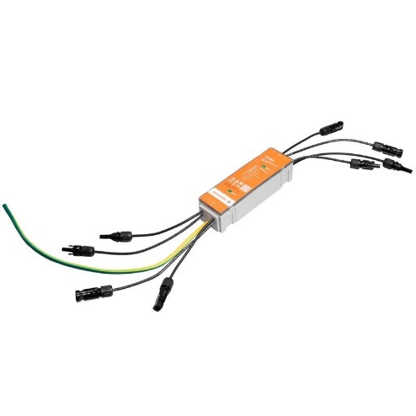
Image caption: PV Inline is currently the most compact surge protection device on the market

The Weidmüller Group
Smart Industrial Connectivity: Electrification, automation, digitalisation, electrical connectivity, electromobility and renewable energies – markets in which Weidmüller feels right at home. The family-owned company established in 1850 has production facilities and sales companies in over 80 countries. As a global player in electric connection technology, Weidmüller achieved a turnover of one billion euros in the 2024 financial year with around 5,700 employees worldwide - around 2,000 of whom work at the company's headquarters in Detmold, in the heart of East Westphalia-Lippe, Germany. What Weidmüller lives by: Diversity with respect
Technologies and engagement for a liveable future - Weidmüller demonstrates how it approaches the topic of sustainability in its interactive sustainability brochure.

Your contact:
Weidmüller Corporate Communication
Marc Landermann, Head of Corporate Communication
Tel.: +49 5231 14-292322
Email: presse@weidmueller.com

