PV Next Fireman Switch for safe remote shutdown for all system sizes
Variants with surge protection added to Weidmüller’s photovoltaics portfolio – for both small and large systems

The number of rooftop photovoltaics systems in Germany is constantly growing – and commercial properties and public buildings are no exception. The German Solar Industry Association expects the expansion of solar power systems on company roofs to grow by around 25 % - including outstanding late registrations (3.6 GW).This is a continuing trend, and is being accelerated by the requirements of the European Green Deal as well as companies and organisations interested in minimising energy costs and bringing energy-neutral products onto the market.
There are a lot of regulations and recommendations to take into account when planning and installing PV systems, including lightning and surge protection and the safety of firefighters in case of fire. Weidmüller has developed particularly compact products for this purpose, offering an extensive product line that includes the right solution for every installation.

Prevent risk to firefighters
In the event of a house fire, speed is of the essence – but the safety of everyone involved is the top priority. To avoid putting themselves in additional danger when fighting the fire, the fire service on site first disconnects the power supply to the house. However, a PV system is not included in this disconnection and typically continues to produce electricity. This can pose a particular risk to firefighters, especially as the PV string cables installed in buildings are under high voltages of up to 1,100 volts while power is being generated. This is an issue especially if string cables become exposed due to fire damage or if firefighters have to break through walls in which string cables are installed to rescue people inside.

Reliable shutdown in the event of fire
To protect firefighters, many PV systems on commercial buildings are now equipped with a fireman switch. The PV Next Fireman Switch is the solution developed by the electrical engineering and connectivity company Weidmüller for automatic disconnection in the event of a fire for small and large systems with 1 to 12 MPP. This compact box makes it possible to switch off a PV system’s DC lines. At the latest, it is installed at the point where the cables enter the building or in front of the area requiring protection. When the fireman switch is activated, it automatically switches off the voltage to the string cables in the building via a switch disconnector so that the fire service can work more safely. “The switch reacts automatically to the AC voltage applied”, explains Pascal Niggemann, Head of PV Systems Home & Business at Weidmüller, explaining how it works. “If the voltage drops to zero because the fire service presses the emergency off switch, the box switches off within a second. If the AC power supply is merely disrupted due to a power cut, however, the box automatically switches back on once a voltage of 230 volts is restored.”

High flexibility for integration and installation
The technical properties of the fireman switch and its means of integration into the building can be determined depending on the specific requirements and area of application. “Usually, the requirements are defined together with the fire service responsible and documented in detail, for example when developing emergency plans”, explains Pascal Niggemann. “After all, in an emergency, the firefighters need to know that a fireman switch is available. Integration into a fire alarm system is also possible on request. PV Next’s modular structure provides a great deal of freedom for installation.”

Install once for twice the safety
Although various authorities recommend the installation of a fireman switch, it is not required by law. It is a different story for lightning and surge protection, however. This has been mandatory for all new buildings since 2019. “More and more of our customers were asking for a product that combines both functions. We responded to this demand by developing different variants of our fireman switch – including variants with integrated lightning and surge protection”, says the Head of PV Systems Home & Business. Both functions are brought together in a single compact housing, saving space and costs. “The combined solution offers a considerable time advantage: the strings only need to be connected once and the housing only needs to be screwed on once”, explains Pascal Niggemann, adding: “The design of the circuit board makes our device particularly compact, clearly arranged and tidy – and unique on the market in this format.”

Full range of products for the use of PV systems and renewable energy
Weidmüller’s PV portfolio provides customised solutions for a wide range of string inverters. In addition to the PV Next Fireman Switch with and without lightning and surge protection, the electrical engineering and connectivity company also offers combiner boxes for inverters with 1 to 12 MPPs.
The Fireman Switch is just one example of how the company is responding to the rapidly changing requirements of planners, installers and operators – both through continuously developing the range of components, tools, markers and plug connectors in the Weidmüller portfolio.

5,570 characters including spaces

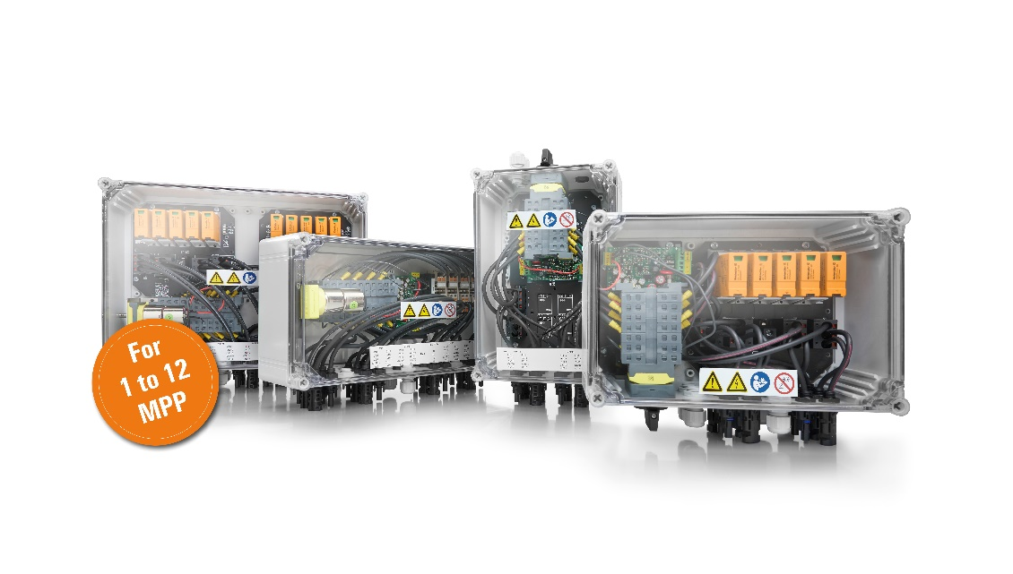
Image caption: The PV Next Fireman Switch is available in different variants – with and without integrated surge protection.

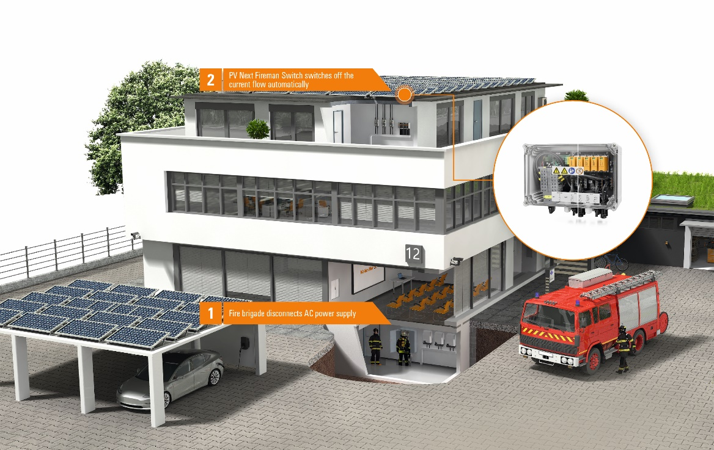
Image caption: The PV Next Fireman Switch is installed at the latest at the entry point of the PV lines into the building. It is also available with integrated surge protection.

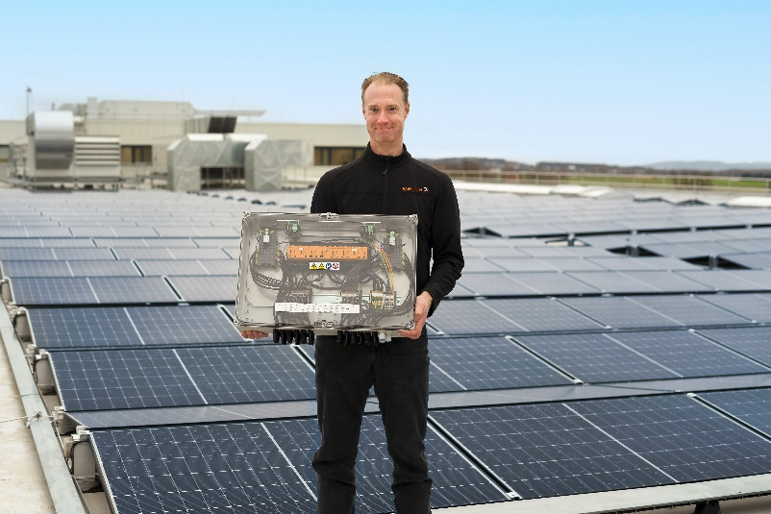
Image caption: Pascal Niggemann, Head of PV Systems Home & Business at Weidmüller.

The Weidmüller Group
Smart Industrial Connectivity: Electrification, automation, digitalisation, electrical connectivity, electromobility and renewable energies – markets in which Weidmüller feels right at home. The family-owned company established in 1850 has production facilities and sales companies in over 80 countries. As a global player in electric connection technology, Weidmüller achieved a turnover of more than one billion euros in the 2023 financial year with around 6,000 employees worldwide - around 2,000 of whom work at the company's headquarters in Detmold, in the heart of East Westphalia-Lippe, Germany. What Weidmüller lives by: Diversity with respect
Technologies and engagement for a liveable future - Weidmüller demonstrates how it approaches the topic of sustainability in its interactive sustainability brochure.

Your contact person: Weidmüller Corporate Communication
Marc Landermann, Head of Corporate Communication
Tel.: +49 5231 14-292322
Email: presse@weidmueller.com

See https://www.solarwirtschaft.de/2025/01/06/photovoltaik-ueberschreitet-100-gigawatt-marke-2/

