Single Pair Ethernet: The market breakthrough starts now
Weidmüller presents the first field-assembly solution and new SPE PCB components, demonstrating seamless communication from the sensor to the cloud.

The market for Single Pair Ethernet (SPE) is on the verge of a breakthrough. At this year’s SPS trade fair, leading user organisations such as PI (Profinet), ODVA and ZVEI are sending a clear signal: SPE is getting ready for industrial use. As part of a coordinated effort, the Single Pair Ethernet System Alliance and the SPE Industrial Partner Network are presenting seven live applications that demonstrate the availability of the technology and its suitability for practical use. More than 150 companies, including industry leaders such as Siemens, Rockwell, Analog Devices and Huawei, are actively driving development within these global alliances.
Weidmüller is taking a pioneering role in this area: as one of the first manufacturers, the company is presenting a miniaturised, field-assembly SPE connection system, available both as a stand-alone component and integrated into a fully functional switch. In addition, Weidmüller is offering new SPE PCB components (PCB sockets) – with or without integrated LEDs – available in protection classes IP20 and IP67. This makes seamless communication from the component to the network a reality.
The foundation for this step is the international standardisation of the SPE interface in IEC 63171-7 ed.2, developed in close cooperation with PROFINET International and leading connector manufacturers. At SPS, Weidmüller is not only presenting products, but an entire Single Pair Ethernet ecosystem – from the component to the application – underscoring its ambition: “Data to Value – Pioneering since Day One”.
SPE is regarded as a key technology for seamless communication from the sensor to the cloud and as the successor to classical fieldbus systems. With its comprehensive portfolio, Weidmüller shows that the market is ready – and that the future of industrial communication begins now.

2,042 characters including spaces

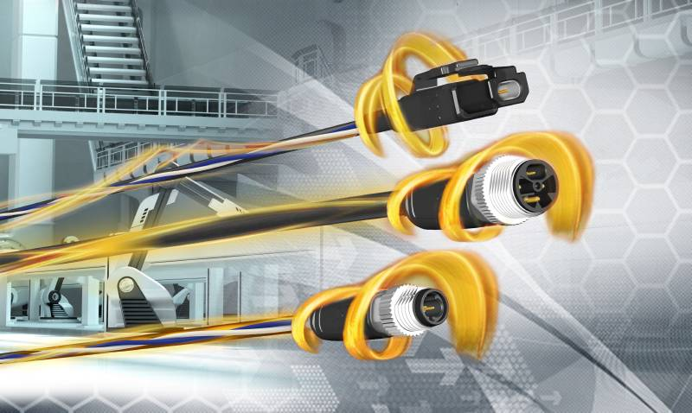
Image caption: Single Pair Ethernet –The network infrastructure for the Industrial IoT.

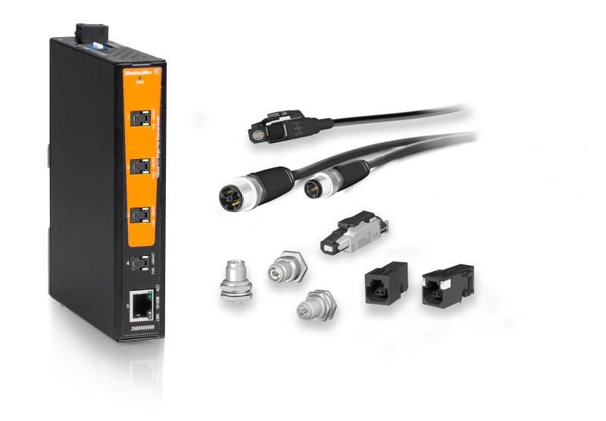
Image caption: Weidmüller offers a comprehensive Single Pair Ethernet product portfolio.

The Weidmüller Group
Smart Industrial Connectivity: Electrification, automation, digitalisation, electrical connectivity and renewable energies – markets where Weidmüller feels right at home. Established in 1850, the family-owned company is represented in over 80 countries with its own production sites and sales companies. As a global player in electrical connectivity, Weidmüller achieved a turnover of almost one billion euros in the 2024 financial year with around 5,700 employees worldwide – about 2,000 of them based at the company’s headquarters in Detmold, in the heart of the East Westphalia-Lippe region of Germany. In all its activities, Weidmüller promotes diversity and respect.

Technologies for and commitment to a liveable future – Weidmüller demonstrates how it approaches the topic of sustainability in its interactive sustainability brochure.

Contact:
Weidmüller Corporate Communications
Marc Landermann, Head of Corporate Communications
Tel.: +49 (0)5231 / 14-292322
Email: presse@weidmueller.com

