Easy and efficient: the Weidmüller ConnectorGuide
The search for the right PCB connection technology for different device applications is often a time-consuming and tedious task. With the ConnectorGuide, Weidmüller has added a product to its portfolio that offers device developers two simple functions for finding customised solutions – and ordering free samples of them directly.

The first function of the ConnectorGuide allows you to carry out a device-specific search (www.weidmueller.com/appguide). The goal is to make the search easier for device developers – with just a few clicks, they can now obtain a selection of suitable products for their specific devices and functional units. The app guides users through a selection process based on the specific requirements. Information is provided on the various devices such as industrial controllers, frequency converters or PV inverters. New devices such as robotics, data centres, heat pumps and electrolysers have now been added to the Weidmüller ConnectorGuide, expanding the potential applications.
To make precise product recommendations, the ConnectorGuide analyses the requirements of each functional area, such as the connections of a servo inverter. Many years of application expertise from sales and product managers have supported the ConnectorGuide with valuable information. Thanks to their expertise, the requirements of each individual functional area can be understood precisely to recommend a suitable connection system. In the process, four main criteria are taken into account: the fulfilment of typical specifications such as current and rated voltage with the smallest possible size, compliance with specific device norms and standards, operating advantages during installation and operation of the devices and consideration of cost. Based on these criteria, developers are recommended a maximum of four different PCB connection products that fulfil their respective requirements. A direct link to the Weidmüller online shop enables developers to order free design-in samples, view data sheets or download 3D models and EDA data for PCB design.
In addition, the second function of the ConnectorGuide facilitates an efficient product search through a simplified visualisation of the connection system in its installed state (www.weidmueller.com/productguide). With the visual navigation through various product categories, developers can quickly find the information they need and order all the necessary samples via the online shop.
The Weidmüller ConnectorGuide not only simplifies the search for the right PCB connection technology, but also offers an efficient way to order it directly. With its user-friendly format and precise product recommendations based on years of experience and expertise, the ConnectorGuide is an indispensable tool for device developers. It also optimises and reduces the costs of the development process.
2,906 characters including spaces

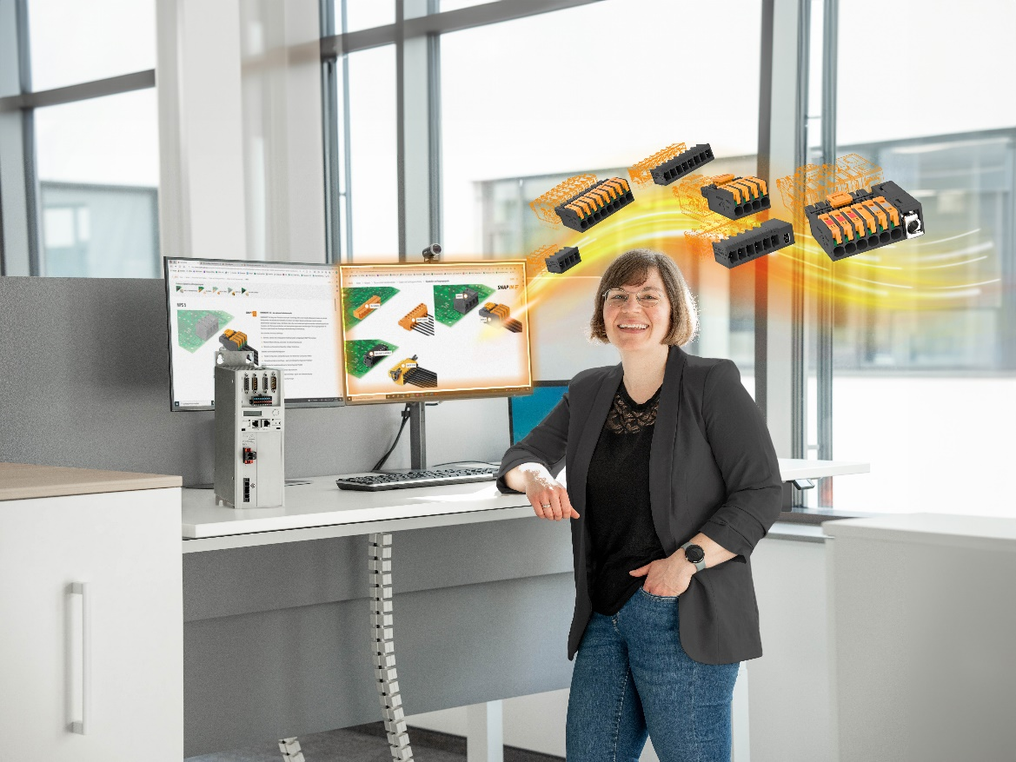
Image caption: With the Weidmüller ConnectorGuide, device developers can find the right product and all the necessary information in just a few clicks

Image caption: Whether robotics, PV inverters, drive control, or other applications: thanks to the ConnectorGuide, developers can now find the right PCB component more quickly

You are free to use all images. We request that you cite the image source.

The Weidmüller Group
Smart Industrial Connectivity: Electrification, automation, digitalisation, electrical connectivity, electromobility and renewable energies – markets in which Weidmüller feels right at home. The family-owned company established in 1850 has production facilities and distributors in over 80 countries. As a global player in electrical connectivity, in 2023 Weidmüller reported revenue in excess of one billion euros with around 6,000 employees worldwide – approx. 2,000 of whom are located at the headquarters in Detmold in the heart of Ostwestfalen-Lippe, Germany. What Weidmüller lives by: Diversity with respect.

Technologies and engagement for a liveable future – Weidmüller demonstrates how it approaches the topic of sustainability in its interactive sustainability brochure.

Contact:
Weidmüller Corporate Communications
Company Spokesperson, Sybille Hilker
Phone: +49 (0)5231 / 14-292322
Email: presse@weidmueller.com

