Press Release 

Handover within the Weidmüller Executive Board
Dr. Timo Berger will succeed José Carlos Álvarez Tobar as Chief Marketing and
Sales Officer of Weidmüller as of September 1st, 2019. Already as of March 1st, 2019 Dr. Berger and Mr. Álvarez Tobar will enter into a close collaboration.

Detmold, March 18, 2019 – Dr. Timo Berger will become Chief Sales Officer of the Weidmüller Group in Detmold as of September 1st, 2019. As of March 1st, 2019, he will enter for an initial six months into a closer collaboration with the current Chief Marketing & Sales Officer (CMSO) José Carlos Álvarez Tobar, who will then retire after 40 years at Weidmüller and around three years as Member of the Executive Board. Dr. Berger joined Weidmüller in 2005 and has been responsible for sales in Germany and the Central Europe region as Managing Director and Regional Manager for 2 years. From September 2019 onwards, Dr. Berger will complete the three-member Executive Board team with Jörg Timmermann (Chief Financial Officer, Speaker of the Executive Board) and Volker Bibelhausen (Chief Technology Officer).

"José Carlos Álvarez Tobar has successfully led the sales department of the Weidmüller Group over the last three years and thus made a significant contribution to the worldwide success of the company", comments Christian Gläsel, Chairman of the Supervisory Board of the Weidmüller Group. "On behalf of the owner family and the entire company, we would also like to thank him for introducing his successor Dr. Timo Berger to his new role step by step in the coming months. This smooth transition will ensure maximum continuity for our worldwide sales activities."

"The planned promotion of Dr. Timo Berger to member of the Executive Board of Weidmüller is another important step in our long-term corporate and management strategy. Dr. Berger combines the highest sales experience and technological competence by working in different product divisions for more than 13 years in our company and, thanks to the transition phase together with José Carlos Álvarez Tobar, guarantees the highest continuity in times of accelerated change at our customers and in our markets", explains Christian Gläsel.
About:
1

Press Release

Dr. Timo Berger (45) has been with Weidmüller for over 13 years in various management positions in Germany and China. During this time, he was, Division Head and, since November 2016, Managing Director and Executive Vice President of Weidmüller Sales in Central Europe and Germany. Dr. Timo Berger is married and lives with his wife and two children near Detmold.

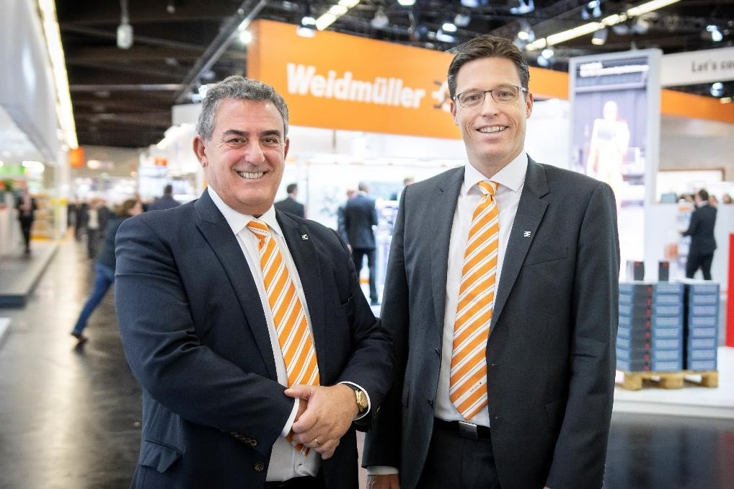
Image Captions: José Carlos Álvarez Tobar (l.) and Dr. Timo Berger (r.) ©Weidmüller / Patrice Kunte

Weidmüller - Your Partner in Industrial Connectivity.
As experienced experts we support our customers and partners around the world with products, solutions and services in the industrial environment of power, signal and data. We are at home in their industries and markets and know the technological challenges of tomorrow. We are therefore continuously developing innovative, sustainable and useful solutions for their individual needs.
Together we set standards in Industrial Connectivity.
The Weidmü ller Group owns manufacturing plants, sales companies and representatives in more than 80 countries.
In its fiscal year 2017 Weidmü ller reached sales of 740 million Euros with 4.700 employees.

Contact: Carsten Nagel
Corporate Communication
Tel.: +49 (0)5231 / 14-291010
E-mail: carsten.nagel@weidmueller.com
2

