Technical change to: two pole tester LCD digital

Dear Madam or Sir,

the below listed articles will be supplied in a modified revision. Please pass this product information on to your employees and, if needed, to your customers. All modifications are performed for reasons of product improvements.

- Initial situation

The current program of the two-pole voltage tester must be revised.

- Technical change

Digi Check and Digi Check Pro VT Digi Pro (only one tester)
- Slightly shorter design
- Larger voltage range up to 1.000V AC/DC
- New: resistance measuring
- now CAT IV 600V
- New price positioning (cheaper than Digi Check and Digi Check Pro)

Multi Check no successor, will be discontinued if sold out

Old version | New version
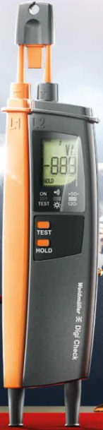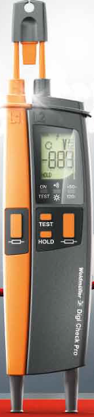 | 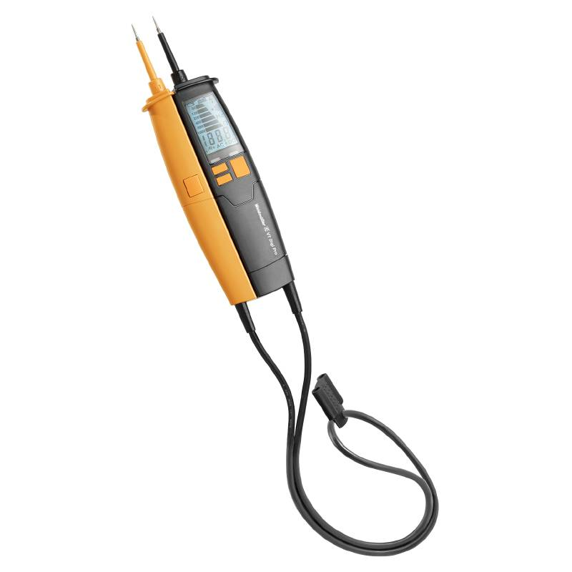

- Reason for change

Since the previous supplier no longer wanted to manufacture these articles, we had to switch to a new supplier. As part of the conversion, the two-pole voltage testers were also technically revised and improved. Furthermore, the testers have already been adapted to the new standard.

- Availability

9918850000 – Digi Check: no stock (successor is the VT Digi Pro)
9918870000 – Digi Check Pro: no stock (chance-over week 18)
9918920000 – Multi Check: 460 pcs on stock (no successor, will discontinued if sold out))

- Affected parts

9918870000 – Digi Check New VT Digi Pro (9918870000)
9918870000 – Digi Check Pro VT Digi Pro
9918920000 – Multi Check no successor

- Data

- PCN-PW641110-20180410-00-A
- 10.04.2018

We are very sorry for all the inconveniences caused and doing everything to adjust this product change as smooth as possible without big influence on delivery times and general functions.

For further questions please contact your sales office directly. All contacts for sales representatives are available here: www.weidmueller.com/contact

Best regards

Product Management

Weidmüller Interface GmbH & Co. KG
Klingenbergstraße 16, 32758 Detmold, Germany

Weidmüller – Your partner in Industrial Connectivity
We look forward to sharing ideas with you – Let’s connect.

