Double-digit sales growth: Weidmüller increased sales in 2018 to EUR 823 million

- Sales in 2018 inreased to EUR 823 million – growth of 11 per cent
- Growth through focus on digitalisation, automation and core business confirms strategy
- Takeovers, cooperation and development of growth markets strengthen global position – North America strongest growth market with 50 per cent growth
- New customer and technology center in Detmold occupied in January
- Outlook for 2019 positive despite general economic weakening
- Dr Timo Berger successor to José Carlos Álvarez Tobar as Chief Marketing and Sales Officer from September

Hanover / Detmold, 1 April 2019. In the 2018 financial year, the Detmoldbased Weidmüller Group generated sales of EUR 823 million. Sustained by an excellent market environment, this corresponds to year-on-year growth of 11 per cent (2017 sales: EUR 740 million). The electrotechnical company announced this at its annual press conference during the Hannover Messe. The figures show that the company is continuing along the positive growth path. "We have been able to generate good double-digit sales growth in an eventful year", explained Jörg Timmermann, Speaker of the Executive Board. "In addition to global growth markets, the drivers of our success were mainly our innovation in automation and digitalisation, our terminal strip portfolio for the A-Series with PUSH-IN connection system that we introduced in 2016 and business in North America. We intend to follow this path through continuous investments in innovation." Looking ahead to the current year, Weidmüller is optimistic about achieving further growth. "We are well prepared for the future with our strategy. But we are faced with many uncertainties due to the weakening of the global economy, the effects of the Brexit negotiations and global trade policy."

Sales increased in all regions and divisions
The increase in sales is spread over all the Weidmüller Group's regions globally. In Europe, sales grew seven per cent, and in the Asian market, they recorded growth of nine percent. The greatest growth of almost 50 per cent was reported in America. This is a new record and at the same time a sign that the company has not become complacent, but is actively shaping its own future. "It shows the importance of our investment in buying back our distribution companies in North America", explains José Carlos Álvarez Tobar, Chief Marketing and Sales Officer. All divisions of Weidmüller contributed to the increase in sales. While the Cabinet Products division, which specialises in panel solutions, recorded growth of ten per cent, the Automation Products and Solutions division saw growth jump by 24 per cent, having reported growth of 25 per cent in 2017. "The demand for the Klippon Connect A-Series from our terminal strip family has exceeded our expectations, but the rapid delivery service for terminal strips and Connectivity Consulting Team also contributed to the rise in sales", noted Álvarez Tobar on the developments. "The sale of automation products, in particular u-remote, is supporting the strong growth. A strong performance in photovoltaics and power supply business also contributed to this positive development."

Securing our own future through innovation and investment
In 2018, Weidmüller also boosted its investment in research and development from EUR 45 million to EUR 49 million. "Sustainable growth also needs investment in the products, solutions and services of the future. We are strengthening the research and development of smart industrial electrical connectivity in order to drive forward the change in industrial infrastructure and the digital description of products. Even the research and development fields were expanded with the addition of more staff in 2018", explained Volker Bibelhausen, Chief Technology Officer.

New customer and technology center in Detmold now occupied
The positive trend is also reflected in the growing number of staff. Weidmüller employed almost 200 staff more in 2018 which means that it now employs close to 4,900, of whom 2,135 work in Germany. After the new customer and technology center took almost two years to build, staff finally moved into it during the year. The building provides space for 470 staff and has 12,000 square metres of floor space. Weidmüller is currently expanding the building by 2,000 square metres, so that 630 staff will be able to move there in October. Great emphasis is being placed on sustainability, energy efficiency and modern workplace design. A conscious decision was made not to have individual offices in order to create an open working atmosphere. "Team offices should strengthen the cooperation and interplay between sales, divisions and research departments as well as unleash synergy effects", continued Timmermann. In February, the foundation stone for the Future Mile 2 building (ZM2) was laid where the University of Paderborn and Fraunhofer IEM will also be tenants alongside Weidmüller.

Strategic direction to be continued – higher investments in IIoT With the presentation on automated machine learning software for machinery and plant engineering, Weidmüller is highlighting that it is consistently continuing to follow the chosen path of generating added value from data and facilitating the development of new business models. "We have had excellent feedback on our Industrial Analytics solution. Based on that, we have focused on developing algorithms that allow machine experts to create and enhance their own models in future", continued Bibelhausen. At the same time, Weidmüller is looking to invest more in the future in the Industrial Internet of Things (IIoT). "We have already established a good basis here with our u-mation portfolio. In future, we intend to invest even more in the development of IIoT solutions for data collection", explains Bibelhausen. A potential area of usage is, for example, housings for photovoltaic units where the company is a leader. Furthermore, the company already presented initial designs at the Hannover Messe for a smart sensor platform which can be used in production facilities for accurate monitoring of process and condition data. "We are currently developing and discussing with partners a solution that can be integrated quickly and easily into existing automation systems", continued Bibelhausen. The company is well placed for the future with investment in industrial infrastructure, automated panel building and services.

Growth path is set to continue in 2019
Overall, the company is optimistic that it will continue along the growth path in 2019 through its strategic orientation and reach the goals it has set itself, but at a slower pace than in 2018. "We must always be aware of the numerous uncertainties so that we can react quickly, if necessary, to the weakening of the global economy, the adverse effects of Brexit and developments on trade policy", explained Timmermann "Nevertheless, we are planning to keep on growing in 2019." From September, this process will be assisted by Dr Timo Berger as the new Chief Marketing and Sales Officer and successor of José Carlos Álvarez Tobar who is retiring after more than 40 years at Weidmüller and for whom it was the last Hannover Messe. "We would like to thank Mr Álvarez Tobar for his hard work and long-term commitment to Weidmüller – as director of our Group company in Spain, as Regional Manager and lastly as Chief Marketing and Sales Officer", said Timmermann. "In my time, I have rarely met anyone else who focused so much on the employee and the customer.

6.952 characters including spaces

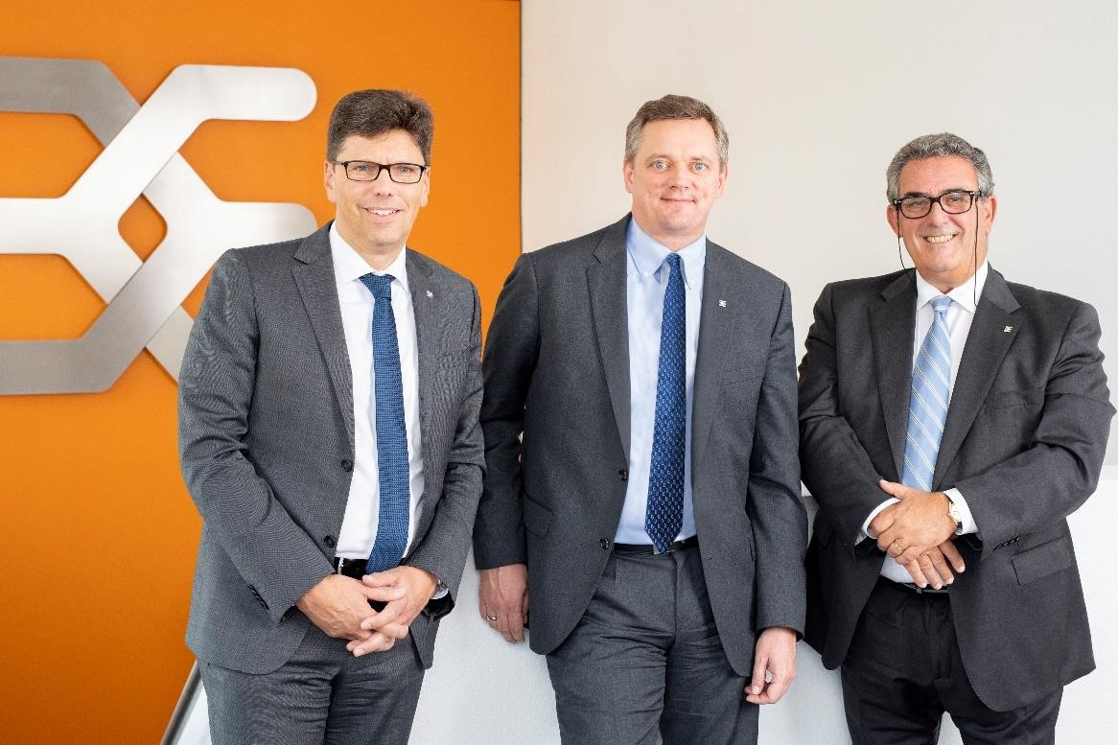
Capture: The Executive Board of the Weidmüller Group around Volker Bibelhausen, Jörg Timmermann and José Carlos Álvarez Tobar (from left to right) is very satisfied with the year 2018, but expects less dynamism for 2019.

Weidmüller – your partner in industrial connectivity.
As experienced experts we support our customers and partners around the world with products, solutions and services in the industrial environment of power, signal and data. We are at home in their industries and markets and know the technological challenges of tomorrow. We are therefore continuously developing innovative, sustainable and useful solutions for their individual needs.
Together we set standards in Industrial Connectivity.
The Weidmüller Group owns manufacturing plants, sales companies and representatives in more than 80 countries.
In its fiscal year 2018 Weidmüller reached sales of 823 million euro with 4,900 employees.

Contact: Carsten Nagel
Corporate Communication
Tel.: +49 (0)5231 14291010
E-mail: carsten.nagel@weidmueller.com

