Facilitating sustainability reporting

With ResMa®, Weidmüller GTI Software offers CO₂ accounting even for small and mid-sized companies

Mid-sized and small enterprises are impacted indirectly by the sustainability reporting directive (CRD) enacted by the EU. As suppliers to large companies, they will be obligated to provide precise information on the CO₂ footprints of their company and/or products. This is essential in order to be able to track CO₂ emissions across all suppliers and to facilitate sustainability reporting.

These measures are making energy management a more important focus in many companies. This is because calculating CO₂ emissions is closely connected to the issue of energy management. Mapping/transparency of energy flows serves as the basis for evaluating energy efficiency and a company's CO₂ footprint.

The open EnMS solution ResMa® from Weidmüller GTI Software offers comprehensive capabilities that can be easily implemented even in small companies:

- Recording all resources in the production process, including quantities of materials used, through connecting to the corresponding machine and process controllers to directly adopt data
- Order or batch-specific recording of all variables to differentiate production batches by specific products. This makes product-specific comparisons and accounting possible.
- Calculating the CO₂ load based on assessment factors for the resources used
- Comprehensive, freely configurable reporting on any time periods
- Complete transparency by converting energy consumption into CO₂ equivalents

When combined with an HMI-SCADA solution, the energy management software ResMa® makes broad process connection possible. Connections to third-party systems like SAP are also possible, allowing order data to be imported. This means the software can link data both via the order itself and via the production process: when was the order received, when was it completed, and how many pieces were produced? The electricity and gas meter can then be used to assign an order to exactly the amount of energy consumed during this time.
After the analysis is complete, the user can choose the visualisation they need from multiple options. A Sankey diagram, for example, provides a good overview of the energy flows to the largest consumers. A heat map, in turn, shows levels throughout the day in a transparent way to help avoid load peaks. For standardized reporting, individual energy reports or production-specific evaluations can be sent automatically. In addition, interactive documentation within the energy management software supports the exchange of information between users.
In accordance with ISO 50001, ResMa® supports standardisation of KPIs. Weidmüller GTI Software is not restricting its work to simple computing operations, but is instead working with data scientists to create AI solutions. The goal is to consider as many variables as possible, then find and quantify relationships through supplementary methods. The results go beyond those obtained with classic statistical methods. This, then, makes it possible to run through different scenarios and predict their impacts with more precision than when using other processes.
Another advantage of ResMa® is that it is certified by TÜV Süd. In addition, the Bundesministerium für Wirtschaft und Ausfuhrkontrolle (BAFA - Federal Ministry of Economics and Export Control) promotes use of the tool.

Energy management software ResMa® enables users to find their easiest path to Industrial IoT and automation. Weidmüller considers itself to be an enabler – “from data to value”. In addition to data analysis and visualisation, Weidmüller provides its customers with hardware and software for recording, pre-processing and managing data, as well as for data communication.

3776 characters including spaces

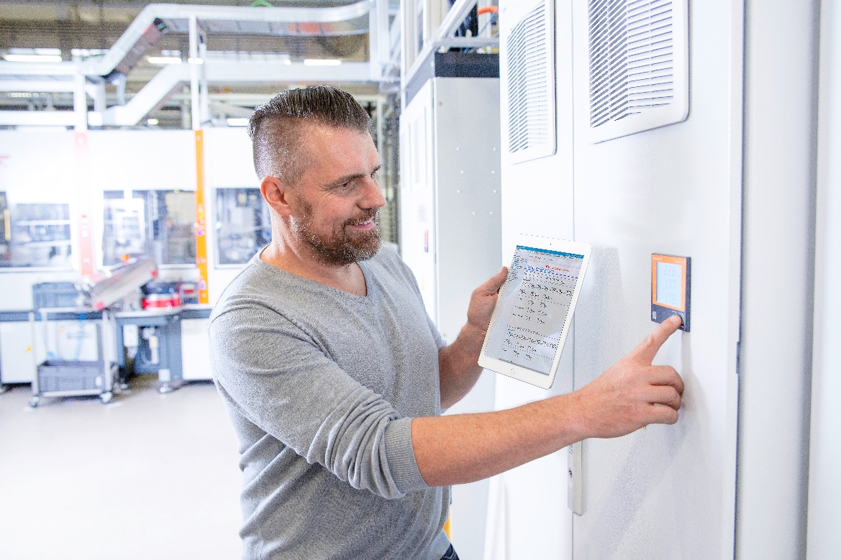
Image caption: ResMa® collects data centrally via connectors and offers a range of intelligent analysis and visualisation options

The Weidmüller Group
Smart Industrial Connectivity: Electrification, automation, digitalisation, electrical connectivity, electromobility and renewable energies – markets in which Weidmüller feels right at home. The family-owned company established in 1850 has production facilities and sales companies in over 80 countries. As a global player in electric connection technology, Weidmüller achieved a turnover of more than one billion euros in the 2023 financial year with around 6,000 employees worldwide - around 2,000 of whom work at the company's headquarters in Detmold, in the heart of East Westphalia-Lippe, Germany. What Weidmüller lives by: Diversity with respect.

Technologies and engagement for a liveable future - Weidmüller demonstrates how it approaches the topic of sustainability in its interactive sustainability brochure.

Your contact: Weidmüller Corporate Communications
Tel.: +49 5231 14-292322
Email: presse@weidmueller.com

