Successful year 2022 for Weidmüller: € 1.175 billion turnover generated

- Turnover mark of one billion euros exceeded
- National and international investment projects
- New logistics facility in Thuringia put into operation
- Future-oriented solutions, concepts and products

Detmold, 17 April 2023. The Weidmüller Group, headquartered in Detmold, looks back on a successful 2022. For the first time, the turnover mark of one billion euros was exceeded in the current fiscal year. In total, Weidmüller achieved a turnover of 1.175 billion euros in 2022. This is a 22 percent increase in turnover compared to the previous year. "We are very pleased that we were able to exceed the one billion euro turnover mark for the first time in our company's history. This means we have reached an important milestone and have established a good starting position for the future," emphasises Chief Technology Officer and Spokesman of the Executive Board Volker Bibelhausen. Despite the various crises and uncertain geopolitical developments, Weidmüller was able to successfully continue to grow.

National and international investment projects

In 2022, long-term investments in all areas again formed the basis for Weidmüller's constant growth. With a total of 83 million euros, the electronics and connection technology company invested 7 percent of its turnover in future-oriented projects and the expansion of its sites. An important component of these investments is the strengthening of the global positioning. The focus here is on the construction of a new production site in China, an expansion of the site in Richmond, USA, a production expansion in Romania and capacity expansions in Thuringia.

Improved value creation, more sustainability and circular economy as well as the strengthening of sustainable local-for-local concepts in the regions are fundamental goals of the investment projects. "With the expansion of our locations, we are on the one hand ensuring more proximity to our customers in the regions. On the other hand, we are expanding and optimising our operational footprint in terms of productivity, efficiency and sustainability," explains Dr Sebastian Durst, the new Chief Operations Officer at Weidmüller, adding: "The projects are essential building blocks of our global growth path in the production and logistics sector."

New logistics facility in Thuringia put into operation

Meanwhile, the completion and commissioning of the Weidmüller Distribution Centre (WDC) marked the successful completion of the largest single investment project in the company's history. Not far from Eisenach, a new logistics centre was built on an area of 72,000 square metres in a construction period of around two years. With the WDC, Weidmüller is significantly and sustainably optimising and revolutionising its logistics processes. The highly modern building complex is located about ten kilometres away from the site of the Thüringischen Weidmüller GmbH (TWG). It is largely automated and enables a fully digitalised and flexibly networked delivery and customer service. "With the Weidmüller Distribution Center, we are well prepared for the multi-layered logistics requirements of tomorrow," explains Dr Timo Berger, Chief Sales Officer at Weidmüller, adding: "By optimising our supply chains, we have set the course for further growth and more service for our customers."

Products and concepts for the future

When developing new concepts, products and solutions, Weidmüller focuses on future-oriented topics. The aim is to make core technical areas simpler, more efficient and more sustainable. Many of the company's products and concepts are used, for example, in photovoltaic systems and machines, wind energy, electromobility and hydrogen production. Weidmüller also develops solutions for the DC industry: the Detmold-based family business is a founding member of the Open Direct Current Alliance (ODCA), which was launched in November 2022 and aims to establish a sustainable DC ecosystem. With the u-control control system, the easyConnect service platform and the u-OS operating system, Weidmüller is also significantly expanding its software and hardware product portfolio in the areas of Industrial IoT and Automation. The electronics and connectivity company develops holistic solutions along all process steps for the cabinet building of the future. The SNAP IN connection technology also enables automated, robot-assisted manufacturing processes. "We clearly align the development of our products and solutions with the conditions and requirements of the future. This applies both in terms of practical added value for our customers and in terms of a more sustainable world," says Chief Technology Officer and Spokesman of the Executive Board Volker Bibelhausen.

With confidence into the future

Following the strong growth in sales to over one billion euros in 2022, the Executive Board of the Weidmüller Group remains confident despite difficult market conditions. "For 2023, we are aiming for a growth rate that is close to double digits compared to the year 2022," explains Chief Financial Officer André Sombecki.

5,115 Characters without spaces

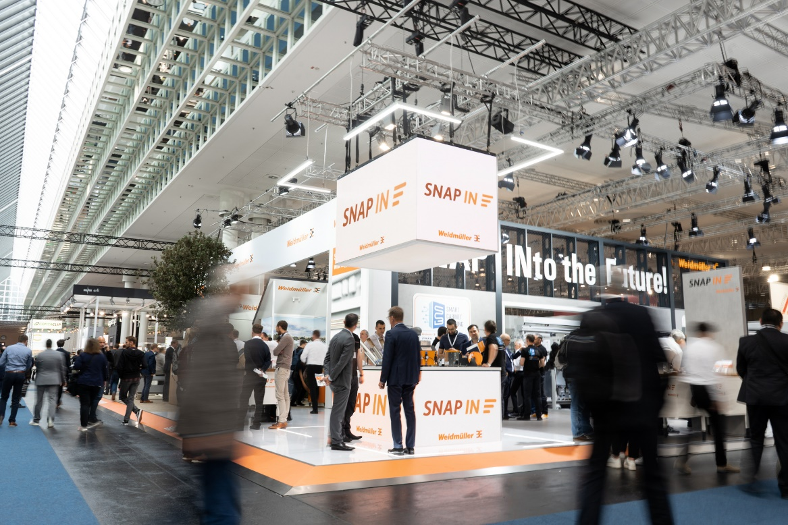
Caption: Weidmüller presents its new products and innovations at the Hannover Messe in Hall 11, Booth C57

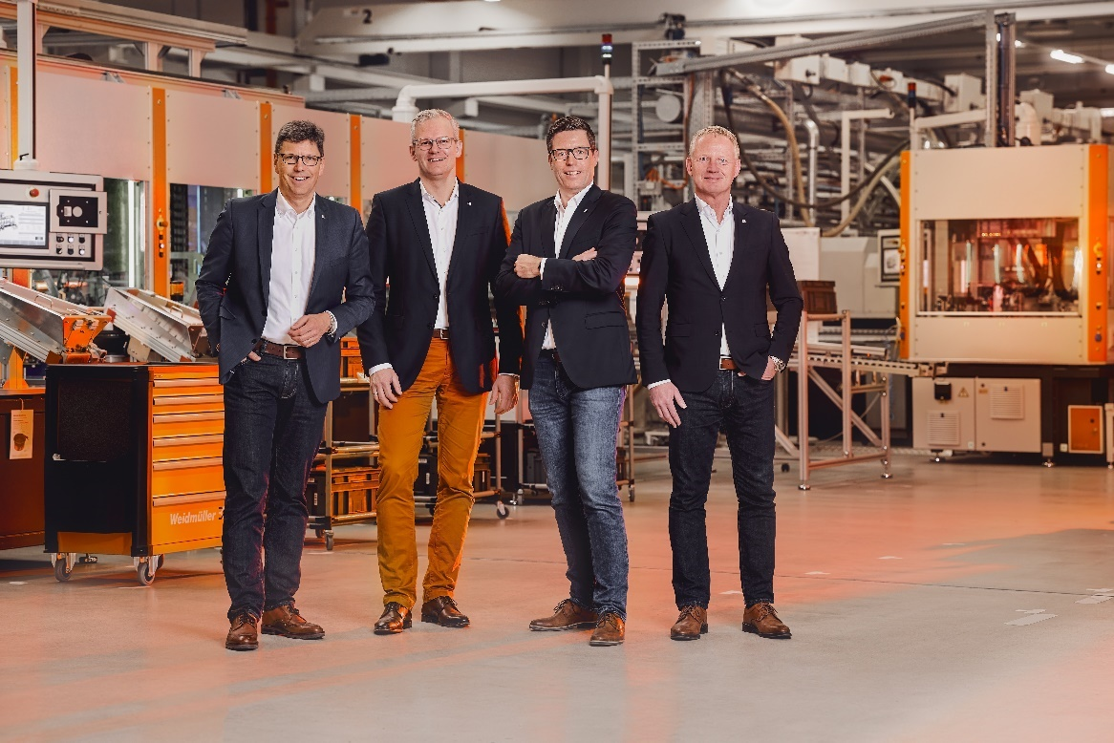
Caption: The Weidmüller Executive Board (from left to right): Volker Bibelhausen (Chief Technology Officer and Spokesman of the Executive Board), Dr Sebastian Durst (Chief Operations Officer), Dr Timo Berger (Chief Sales Officer), André Sombecki (Chief Financial Officer)

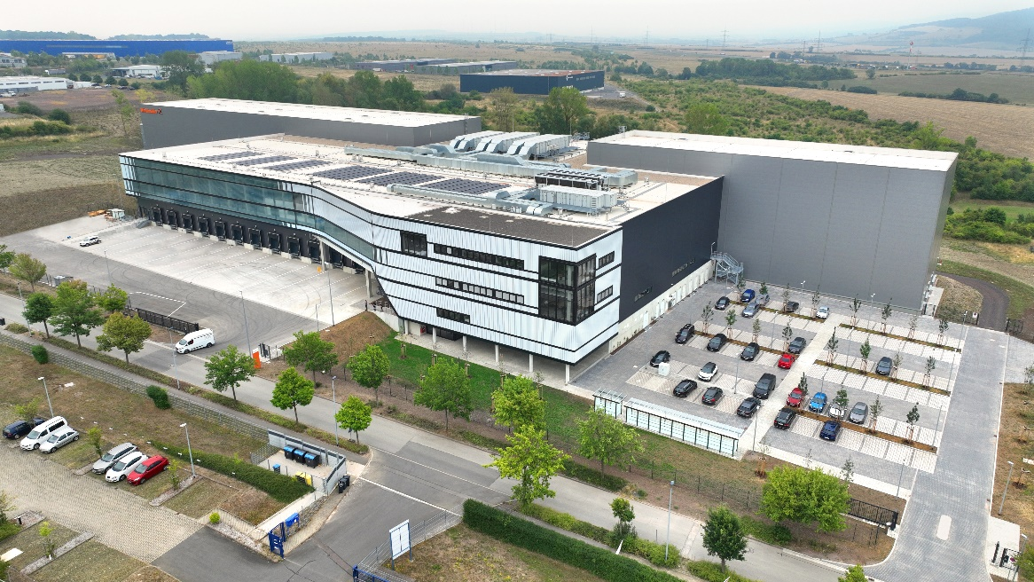
Caption: The new Weidmüller Distribution Center was officially put into operation

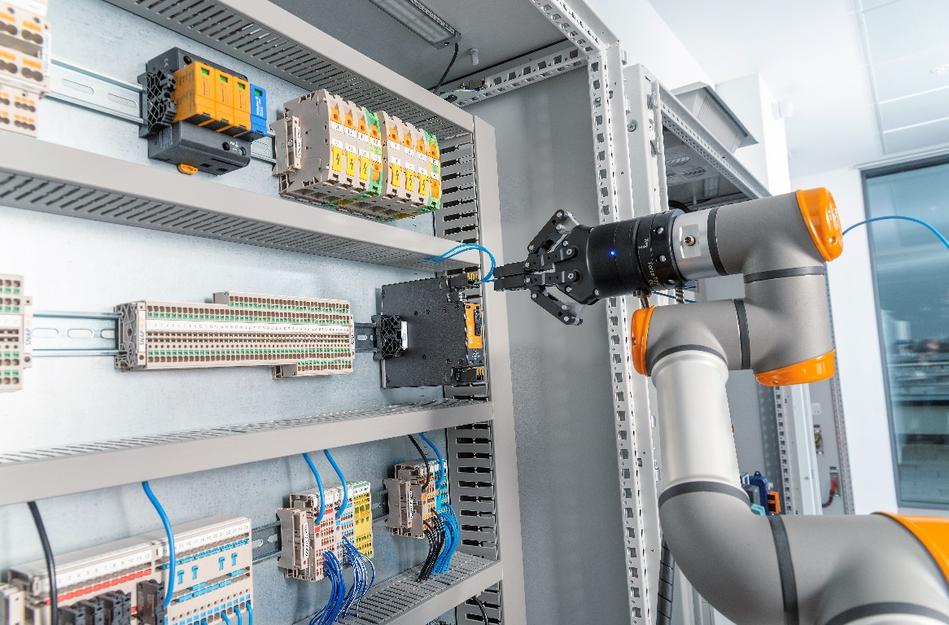
Caption: SNAP IN connection technology from Weidmüller enables the automated, robot-assisted wiring of the future

Your contact: Weidmüller Corporate Communications
Tel. +49 (0) 5231 / 14-292322
E-Mail: presse@weidmueller.com

Weidmüller – Partner of Smart Industrial Connectivity

The Weidmüller Group has production facilities, sales companies and representatives in more than 80 countries. Together with our customers, we are shaping the digital transformation – with products, solutions and services for Smart Industrial Connectivity and the Industrial Internet of Things. In the 2022 financial year, Weidmüller generated sales of more than one billion euros with around 6,000 employees around the world.

Responsible for content: Weidmüller Corporate Communications
Corporate Spokesperson, Sybille Hilker

