Technical change to: two pole tester LED

Dear Madam or Sir,

the below listed articles will be supplied in a modified revision. Please pass this product information on to your employees and, if needed, to your customers. All modifications are performed for reasons of product improvements.

- Initial situation

The current program of the two-pole voltage tester must be revised.

- Technical change

Combi Check and Combi Check Pro VT Combi Pro (only one tester)
- Slightly shorter design
- now CAT IV 600V
- All functions of the Combi Check Pro at the lower price of the Combi Check

Master Check VT Master
- Significantly smaller and more compact
- Larger voltage range up to 690V
- Including buzzer
- No magnetic locking more

Old version | New version
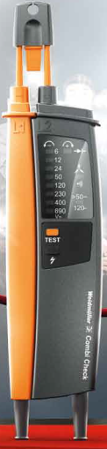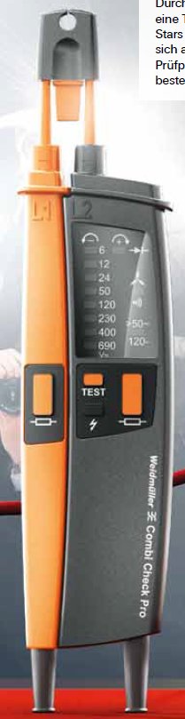  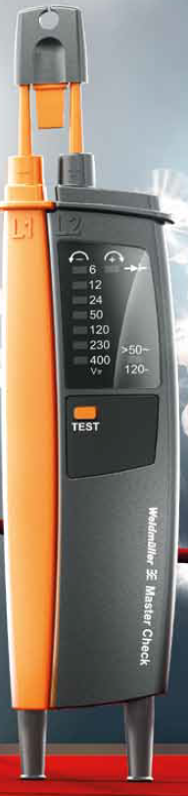 | 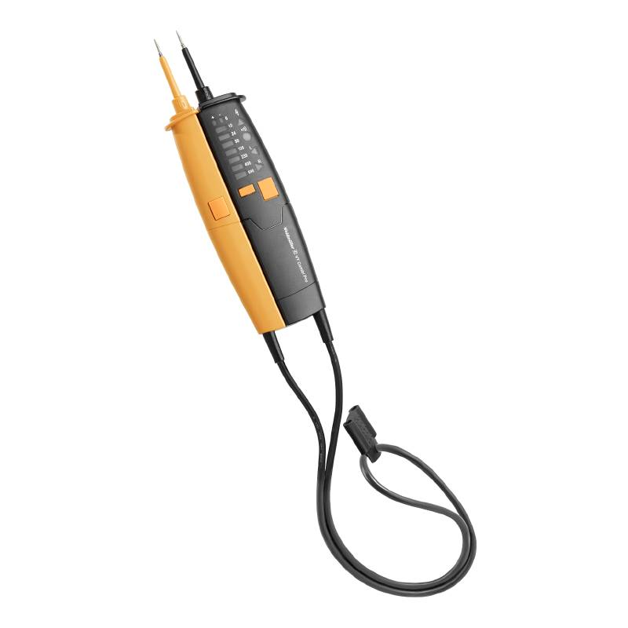  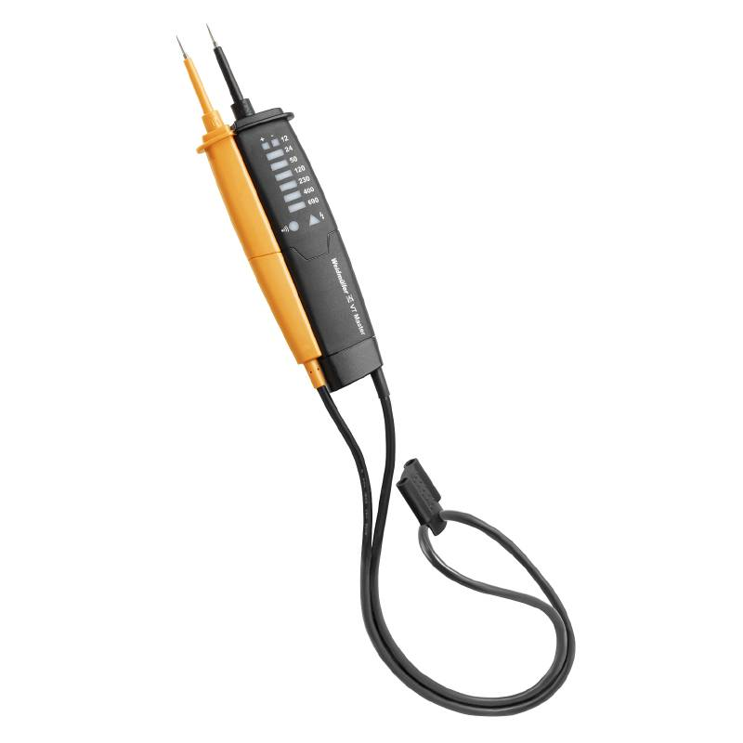

- Reason for change

Since the previous supplier no longer wanted to manufacture these articles, we had to switch to a new supplier. As part of the conversion, the two-pole voltage testers were also technically revised and improved. Furthermore, the testers have already been adapted to the new standard.

- Availability

9918860000 – Combi Check: a few quantities available (chanceover to week 18)
1279330000 – Combi Check Pro: still 800 pieces (successor VT Combi Pro)
9918880000 – Master Check: no stock (chanceover to week 16)

- Affected parts

9918860000 – Combi Check New VT Combi Pro
1279330000 – Combi Check Pro (successor VT Combi Pro)
9918880000 – Master Check New VT Master

- Data

- PCN-PW641010-20180410-00-A
- 10.04.2018

We are very sorry for all the inconveniences caused and doing everything to adjust this product change as smooth as possible without big influence on delivery times and general functions.

For further questions please contact your sales office directly. All contacts for sales representatives are available here: www.weidmueller.com/contact

Best regards

Product Management

Weidmüller Interface GmbH & Co. KG
Klingenbergstraße 16, 32758 Detmold, Germany

Weidmüller – Your partner in Industrial Connectivity
We look forward to sharing ideas with you – Let’s connect.

