After a challenging year in 2023: Weidmüller stays the course

Detmold, 08/03/2024. The Weidmüller Group, headquartered in Detmold, achieved a turnover of €1.102 billion in the challenging 2023 fiscal year. The company is setting itself up for the future with record investments of €99 million and new solutions for electrification, automation and digitalisation.

Weidmüller Executive Board members Volker Bibelhausen and Dr Sebastian Durst answered questions from journalists at the Light + Building in Frankfurt. During the last fiscal year, the company once again significantly exceeded the billion euro turnover mark. The drop in six per cent from the previous year was due primarily to the weak economic situation in China. “We expected that there would be a correction after two years of very strong growth in 2021 and 2022. The European and North American markets relevant for us saw moderately positive development over the last year. Nevertheless, the difficult environment in China had a strong influence on us”, Volker Bibelhausen concluded.

To set the stage for future growth, Weidmüller invested once again in long-term projects and in expanding its sites in 2023. Since 2018, Weidmüller has invested around €400 million in the further development of the global production and logistics network. The new Weidmüller Distribution Center (WDC) began operation near Eisenach in Thüringen and is currently in the start-up phase. Last summer, construction began in Detmold for a new, 19,000-square-meter electronics production site. Dr Sebastian Durst emphasised the importance of these two major projects: “These have been the largest individual investments in Weidmüller’s history and underscore our commitment to manufacturing in Germany, with all of the possibilities and excellent specialists it offers”.

At the same time, Weidmüller significantly increased its number of junior staff members to over 230 trainees and dual students, corresponding to a ratio of 8 per cent. In doing so, the company is addressing the expected lack of trained professionals from an early stage. In another positive development, the company’s ongoing improvements in the areas of sustainability and corporate social responsibility (CSR) were confirmed by a gold rating from EcoVadis. With this rating, Weidmüller joins more than 100,000 companies worldwide that are among the top 6 per cent of sustainable businesses.

The expansion of the USA site launched in 2023 is the focus of Weidmüller’s efforts to further consolidate its global position.. “Our goal is to be closer to our customers. By expanding our site in Richmond, Virginia, we will have a bigger presence on the US market in the future, as well as greater manufacturing capabilities”, Bibelhausen explains. At the same time, Weidmüller successfully completed an expansion of its production in Romania. The goal of both projects is to build up its production capacity while reinforcing flexible local-for-local concepts, along with shorter transportation routes and the associated reduction in carbon emissions.

The Weidmüller Executive Board is optimistic about the future: “Of course, we live in turbulent times with a lot of uncertainty. As a company, we can only make the case for remaining open to the many innovations in our industry. Electrification, automation and digitalisation solutions have a major potential to promote climate neutrality. As a pioneer in our industry, we are developing the right products, pointing the way forward with new concepts, and in this way making our contribution to ensuring a liveable world of the future”. This strategic alignment makes the company optimistic about the future: “In 2023, we successfully completed multiple projects and began others. In doing so, we are developing a good starting position for the future. Once the framework conditions in Germany, in particular, improve and the markets recover, we will be ready” – of that, the Weidmüller Executive Board is certain.

4,102 characters including spaces

You are free to use all images. You can download them at the following link: https://www.picdrop.com/weidmueller/qtGGXm2zFD

Image source: Weidmüller

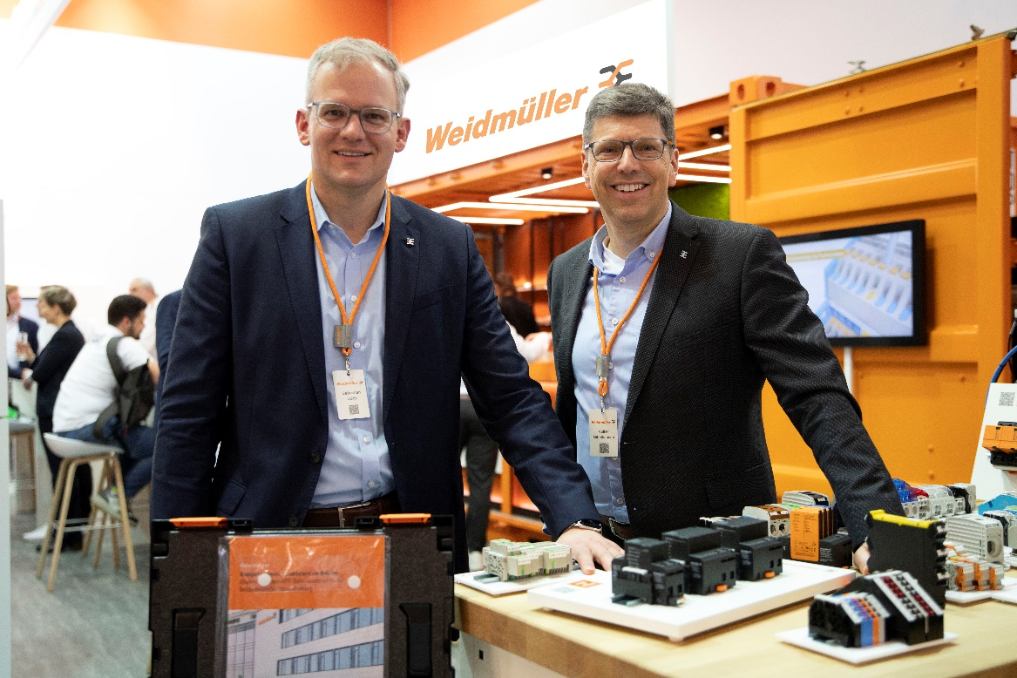
Image caption image 1: Dr Sebastian Durst (Chief Operating Officer) and Volker Bibelhausen (Chief Technology Officer and Speaker of the Executive Board) answered questions from journalists

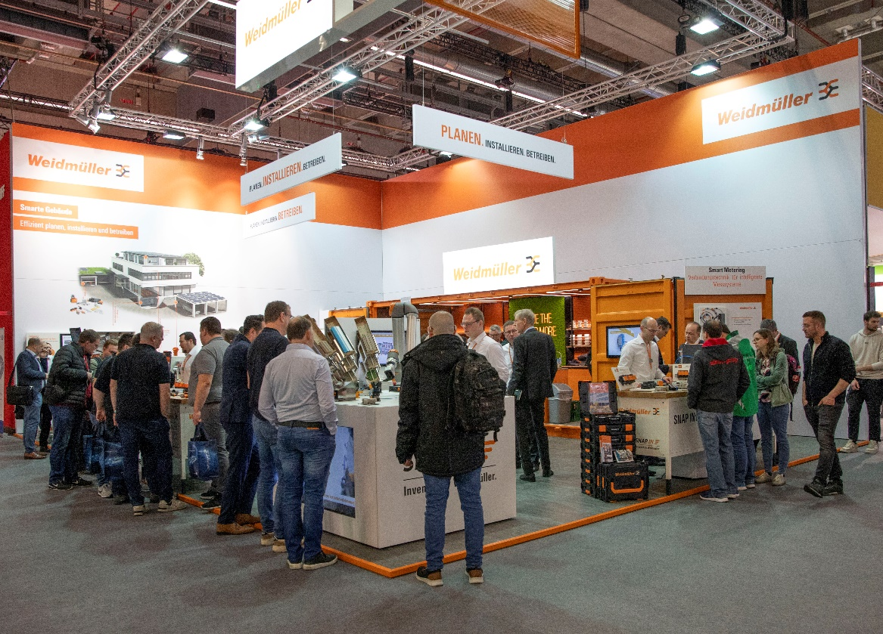
Image caption image 2: Weidmüller presented several of its solutions and technologies at the Light + Building exhibition in Frankfurt

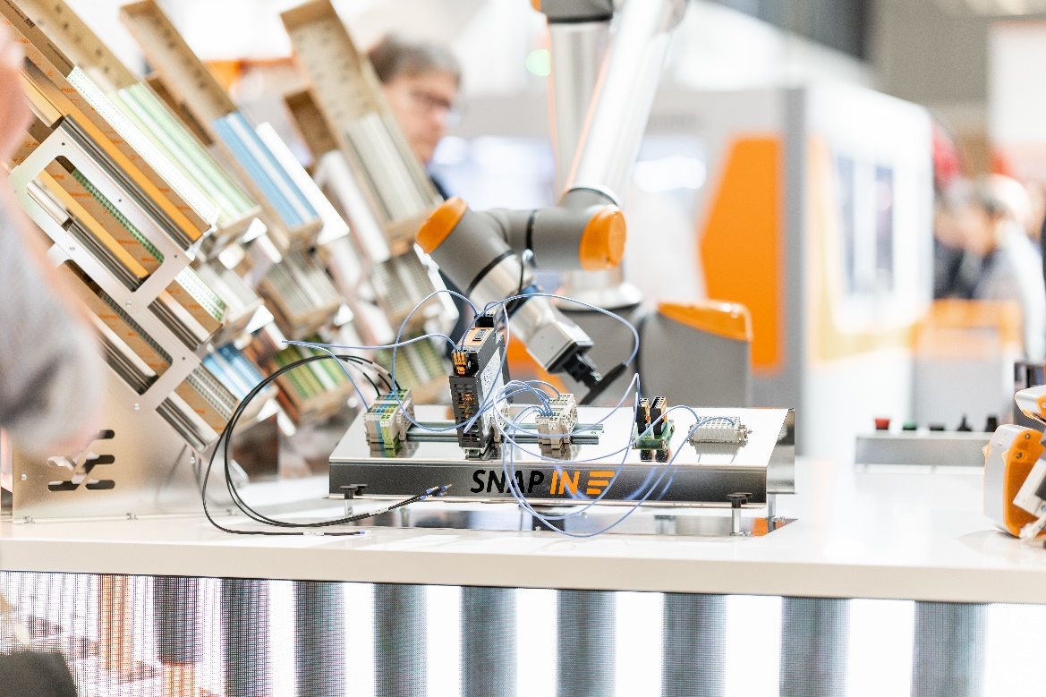
Image caption image 3: One of the technologies Weidmüller presented was SNAP IN, its innovative connection technology

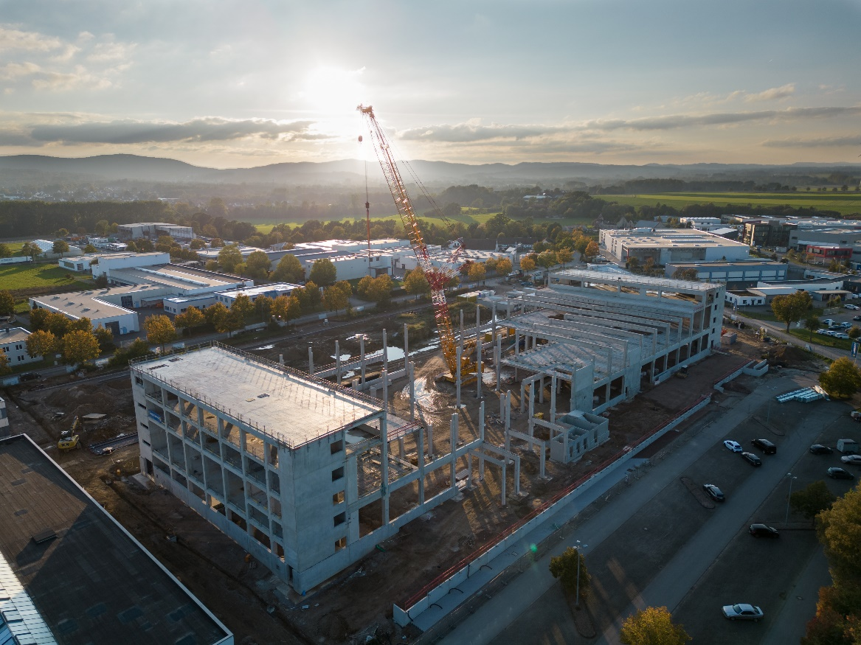
Image caption image 4: A new electronics production facility is being created at Detmold

Numbers, data, facts

Turnover and economic development

- €1.102 billion turnover in 2023
- 6% drop in turnover due to difficult economic framework conditions and geopolitical tensions

Investments

- Since 2018, Weidmüller has invested €400 million in the further development of the company
- Total of €99 million invested in 2023
- Construction of a new electronics production facility at the headquarters in Detmold
- Operations commenced at own logistics centre in Thüringen
- Expansion of the USA site
- Two new production facilities opened in Romania
- Investment of €65 million for research and development
- Increase of 6%
- Approx. 500 employees in the R&D area

Development of the team

- Number of employees remains essentially the same all over the world (approx. 6,000 employees worldwide)
- Junior staff ratio of 8%
- Currently over 230 trainees or dual students

The Weidmüller Group

Smart Industrial Connectivity: Electrification, automation, digitalisation, electrical connectivity, electromobility and renewable energies – markets in which Weidmüller feels right at home. The family-owned company established in 1850 has production facilities and distributors in over 80 countries. As a global player in electrical connectivity, in 2023 Weidmüller reported revenue in excess of one billion euros with around 6,000 employees worldwide – approx. 2,000 of whom are located at the headquarters in Detmold in the heart of Ostwestfalen-Lippe, Germany. What Weidmüller lives by: Diversity with respect.

Technologies and engagement for a liveable future – Weidmüller demonstrates how it approaches the topic of sustainability in its interactive sustainability brochure.

Contact:
Weidmüller Corporate Communications
Company Spokesperson, Sybille Hilker
Tel.: +49 (0)5231 / 14-292322
Email: presse@weidmueller.com

