Press release 

Weidmüller wins German Design Award 2020
Relay modules from the electrical engineering firm are recognised for simple handling thanks to special product design – the family-owned company is presented with the Design Award by the German Design Council

Detmold, 17 February 2020. The Detmold-based electrical engineering firm Weidmüller was honoured with the German Design Award on 7 February in Frankfurt am Main. The German Design Council presented the award for the
“PUSH IN TERMSERIES” relay modules in the “Excellent Product Design
Industry” category. This relay coupler not only impresses through its functionality and easy handling, but also through its colourful design.

“The German Design Award is extremely important to us – it shows that our product designs are always innovative and customer-focused,” emphasised Thomas Peter, Head of the Business Unit Digital Signaling & Protection at Weidmüller. The independent and objective jury – comprised of representatives from economy, design and science – was also impressed by the combination of design and functionality in the PUSH IN TERMSERIES: The black relay module has a space-saving design with integrated orange-coloured pushers to prevent incorrect wiring. What's more, the large illuminated ejection lever provides a clear status indicator, while the orange-coloured separation plates ensure a clear arrangement. It also impresses through good ergonomics as well as faster and safer wiring due to PUSH IN connections. “When developing the switching device, we focused on emphasising simple and fast handling – we're proud to have achieved this,” explains Peter.

The German Design Award – one of the most recognised and international prizes – is presented by the German Design Council. The prize honours products and projects that are pioneering on the German and international design landscape. This year, the German Design Council received around 5,300 submissions from 69 countries. The jury honours 70 Gold Prize Winners in 61 categories.

1917 Zeichen inklusive Leerzeichen

1

Press release
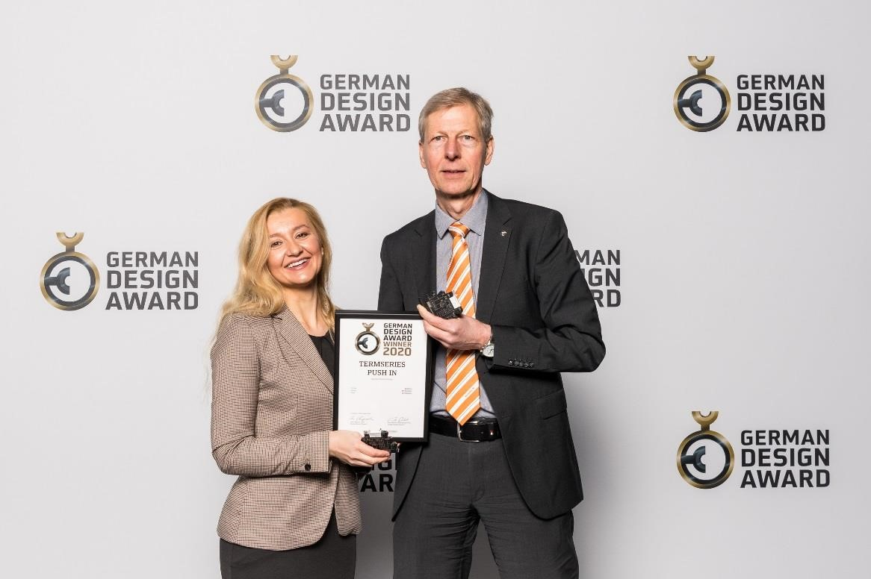

Image caption: Company spokeswoman Sybille Hilker (l.) and Thomas Peter (r.), head of the Digital Signaling & Protection business unit at Weidmüller, accepted the award in Frankfurt.

Weidmüller – your partner in industrial connectivity.
As experienced experts we support our customers and partners around the world with products, solutions and services in the industrial environment of power, signal and data. We are at home in their industries and markets and know the technological challenges of tomorrow. We are therefore continuously developing innovative, sustainable and useful solutions for their individual needs.
Together we set standards in Industrial Connectivity.
The Weidmüller Group owns manufacturing plants, sales companies and representatives in more than 80 countries. In its fiscal year 2018 Weidmüller achieved sales of EUR 823 million with around 4,900 employees.

Contact: Carsten Nagel
Corporate Communications
Tel.: +49 (0)5231 14-291010
E-mail: carsten.nagel@weidmueller.com
2

