Weidmüller continues its success story in China
After an eight-month construction phase, the electrical engineering company moves into its new production facility in the Chinese city of Suzhou, creating more space for growth

Detmold / Suzhou, 31.07. 2019. The electrical engineering company
Weidmüller is celebrating the opening of a new production building in the Chinese city of Suzhou. The ground-breaking ceremony for the new ultramodern production facility took place in July of last year. After just eight months of construction, the building was ready at the end of April. With a total usable surface area of 14,000 square metres and a modern reception area, the tenmetre high building is a huge improvement on the former production facility. As part of the construction project, the project managers drew upon many concepts from Weidmüller's other production sites. “The structure of the halls enables us to use the available space far more efficiently. The production routes and warehouse both follow strictly defined rules, which explains why the transporting of goods throughout the premises is now far more flexible, fast and simple,” explains Thomas Kipke, Head of Global Production at Weidmüller. With an additional 2,500 square metres of open space at the new production facility, Weidmüller has additional capacities to pursue and implement its ideas for lean production and sustainable development in the future too.

The project managers attached a great deal of importance to designing modern work stations that will help to increase productivity and creativity while retaining motivated employees at the company. At the same time, Weidmüller has opted for a solar technology power supply in the form of an energy generation system at the site in Suzhou. Therefore, production is greener, safer and more sustainable. The entire IT infrastructure is geared towards security and efficiency. “Our aim is to systematically network all our resources together, beginning with our production facilities, products and of course our employees, with a view to developing more intelligent solutions for our customers on this broad basis,” explains Lance Zhao, Executive Vice President Region Asia at Weidmüller.

The production site plays a major role in Weidmüller's global production strategy. The company has been represented locally since 1994 and during this period it has evolved from being a producer of individual products in the area of connectivity to a provider of intelligent system solutions. Today it is an important partner for many Chinese companies in the areas of industrial automation and digitalisation, robotics, connectivity and intelligent logistics, Big Data analyses, energy management and solutions for wind turbines.

2.526 characters including spaces

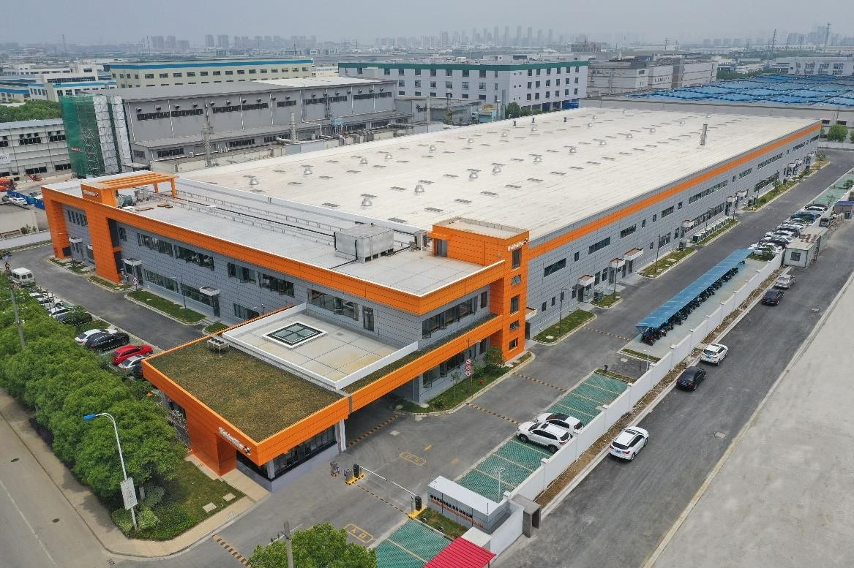
Image caption 1: Glistening in the typical Weidmüller orange and offering 14,000 square metres of additional space for production: the new production building in the Chinese city of Suzhou.

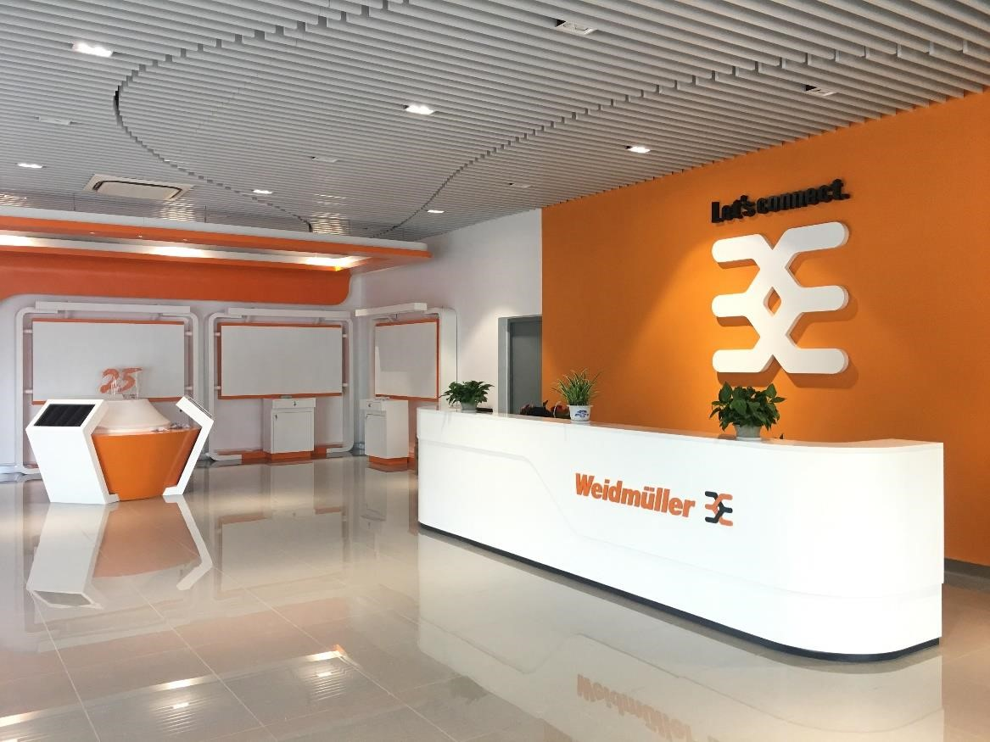
Image caption 2: The reception hall of the building also has an attractive design.

Weidmüller – your partner in industrial connectivity.
As experienced experts we support our customers and partners around the world with products, solutions and services in the industrial environment of power, signal and data. We are at home in their industries and markets and know the technological challenges of tomorrow. We are therefore continuously developing innovative, sustainable and useful solutions for their individual needs. Together we set standards in Industrial Connectivity. The Weidmüller Group owns manufacturing plants, sales companies and representatives in more than 80 countries. In its fiscal year 2018 Weidmüller reached sales of 823 million euro with 4,900 employees.

Contact: Carsten Nagel
Corporate Communication Tel.: +49 (0)5231 / 14-291010 email: Carsten.Nagel@weidmueller.com

