Weidmüller is building a new electronics manufacturing facility in Detmold

Detmold, 14 August 2023. Electronics and connection technology company Weidmüller is expanding its headquarters in Detmold with a new manufacturing building. The new building on Ohmstraße will be used to produce electronic components in the future, among other products. A symbolic groundbreaking ceremony was held on August 14th 2023.

Volker Bibelhausen, Chief Technology Officer and Speaker of the Executive Board at Weidmüller, is happy about the launch of this major project: “With the new electronics production facility in Detmold, we are strengthening our presence in Germany and offering attractive jobs in the East Westphalia-Lippe region. The project is an important step to further expand our innovative capacity and competitiveness in the electronics area.“

Circuit board assembly, installation, plastics manufacturing and logistics processes will be housed in the new Weidmüller company manufacturing building. In total, Weidmüller is investing approx. 60 million euros in the project over a period of three years.

Sustainable and local-for-local

The concept for the new building includes modern equipment and a high degree of automation. In addition, the new building will be very energy efficient. Reversible heat pumps will be used to heat and cool the warehouse, and waste heat from production will also be recovered. District heating will be used to supply further heating requirements. The entire surface of the building’s roof will be equipped with a 600 kWp photovoltaic system, so that electronics production can be powered using solar energy.

Dr. Sebastian Durst, Chief Operations Officer at Weidmüller, emphasises the comprehensive and sustainable concept behind the project: “In our new production building, we are focusing on sustainability and energy efficiency in all areas. Firstly, the building concept is designed to use renewable energy sources. Secondly, we are producing products specifically for our European customers in Detmold, in order to shorten transport routes and shrink our CO2 footprint”.

The groundbreaking ceremony for the new electronics production facility was held on site on Ohmstraße in Detmold. Axel Lehmann, county commissioner for the District of Lippe, was among the attendees. Construction is expected to take around two years. The start of production at the new manufacturing building is scheduled for early 2025. The project is being executed by the construction company Depenbrock from Stemwede.

2,526 characters including spaces

All images are at your free disposal. You can download them in high quality under the following link: https://www.picdrop.com/weidmueller/xVij1YfTwZ

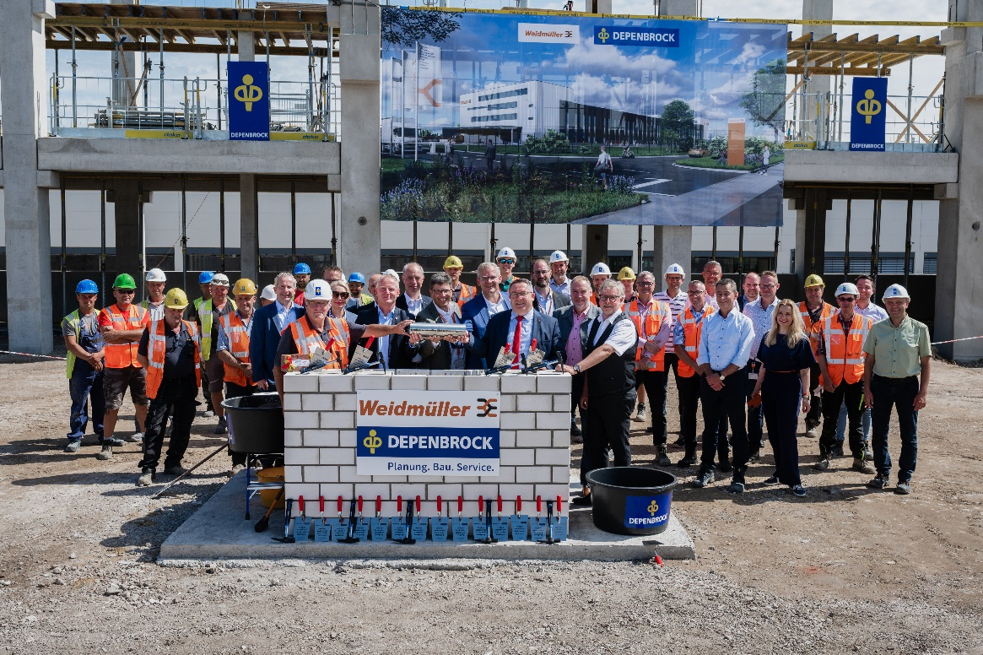
Caption: Happy about the groundbreaking ceremony (front row, from left to right): Hermann Schwagmann (Head of Innovation and R&D Center; Weidmüller), Claus Rettkowsk (Depenbrock), Helene Derksen-Riesen (Head of Corporate Development & Real Estate; Weidmüller), André Sombecki (Chief Financial Officer; Weidmüller), Volker Bibelhausen (Chief Technology Officer and Speaker of the Executive Board; Weidmüller), Dr. Sebastian Durst (Chief Operations Officer; Weidmüller), Dr. Axel Lehmann (District Administrator; County of Lippe), Olrik Meyer (Head of Environment, Sustainable Development and Mobility; County of Lippe), Thomas Lammering (Technical Councillor; City of Detmold)

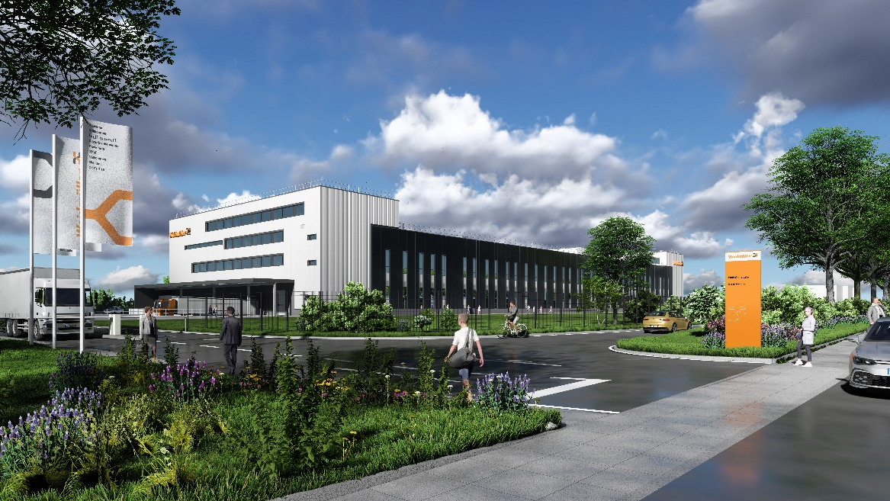
Image caption: Weidmüller is building a new electronics manufacturing facility on Ohmstraße in Detmold

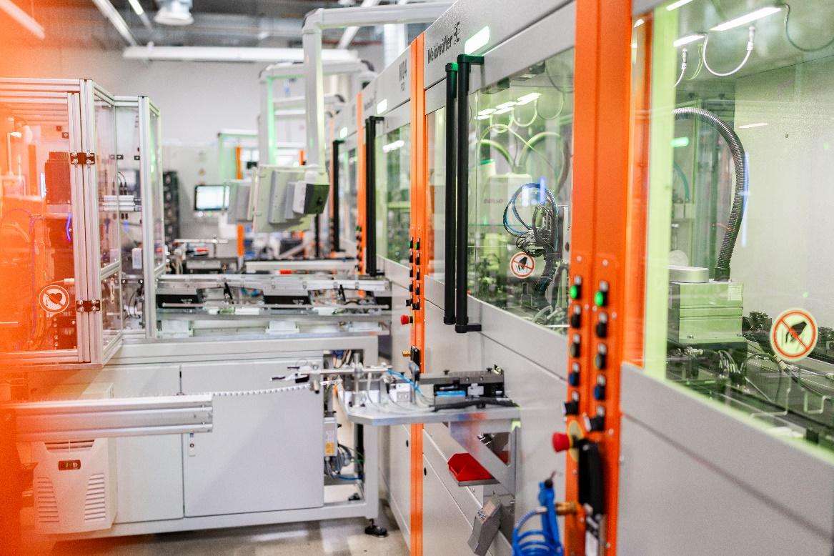
Image caption: With the new construction, the company continues to expand its electronics expertise

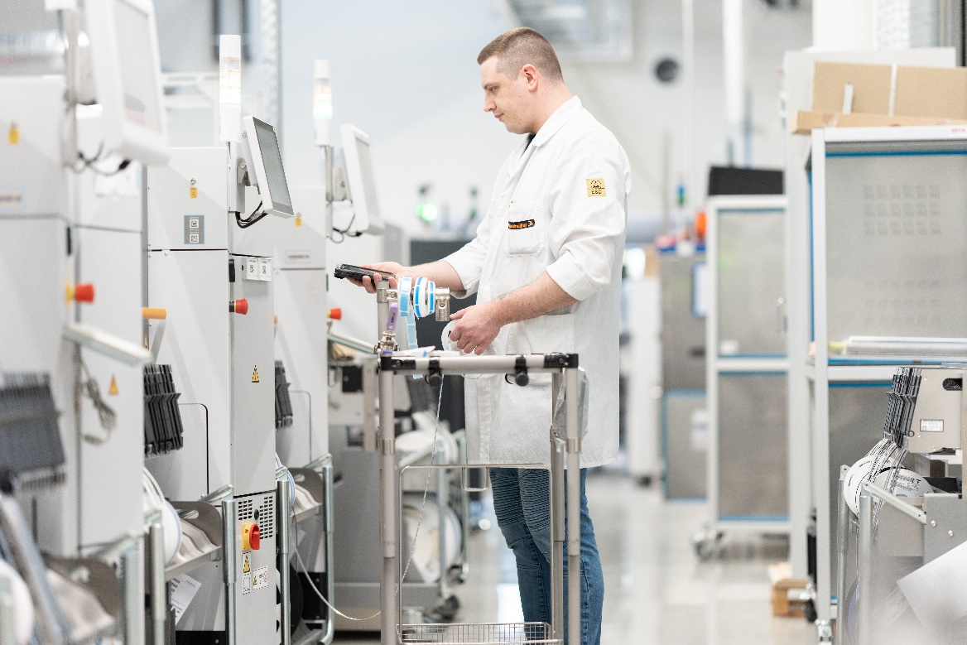
Image caption: Automation technology in particular will be produced in Weidmüller's new building

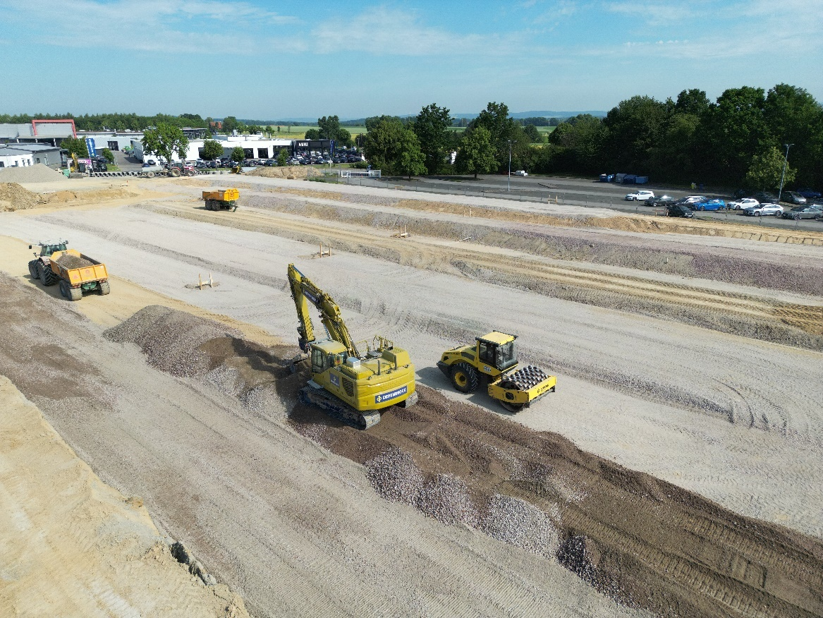
Image caption: Construction work for the new manufacturing building has already begun – the Depenbrock Group from Stemwede was commissioned as the construction company

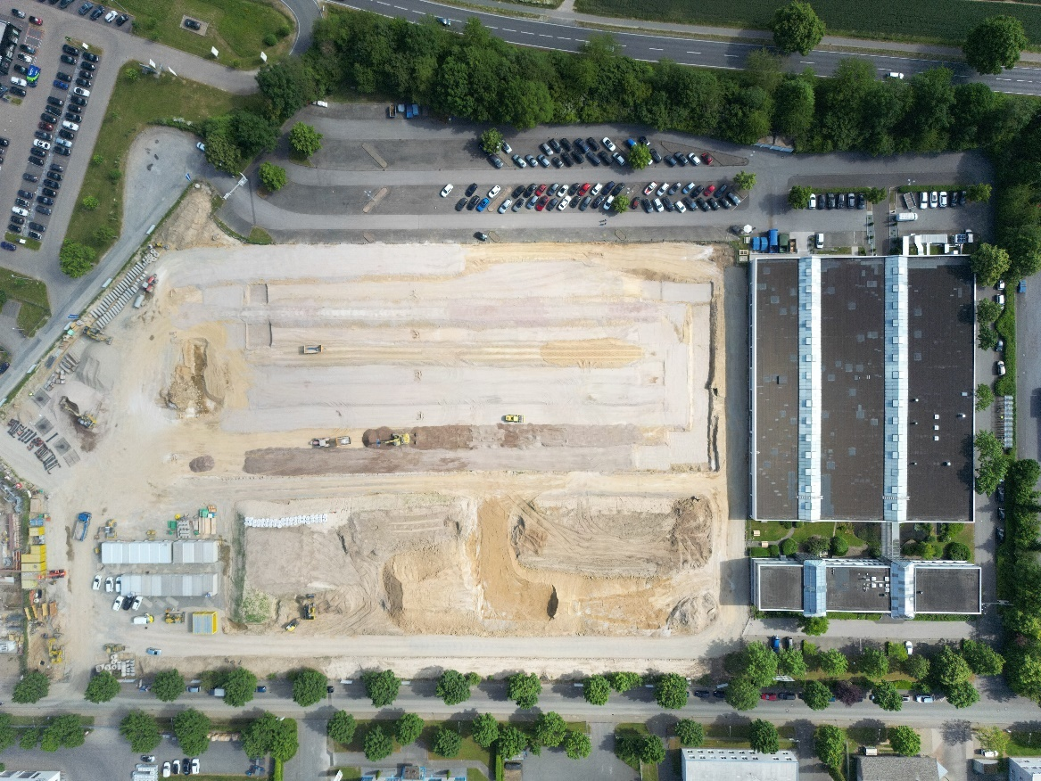
Image caption: The construction site extends over an area of 45,000 square meters

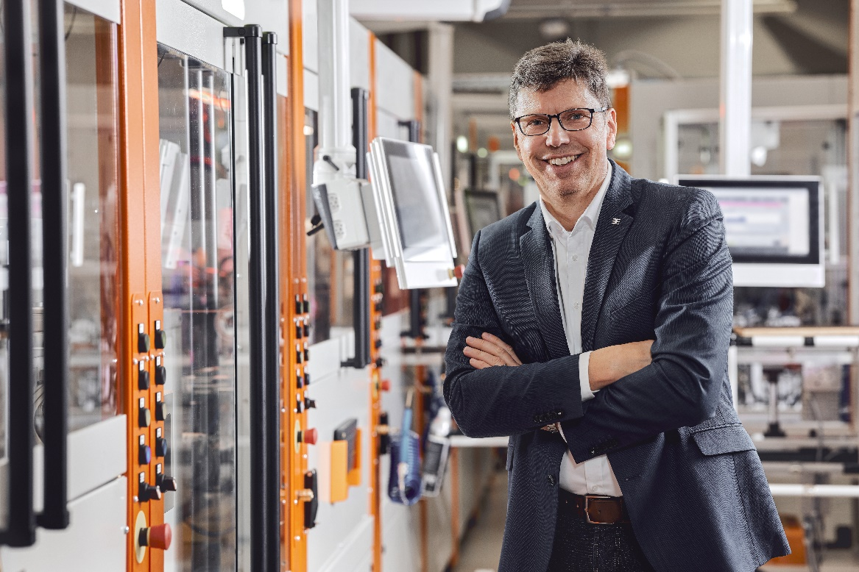
Image caption: Volker Bibelhausen, Chief Technology Officer and Speaker of the Executive Board at Weidmüller

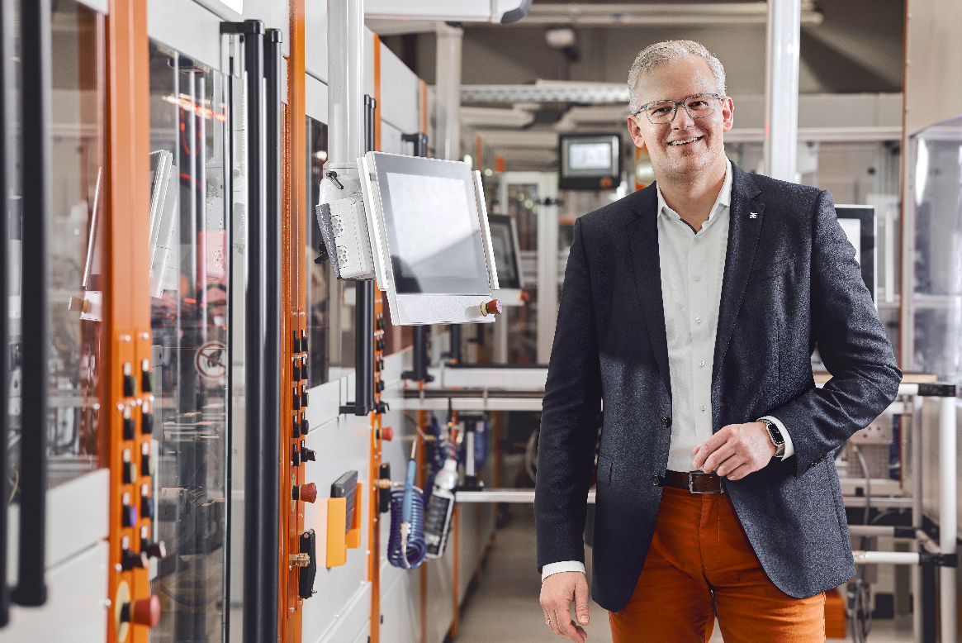
Image caption: Dr Sebastian Durst, Chief Operations Officer at Weidmüller

The Weidmüller Group

Smart Industrial Connectivity: Electrification, automation, digitalisation, electric connectivity, electromobility and renewable energies - markets in which Weidmüller is at home. Founded in 1850, the family-owned company is represented in over 80 countries with production facilities and sales companies. As a global player in electric connection technology, Weidmüller achieved a turnover of more than one billion euros in the 2022 financial year with around 6,000 employees worldwide - around 2,000 of whom work at the company's headquarters in Detmold, in the heart of East Westphalia-Lippe.
Responsible for content:
Company Spokesperson, Sybille Hilker
Department Head Marc Landermann

Contact:
Weidmüller Corporate Communications
Marc Landermann
Head of Corporate Communications
Tel.: +49 (0)5231 / 14-292322
Email: presse@weidmueller.com

