The L-BOXX installation terminal block starter set from Weidmüller – an indispensable kit for every electrician

The L-BOXX installation terminal block starter kit from the electrical engineering and connectivity company Weidmüller – a must-have for every electrician. The L-BOXX is an innovative storage system that ensures order and efficiency in a variety of industrial areas, especially in the skilled trades. The set is specially designed for electricians as a symbol of innovation and advanced organisational solutions.
The L-BOXX offers an intelligent solution for the storage, transport and organisation of tools, materials and accessories. Thanks to its compact design, it can accommodate the essential components for electricians in a single, handy unit. Moreover, the proper storage of and easy access to the required components not only reduces working time, but also minimises the risk of errors.

This comprehensive starter kit contains installation terminal blocks including all accessories needed for three standard-compliant distribution boards in single and multi-family houses.

For efficient work that makes a professional impression
The installation kit offers both electricians and installers an innovative solution for fast, reliable and safe installations in the building infrastructure. From compact connection terminal blocks to robust feed-through terminal blocks, the L-Boxx variant INSTA 1 covers a broad spectrum of applications.
After all, Weidmüller’s installation terminal blocks are specially designed for use in electrical installations and offer a number of advantages. With their space-saving design and easy handling, they enable efficient wiring in a wealth of different applications. In addition, the installation terminal blocks comply with all standards and regulations and offer a secure connection for a wide range of installation situations.
1,917 characters including spaces

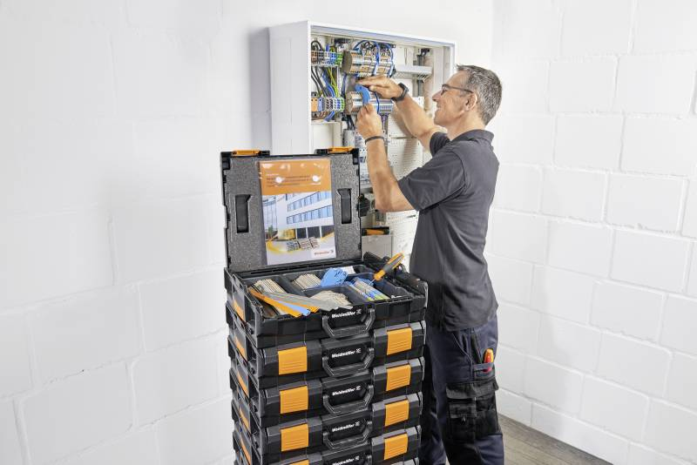

Image caption: Innovative storage system – stackable and customisable

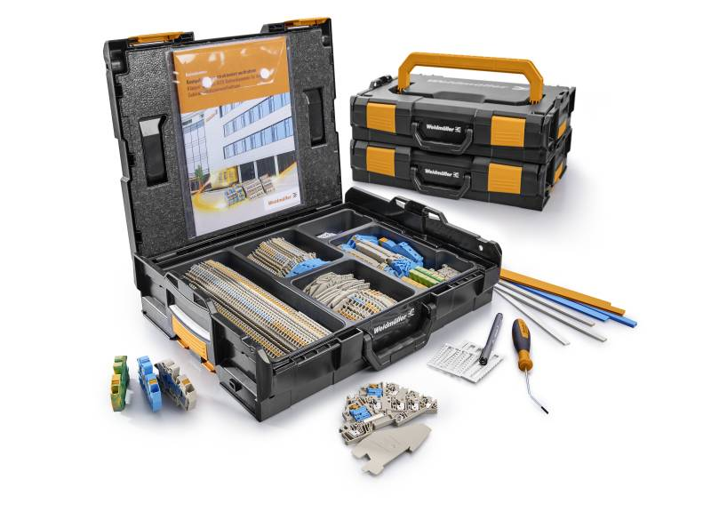

Image caption: The L-BOXX kit INSTA 1 – an efficient solution for building infrastructures

You are free to use all images. We request that you cite the image source.

The Weidmüller Group

Smart Industrial Connectivity: Electrification, automation, digitalisation, electrical connectivity, electromobility and renewable energies – markets in which Weidmüller feels right at home. The family-owned company established in 1850 has production facilities and distributors in over 80 countries. As a global player in electrical connectivity, in 2023 Weidmüller reported revenue in excess of one billion euros with around 6,000 employees worldwide – approx. 2,000 of whom are located at the headquarters in Detmold in the heart of Ostwestfalen-Lippe, Germany. What Weidmüller lives by: Diversity with respect.

Technologies and engagement for a liveable future – Weidmüller demonstrates how it approaches the topic of sustainability in its interactive sustainability brochure.

Contact:
Weidmüller Corporate Communications
Company Spokesperson, Sybille Hilker
Tel.: +49 (0)5231 / 14-292322
Email: presse@weidmueller.com

