OMNIMATE® 4.0 connectors – modular system with virtually unlimited combination options – transmission of power, signals and data in a single connector – quick and easy connection thanks to SNAP IN connection technology – efficient engineering in the Weidmüller Configurator WMC and on the web – ready for dispatch within 3 days

Maximum efficiency and flexibility in device connectivity
A single connector for power, signals and data

Today’s networked world is leading to high levels of complexity and increasing demands in the development of electrical devices. With OMNIMATE® 4.0, Weidmüller offers a consistent and efficient solution in connection systems to make devices and their development future-proof for the IIoT, the Industrial Internet of Things.
OMNIMATE® 4.0 combines the fast connection technology SNAP IN, a modular, configurable product design for hybrid interfaces and the delivery of individual products within three days.
The product design, consisting of individual discs, offers users a wide range of combination options, for example to transmit power, signals and data in a single connector. Thanks to the SNAP IN connection technology, flexible, fine-wire conductors can also be connected directly without crimped-on ferrules. The connection point is already open on delivery, thus enabling safe wiring in record time. This makes OMNIMATE® 4.0 “Ready to Robot” for industrial, automatic wiring. The associated headers with high pin precision and automation-compatible packaging are suitable for both wave and reflow soldering processes.

From energy to Ethernet – all in a single connector
The product series of OMNIMATE® 4.0 PCB connectors can be used for the transmission of power as well as signals and have all relevant approvals according to IEC 61984 and UL 1059 for industrial applications. Data transmission with Single Pair Ethernet (SPE) according to IEC 63171-2 is also already integrated as an independent module. This means that hybrid combinations with the fast SNAP IN connection and the future-proof SPE data transmission can be implemented as required – for a motor connection, for example.

Custom-fit engineering the easy way
OMNIMATE® 4.0 offers a digital product configurator to quickly create an individually tailored product from countless possible combinations. This can be done in two ways: on the one hand, it is part of the freely available Weidmüller Configurator (WMC), which allows configurations to be created from over 12,000 Weidmüller products. In addition, OMNIMATE® 4.0 connectors can be configured online in the new easyConnect service platform. The online version offers the full range of functions and allows users to configure the system quickly and easily without having to download or install anything. The individual configuration of the modules always complies with the IEC 61984 and UL 1059 standards. Individual labelling and colour printing requests are entered in the configurator as required. The associated engineering data for the further design-in process can be downloaded immediately. This way, the technical data, drawings as well as 3D models and PCB layout data (EDA data) support and accelerate development activities. In addition to the quick and easy digital design-in, the configurator simplifies the procurement of products. For instance, users have the option to request individual quotations or to order free product samples via the 72-hour sample service. For larger quantities, it is also possible to transfer the desired products directly to the Weidmüller webshop and order them from there.
In addition to the digital configurator for OMNIMATE® 4.0, our OMNIMATE® Services offer further support for every step in device development. From obtaining information with the help of technical white papers to application-specific product recommendations in our AppGuide to handling videos that can be accessed directly via the QR code on the product.
Apart from ultra-fast connection technology, simple configuration and custom-fit services, rapid product availability is also of great importance in the development process. That is why all OMNIMATE® 4.0 products are ready for dispatch within three days as standard. In a nutshell: OMNIMATE® 4.0 is the business booster for maximum efficiency in device design.

4,307 characters including spaces

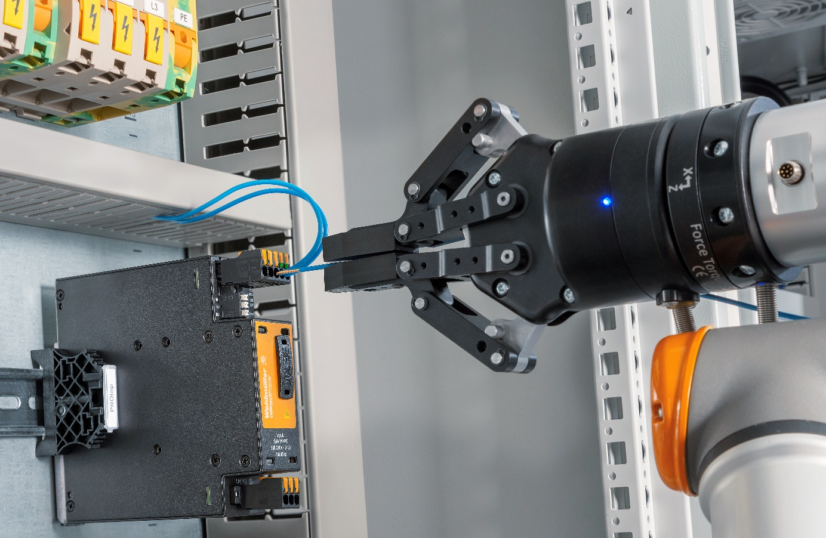
Image caption: OMNIMATE® 4.0 connectors are Ready to Robot
Thanks to the innovative SNAP IN connection system, conductors can be connected as quickly as possible and tool-free – even in fully automated wiring processes

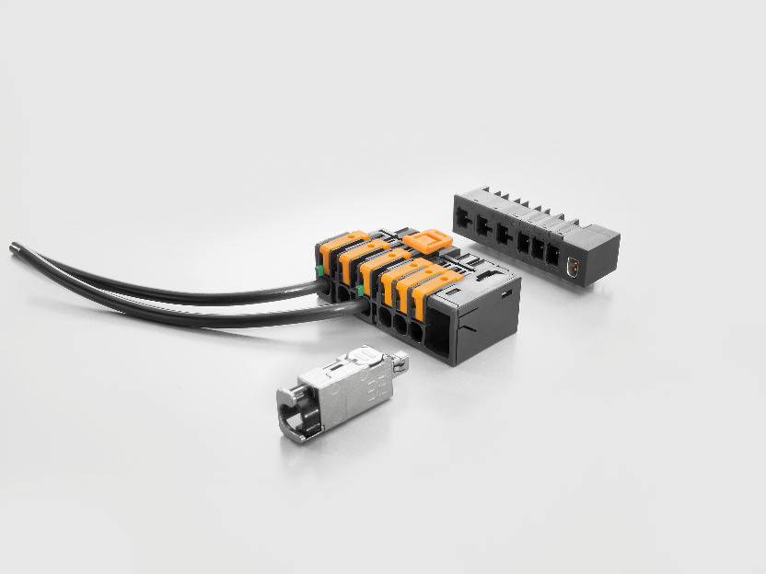
Image caption: Hybrid OMNIMATE® 4.0 connector
The modular product design of OMNIMATE® 4.0 enables power, signal and data transmission, including Single Pair Ethernet, in a single connector
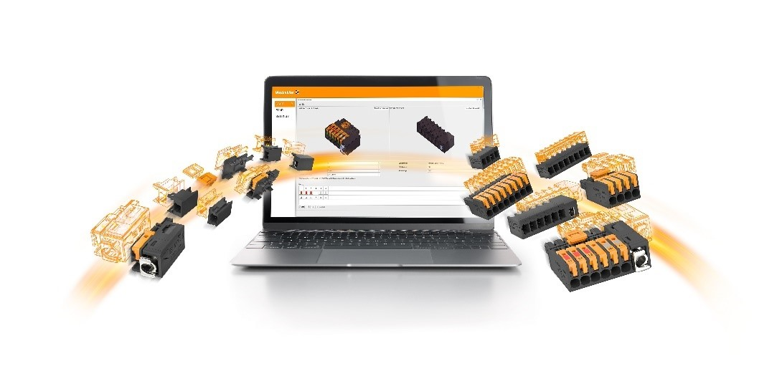
GR_Omnimate_4.0_Wizard_Visual_HA1
Image caption: Simple configuration with the Weidmüller Configurator
A few clicks is all it takes to configure and order individual PCB connectors

Your contact person: Weidmüller Corporate Communications
Tel. +49 (0) 5231 / 14-292322
Email: presse@weidmueller.com

Weidmüller – your partner in industrial connectivity.
The Weidmüller Group has production facilities, marketing companies and representative offices in more than 80 countries. Together with our customers, we shape the digital transformation – with products, solutions and services for Smart Industrial Connectivity and the Industrial Internet of Things. In the fiscal year of 2021, Weidmüller reached sales of 960 million euros with around 5,300 employees.

Responsible for the content: Weidmüller Corporate Communications
Corporate Spokesperson, Sybille Hilker

