edgeML – Weidmüller enables machine learning directly at the controller

With edgeML, industrial users can implement machine learning right at the machine, without a connection to the cloud.

The new edgeML machine learning solution from Weidmüller works independently of cloud and internet access. Learning algorithms can now run directly at the edge – whether in the form of a PLC or IPC. Moreover, the software is available as a Docker container. This means that edgeML is manufacturer-independent and can be used on all standard industrial controllers that support the execution of Docker containers. edgeML can execute various machine learning models and is well-suited for automation engineers. Weidmüller’s no-code approach makes it possible to deploy ML models on a controller with no knowledge of Python or data science.

Creating added value with edgeML

Machine learning directly at the system offers numerous advantages. One of the most important advantages is the local collection, storage and processing of data. Unlike cloud-based ML solutions, the machine or controller does not have to transfer the data to the cloud. Instead, it is processed locally. This allows operators to ensure that sensitive data does not leave the company.
Furthermore, the new ML solution also delivers speed: discrepancies in the production process are detected right at the machine. This speeds up troubleshooting, prevents prolonged downtimes and reduces the production of rejects. At the same time, edgeML reduces costs, as it eliminates the need for cloud licences and fees for data transmission and storage.
Production lines with machines and systems that cannot be connected to the internet for security reasons also benefit from machine learning with edgeML.

easy model creation and customisation

The path to a machine learning model at the edge begins with data collection at the system. Automation engineers or domain experts import this into ModelBuilder, where they can now create ML models based on the data. In the final step, these models are transferred to edgeML.
As edgeML supports the standard ONNX format, users have further options for creating models besides ModelBuilder, such as Python. This allows users to implement machine learning in a familiar environment. edgeML also allows the reuse of existing ONNX models.
If a model no longer performs as desired, it can be easily replaced without having to adjust the communication settings. In this way, edgeML helps make it easier to manage the life cycles of ML models (MLOps). In order to minimise the use of time and resources when creating ML solutions, Weidmüller will also enable the calibration of created models in the future. This function is already available in ModelRuntime. A standard model for a machine family thereby becomes a template whose use can be extended to other machines of the same class. The applied model continues to learn from these machines in order to adapt to the relevant system. This enables the ML models to be scaled and reused as needed.

For use on all systems

Customers who have already integrated an HMI or MS system can also use edgeML via a REST API. For the next stage of development, Weidmüller plans to further improve the accessibility of the product. A connector will overcome the boundaries of fieldbuses and protocols, making edgeML available for use on all systems.

3365 characters including spaces
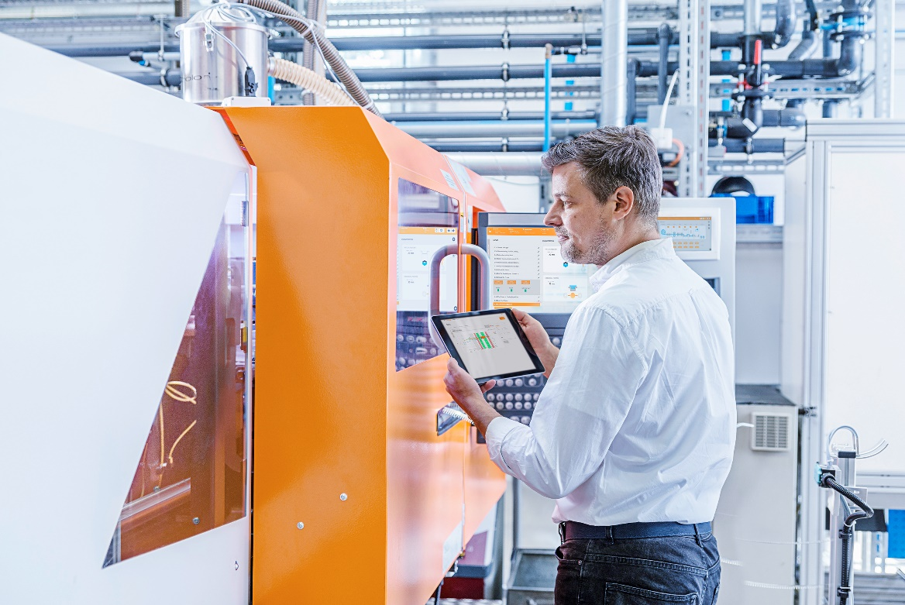
Image caption: edgeML makes machine learning possible right where the data is generated

Your contact person: Weidmüller Corporate Communications
Tel.: +49 5231 14-292322
Email: presse@weidmueller.com

Weidmüller - Your Partner in Industrial Connectivity
The Weidmüller Group has production facilities, marketing companies and representative offices in more than 80 countries. Together with our customers, we shape the digital transformation – with products, solutions and services for Smart Industrial Connectivity and the Industrial Internet of Things. In the fiscal year of 2021, Weidmüller reached sales of 960 million euros with around 5,300 employees.

Responsible for the content: Weidmüller Corporate Communications
Corporate Spokesperson, Sybille Hilker

