Weidmüller presents innovative solutions at WindEnergy Hamburg
Pioneering condition monitoring solutions for wind turbines

WindEnergy Hamburg, which takes place from 24 to 27 September 2024, is considered one of the world's most important trade fairs for the wind industry. As a leading provider of industrial connection solutions and a pioneer in the development of highly specialised monitoring systems for wind turbines, Weidmüller will once again be presenting its latest solution and product highlights in Hall B6, Stand 252, including the BLADEcontrol® condition monitoring system for rotor blades, the BOLTcontrol bolt breakage detection system and the TwinCap® condition monitoring system for rotor blade bearings.

BLADEcontrol® with WebVis - real-time rotor blade monitoring

With BLADEcontrol®, Weidmüller offers one of the world's leading solutions for monitoring the condition of rotor blades. This system enables the early detection of damage and signs of wear, which extends the service life of the rotor blades and significantly increases operational safety. BLADEcontrol® continuously monitors vibrations and recognises anomalies that may indicate structural damage. This reduces unplanned downtime and significantly lowers maintenance costs. The additional SaaS solution WebVis provides plant operators with a real-time overview using customised dashboards.
Read more: BLADEcontrol®

BOLTcontrol - Monitoring system for blade bearing bolts

Broken bolts can have serious consequences for the stability and safety of wind turbines. BOLTcontrol detects broken bolts, enabling timely maintenance work to be carried out. BOLTcontrol also prevents potential damage by holding the bolts in place despite breakage. With BOLTcontrol, nothing stands in the way of the safe and efficient operation as well as continued operation of wind turbines.
Read more: BOLTcontrol

TwinCap® - Reliable monitoring of blade bearings
Alongside rotor blades, the rotor blade bearings and the bolts and nuts installed in them are among the most heavily stressed components of a wind turbine. They are exposed to dynamic forces that can lead to cracks. TwinCap® recognises blade bearing cracks and automatically shuts down the turbine in the event of blade bearing damage in order to prevent major damage such as blade collapse. Early detection means that the blade bearing can be replaced in a planned manner in the event of damage. The TÜV SÜD-certified monitoring system increases the reliability and safety of wind turbines and minimises the risk of unexpected failures.
Read more: TwinCap®

Pioneer for artificial intelligence - strong partnerships for high customer benefit
In addition to product innovations, collaborations also play a key role for Weidmüller. Together with ProTecBird, the company is implementing an AI-based anti-collision system that has been specially designed for wind turbines. This system detects birds using a camera system, tracks their flight path and scares them off in the event of imminent collisions using directional speakers. Weidmüller is responsible for the industrialisation of the systems and develops customer-specific housings for the cameras and speakers that meet the highest safety and reliability standards. The project makes an important contribution to the protection of animal species by preventing collisions between birds and wind turbines.

Another example of successful cooperation is the intensive partnership with Turbit. Weidmüller and Turbit are combining their expertise in rotor blade monitoring and AI-based data evaluation to make the operation and maintenance of wind turbines more efficient and cost-effective. By integrating Weidmüller's BLADEcontrol® data into Turbit's comprehensive software, anomalies in the operating behaviour of the complete wind turbine can be detected at an early stage and preventive maintenance measures can be taken.

Visit Weidmüller at WindEnergy Hamburg and learn more about the company's innovations that increase the efficiency and safety of wind turbines worldwide: Hall B6, Stand 252.

4,061 characters including spaces

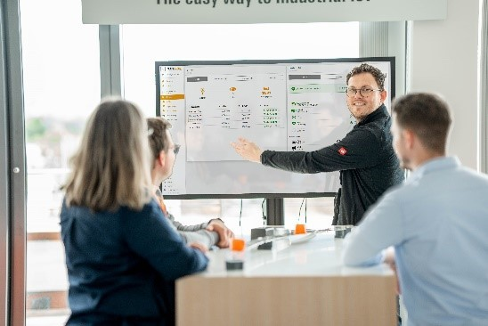
Image caption: The user-friendly dashboards of BLADEcontrol® WebVis enable operators to monitor their systems in real time.

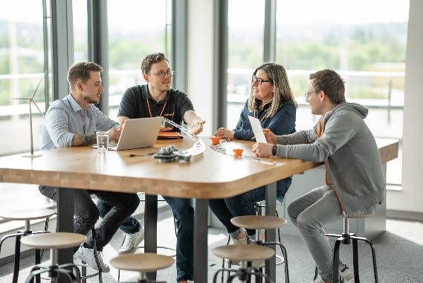
Image caption: The BOLTcontrol bolt breakage detection system prevents potential damage by holding the bolts in place despite breakage.

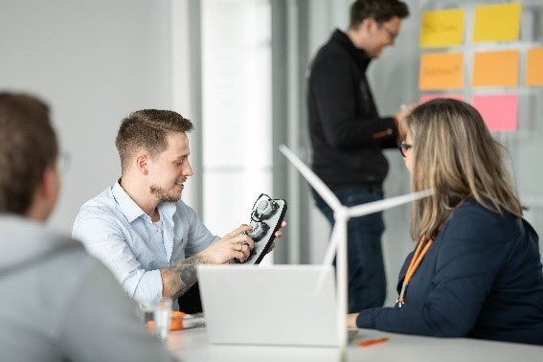
Image caption: The condition monitoring system for rotor blade bearings, TwinCap®, recognises blade bearing cracks and automatically shuts down the turbine.

You are free to use all images. We request that you cite the image source Weidmüller.

The Weidmüller Group
Smart Industrial Connectivity: Electrification, automation, digitalisation, electrical connectivity, electromobility and renewable energies – markets in which Weidmüller feels right at home. The family-owned company established in 1850 has production facilities and sales companies in over 80 countries. As a global player in electric connection technology, Weidmüller achieved a turnover of more than one billion euros in the 2023 financial year with around 6,000 employees worldwide - around 2,000 of whom work at the company's headquarters in Detmold, in the heart of East Westphalia-Lippe, Germany. What Weidmüller lives by: Diversity with respect
Technologies and engagement for a liveable future - Weidmüller demonstrates how it approaches the topic of sustainability in its interactive sustainability brochure.

Your contact person: Weidmüller Corporate Communications
Tel.: +49 5231 14-292322
Email: presse@weidmueller.com

