PV Weather Box optimises the output of the ground-mounted system

Weidmüller's new PV Weather Box can detect from the data whether the weather or a technical fault is slowing the system down.

Let's talk about the weather: clouds, wind and precipitation influence the output of a photovoltaic system, as do the temperature, pressure and humidity of the ambient air. All weather parameters together determine the countable output of the solar cells, not just the intensity and angle of incidence of the sun's rays.

The temperature is therefore crucial. Most solar modules generate the optimum amount of electricity at 25 deg Celsius, and the output drops by half a percent with every degree above that. A cool wind, however, can increase performance again because it lowers the temperature on the surface of the modules, but only if it blows from the right direction. The change in humidity in turn influences the electromagnetic spectrum of solar radiation and thus the energy output of the solar cells. It is therefore necessary to have detailed knowledge of the current weather, particularly for ground-mounted systems. This is the only way to correctly interpret the constantly fluctuating electricity outputs: could it be the weather or a fault?

Juan Francisco Martínez, Head of Global Application Center PV, says: "We have developed the PV Weather Box for ground-mounted systems that regularly measures all weather parameters on site. This enables the SCADA system to calculate if a PV system is operating at its optimum performance in the current weather conditions. If the output falls short of the weather-related output potential, the operator is immediately alerted that a technical error has clearly occurred in the PV power generator that must be promptly resolved.”

However, without the PV Weather Box, the operator has no indication of the influence of the weather on the current electricity output. The operator cannot therefore detect beyond doubt if the ground-mounted system is performing below its potential due to a technical fault. Operators may only discover the problem in a few months' time during the next preventive maintenance work, which is often very costly. Large-scale systems or very remote installation sites, such as in the desert, are particularly expensive. A small loss of output that remains undetected for a long period adds up to a substantial financial loss, especially in the case of large ground-mounted systems.

Weidmüller has rooted the innovative PV Weather Box as an integral part of its proven PV Communication Box for ground-mounted systems to protect its customers from the loss of output trap. The certified housing is extremely robust and provides optimal protection against all weather influences. The integrated power backup guarantees maximum availability of the data, the IP degree of which is certified specifically for outdoor use.

Juan Francisco Martínez, Head of Global Application Center PV emphasises: "Our PV Weather Box is characterised by an excellent price-performance ratio because we build it on a modular basis in accordance with standard references: We equip it to adapt to the customer's environmental conditions, the electrical installations and the type of data transmission used. Our PV Weather Boxes are ready to use, factory certified and meet all the important standards and requirements.”

The Weidmüller product portfolio has a range of weather sensors; after all, the Detmold-based company has been a global pioneer and partner for future-oriented digitalisation and automation solutions in industry for over a decade. The sensors are simply connected to the PV Weather Box via modular I/O cards. It bundles the sensor data and transmits it via the PV Communication Box to the SCADA system, which compares the influence of the weather with the current output of the system in real time.

In addition, all the leading monitoring and SCADA systems and data loggers are fully compatible with this all-in-one PV Communication Box from Weidmüller. The integrated PV Weather Box maximises the financial yield of every PV ground-mounted system, so we’ll never have to talk about the weather again!

4,161 characters including spaces

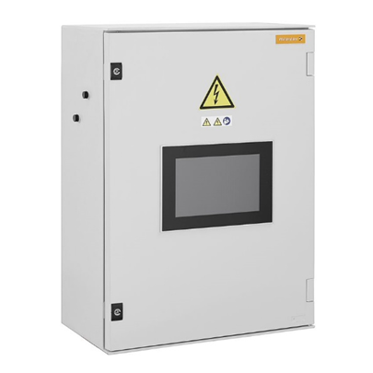

Image caption: PV weather box with optional integrated display
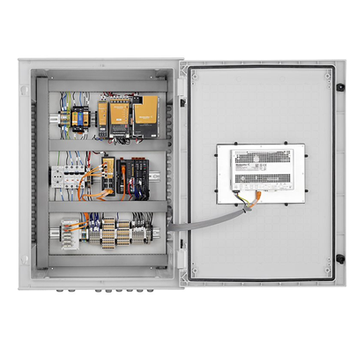
Image caption: The PV weather boxes from Weidmüller are individually equipped according to the needs of the system infrastructure

Your contact person: Weidmüller Corporate Communications
Tel. +49 (0) 5231 / 14-292322
Email: presse@weidmueller.com

Weidmüller – Your Partner in Smart Industrial Connectivity
The Weidmüller Group has production facilities, marketing companies and representative offices in over 80 countries. Alongside its customers, the family-owned company from Detmold is shaping the digital transformation – with products, solutions and services for Smart Industrial Connectivity and the Industrial Internet of Things. In the 2022 financial year, Weidmüller generated sales of more than a billion euros with around 6,000 employees.

Responsible for content: Weidmüller Corporate Communications
Corporate Spokesperson, Sybille Hilker

