The new Klippon® Connect terminal block with the lateral PUSH IN wire connection technology

The new Klippon® Connect terminal block with the lateral PUSH IN conductor connection combines the advantages of PUSH IN and screw connection technology.

The demands on modern industrial plants and machine control systems are constantly increasing, especially when it comes to space requirements and installation in small and flat distribution boxes. Wiring such installations is particularly challenging, as it is often tedious and time-consuming. This calls for special connection technologies that enable safe and efficient wiring in confined spaces. The challenge is to find solutions that reduce space requirements, increase connection safety and simultaneously ensure easy maintenance and repair.

To meet these challenges, Weidmüller’s new Klippon® Connect terminal blocks with the lateral PUSH IN connection offer an innovative solution for efficient and safe wiring in confined distribution boxes. The terminal blocks combine the advantages of proven screw connection technology with the simple and reliable operation of PUSH IN technology. This allows for tool-free, well-organised wiring without a protruding bending radius. The lateral insertion of the conductors into the terminal reduces the installation height and increases the reliability of the connection without having to bend the cable. This enables clearly arranged and space-saving wiring. The clear layout of the lateral conductor entry means that the terminal blocks are accessible for test systems even when wired. At the same time, the convenient PUSH IN connection provides a vibration-proof, gas-tight and permanently reliable connection. If the conductor has to be disconnected again, simply press the pusher on the top of the terminal.
In addition, the markings and functional areas are clearly visible – even when wired.

As a result, installers benefit from easy installation and a fast, error-free maintenance and repair process for the components. In addition, it’s compatible with PUSH IN terminal blocks and a wide range of A-series accessories. This facilitates the duplication of potentials via cross-connections and reduces ordering and storage costs.

Thanks to the advantages of PUSH IN and screw connection technology, the new Klippon® Connect terminal blocks with the lateral PUSH IN connection offer a compact and reliable solution for wiring industrial equipment and machine controls.

2,464 characters including spaces
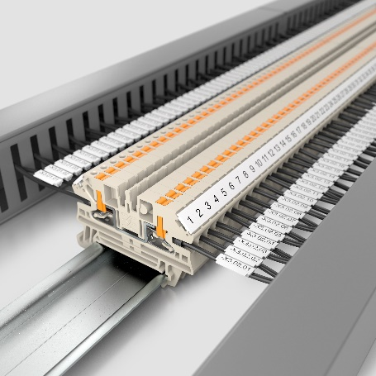
Image caption: The new Klippon® Connect terminal blocks with the lateral PUSH IN connection offer an innovative solution for efficient and safe wiring

Your contact person: Weidmüller Corporate Communications
Tel.: +49 (0) 5231 / 14-292322
Email: presse@weidmueller.com

Weidmüller – Your Partner in Smart Industrial Connectivity
The Weidmüller Group has production facilities, marketing companies and representative offices in over 80 countries. Alongside its customers, the family-owned company from Detmold is shaping the digital transformation – with products, solutions and services for Smart Industrial Connectivity and the Industrial Internet of Things. In the 2022 financial year, Weidmüller generated sales of more than a billion euros with around 6,000 employees.

Responsible for content: Weidmüller Corporate Communications
Corporate Spokesperson, Sybille Hilker

