About Sacher cake, strudel and software

Conditorei Coppenrath & Wiese KG (Coppenrath & Wiese) relies on Weidmüller’s ResMa® software for its energy management needs

Weidmüller GTI Software is equipping Coppenrath & Wiese with the ResMa® energy management system. This system enables the baked goods manufacturer to generate an exact, site-wide overview of its energy consumption. It uses data obtained from production and management to rapidly identify irregular consumption levels and potential areas for reducing energy consumption. Moreover, the ResMa® software for process and energy optimisation also allows the direct evaluation of the effectiveness of measures taken.

Conditorei Coppenrath & Wiese also places great value in reducing its own energy consumption in order to fulfil climate protection as well as to reduce costs. In addition to its use of regional ingredients, the company also gears all its processes and systems towards high energy efficiency. Heat recovery, heat pumps and high-efficiency drives have been employed as standard for years and are improved continuously.
Coppenrath & Wiese has found the right partner in Weidmüller GTI Software. The Weidmüller subsidiary specialises in industrial software solutions. Weidmüller GTI Software offers software services that are highly intuitive to use as well as customisable. “Our previous system did not meet our requirements for user-friendliness. We couldn’t adapt it to our parameters on our own”, explains Jürgen Siegbert, Head of Visualisation, adding: “Then we became aware of the resource management tool from Weidmüller GTI Software. We can work easily with this software, even without a service technician. That’s what won us over.” Furthermore, the functions of the resource management tool go beyond mere energy management. This creates even more added value for Coppenrath & Wiese.

Versatile uses of ResMa®
In addition to its standard use as an energy management system in accordance with DIN EN ISO 50001, the tool can also be used for process optimisation based on production data. A Human Machine Interface (HMI) can also be integrated. ResMa® prepares the data for external evaluation options, allowing AI tools to access it and create smart models.
At Coppenrath & Wiese, more than 680 measuring devices from its production site in Mettingen and logistics centre in Osnabrück send data to the ResMa® energy management system every 15 minutes. This data is transmitted either directly from the meter via the Modbus communication protocol or via various database server systems as a secondary option. ResMa® can provide a customised display of the data collected. The experts at Conditorei Coppenrath & Wiese decide whether values should be read out and displayed for each measuring station or summarised for an entire production line based on the individual circumstances. The software also allows users to flexibly adjust the time interval for regular energy consumption checks. Critical consumption values that must be recorded at shorter intervals are defined in the energy management system. The period for data collection can also be adjusted individually. The data is displayed in tabular form can be transferred to other software, where it can be used for other purposes. This energy management tool gives Coppenrath & Wiese a flexible, demand-based means of evaluating the measured values obtained from production, logistics and administrative processes. The company also uses the visualisation options offered by ResMa®: the reports are summarised in chart form, offering a quick, global overview of the data. This makes it easier for them to identify weak points. A bitmap of the Mettingen site also shows the local position of the meters in the various buildings. This makes it easy to determine where the measuring points are installed.
In addition to this basic function, Conditorei Coppenrath & Wiese uses ResMa® as a process optimisation tool. Energy managers evaluate the reports generated by the software, which allows them to filter out energy-intensive processes in a targeted way. Based on this evaluation, they develop energy-saving strategies. The company’s objective is to reduce energy consumption by 2% annually. ResMa® is an important stepping stone both in achieving this goal and in documenting the progress made towards it.
In addition to the energy management system, Germany’s market leader for frozen tarts, cakes and rolls uses yet another Weidmüller solution: the visualisation tool PROCON-WEB. This software reads control data via protocols such as OPC UA and forwards it to ResMa®. There, the data is automatically integrated into the reports. The result is a full overview of energy consumption in production.

Intuitive, easy-to-install resource management software

Following the successful implementation of ResMa®, the experts at Weidmüller GTI Software offer comprehensive training courses. In these trainings, they offer instruction on all the tool’s functions, enabling their customers to work with the solution on their own. They also provide training in compatible software solutions, such as PROCON-WEB.
The ResMa® resource management software is one of the products recognised by the Federal Office for Economic Affairs and Export Control (BAFA). Companies can receive state funding to purchase the system.
ResMa® is one of numerous solutions and products that Weidmüller offers in the areas of Industrial IoT and automation. The company provides innovative concepts for data acquisition, pre-processing and control, data communication, as well as data visualisation and analysis. “As an ‘enabler from data to value’, we empower our customers to easily digitalise their systems and thus maximise the value they can generate from their data”, explains Dr Thomas Bürger, Head of the Automation Products and Solutions Division at Weidmüller. “Our goal is to offer our customers solutions for the seamless integration of data, thus giving them a competitive advantage in the era of Industry 4.0.”

6017 characters including spaces

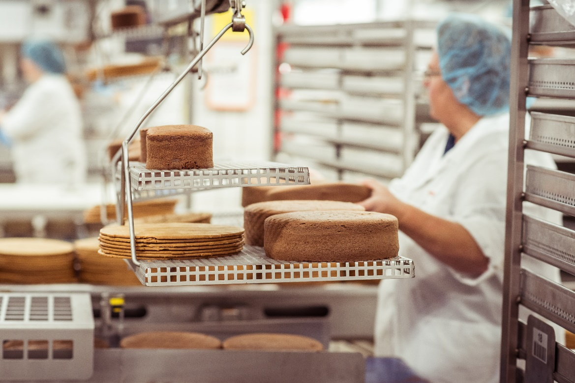Image caption: Baking and refrigerating baked goods requires a great deal of energy – this is where the ResMa® energy management system comes into play

Image rights: Timo Lutz

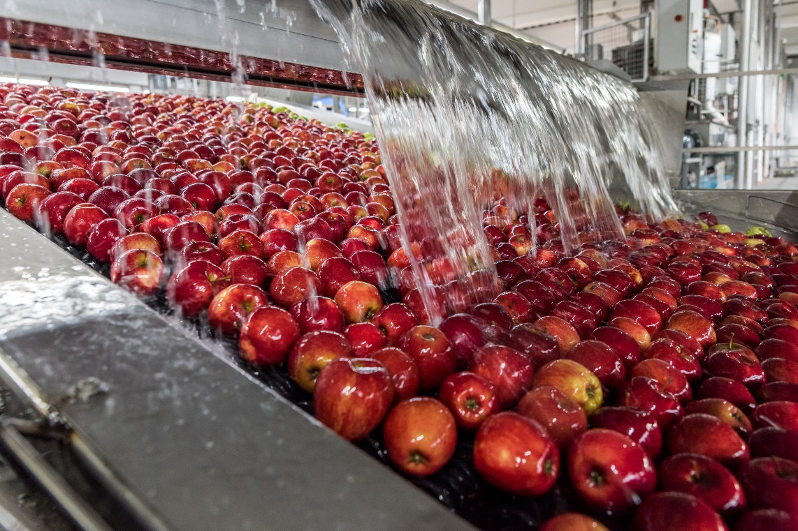
Image caption: Data is also generated during fruit washing operations, and Conditorei Coppenrath & Wiese can also put this data to good use thanks to ResMa®

Image rights: Timo Lutz

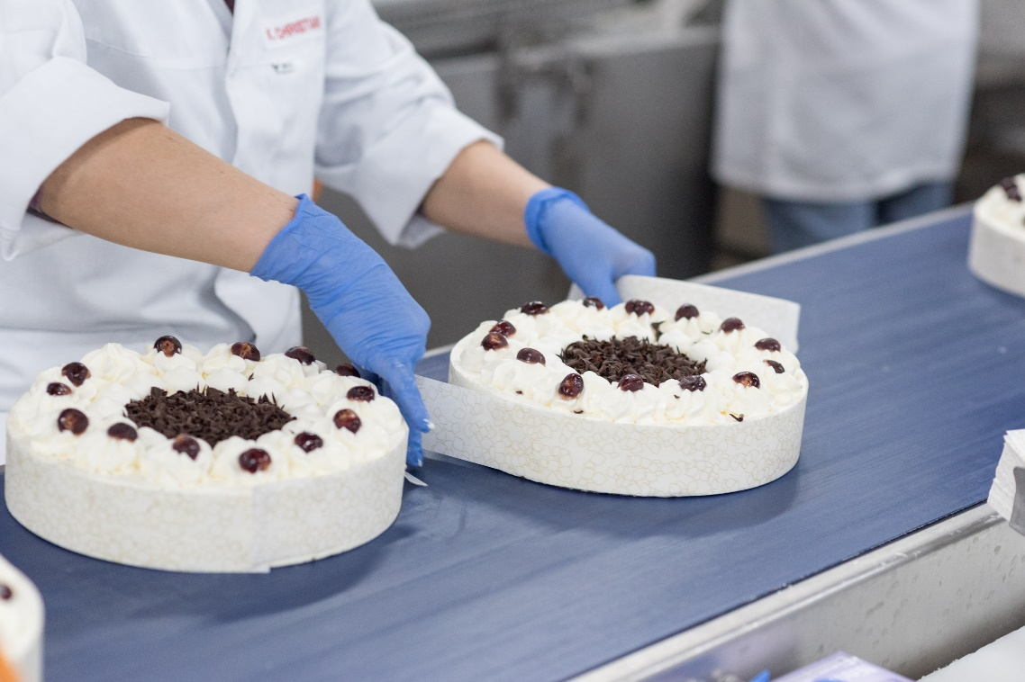
Image caption: At Coppenrath & Wiese, ResMa® is used in conjunction with the PROCON-WEB visualisation tool from Weidmüller – together, the two tools give a full overview of energy consumption in production

Image rights: Timo Lutz

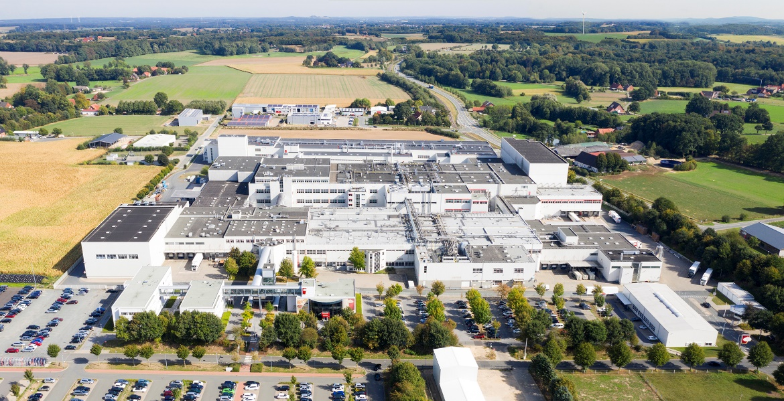
Image caption: Over 680 measuring devices are distributed across five plants at the Mettingen site

Image rights: Conditorei Coppenrath & Wiese

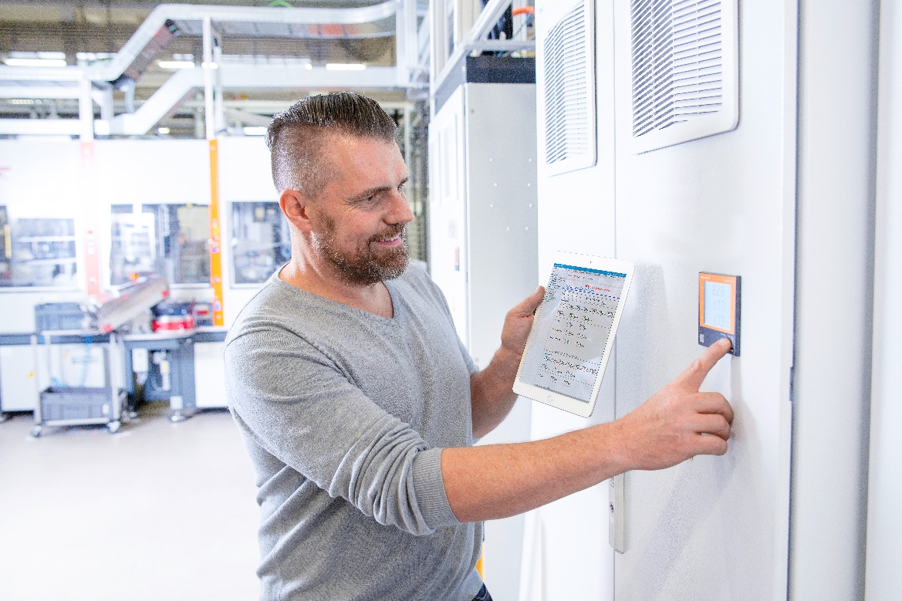
Image caption: ResMa® monitors values from numerous measuring stations and offers visualisation options

Image rights: Weidmüller

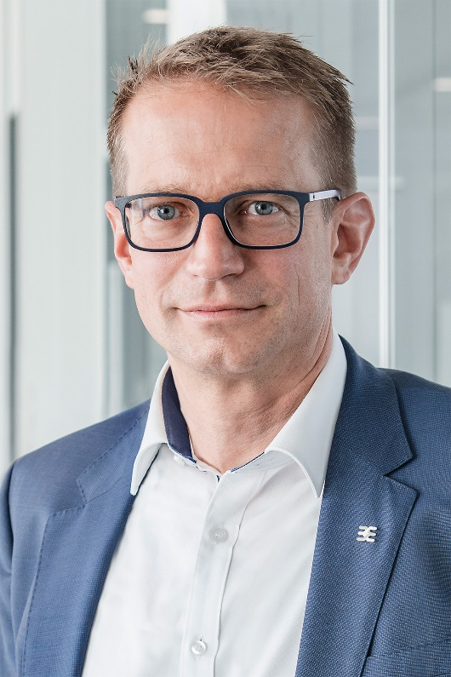
Image caption: Dr Thomas Bürger, Head of the Automation Products and Solutions Division at Weidmüller

Image rights: Weidmüller

The Weidmüller Group
Smart Industrial Connectivity: Electrification, automation, digitalisation, electrical connectivity, electromobility and renewable energies – markets in which Weidmüller feels right at home. The family-owned company established in 1850 has production facilities and sales companies in over 80 countries. As a global player in electric connection technology, Weidmüller achieved a turnover of more than one billion euros in the 2023 financial year with around 6,000 employees worldwide - around 2,000 of whom work at the company's headquarters in Detmold, in the heart of East Westphalia-Lippe, Germany. What Weidmüller lives by: Diversity with respect
Technologies and engagement for a liveable future - Weidmüller demonstrates how it approaches the topic of sustainability in its interactive sustainability brochure.

Your contact person: Weidmüller Corporate Communications
Tel.: +49 5231 14-292322
Email: presse@weidmueller.com

