Consulting that works: B&F Elektro GmbH successfully optimises processes
Tap into efficiency potential with Connectivity Consulting from Weidmüller and sustainably optimise production processes in line with Industry 4.0.

Efficiency through structure and consulting
B&F Elektro GmbH, a modern electrical engineering company for switchgear and control systems, is breaking new ground together with the Connectivity Consulting experts at Weidmüller. Together, the two companies have initiated a structured maturity analysis to assess and further develop B&F’s production processes. The analysis provided comprehensive documentation which not only provided a detailed snapshot of the current situation, but also enabled our experts to propose practical, tailor-made solutions. By later participating in the Workplace Solutions Days and an in-depth workshop, the B&F team received concrete input on workplace optimisation, automation and digital integration. The concrete solutions developed through the partnership are now being implemented step by step, with the first measures already successfully put into practice. For example, the warehouse and material supply have been reorganised, resulting in significantly improved availability and reduced search times. As part of the project, the workstations were purposefully redesigned, including the introduction of a digital model workstation. This serves as hands-on test environment where employees can try out the transition from analogue to digital processes for themselves. This makes the transformation tangible, actively involving the entire team in the process. Driven by the positive experiences to date, further workplace redesigns are planned for the future.

Assembling, marking and wiring
Decoupling preparatory tasks not only boosts efficiency, but also makes staff deployment more flexible.
Thanks to pre-assembled workstations and clearly structured material provision, time-consuming searches are completely eliminated – a significant improvement that employees are keen to point out. Another key element was the conversion of conductor pre-assembly through the automation of work processes: trained workers now pre-assemble cable harnesses using the Weidmüller CRIMPFIX R VARIO. After subsequent inspection, this reduces the wiring time for skilled employees by 20 to 30 per cent. At the same time, material provision has also been optimised: instead of the previous manual assembly of wiring material by electrical designers, logistics personnel now provide project-related, pre-assembled trolleys. This process conversion has led to an efficiency increase of up to 80 per cent – especially in wiring, where the work required has been significantly reduced.
“The results we have achieved inspire a desire for more, strengthening our drive as a team to continuously improve efficiency”, says Henny Nannen-Wolle, Managing Director at B&F. A further efficiency gain was achieved by digitalising the marking process. By using ECAD data and the M-Print® PRO marking software, the time required for the manual creation of labels can be reduced by around 50 per cent with just a few mouse clicks.

Involving every employee
The change processes at B&F are shaped together with employees and can be harnessed to enhance the company’s future competitiveness. This participatory approach is proving effective: more and more employees are independently contributing suggestions for improvement and want to play an active role in the company’s future. The optimisations are intended not to save on labour, but to maintain competitiveness. Greater efficiency makes processes more effective, which in turn enables more competitive pricing – giving B&F a clear advantage in the market. Thanks to its collaborative partnership with Weidmüller, B&F has been able to develop new, efficiency-boosting approaches and successfully put them into practice.
3,890 characters including spaces

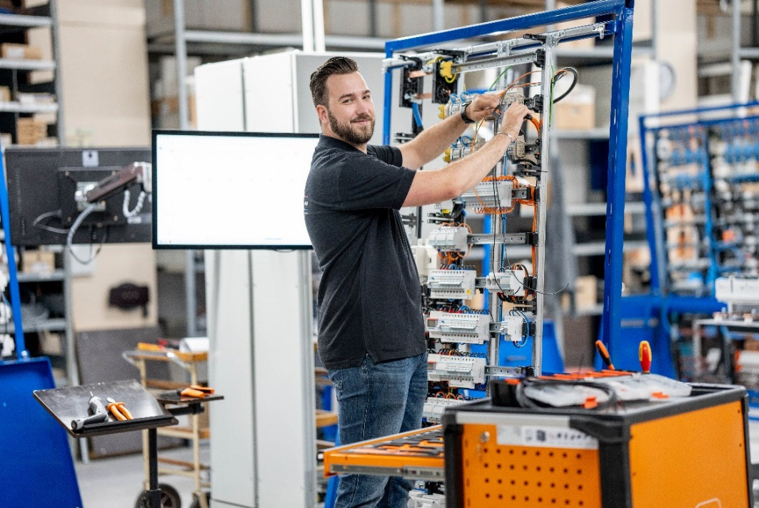
Image caption: The work required for wiring could be reduced by up to 80 per cent.

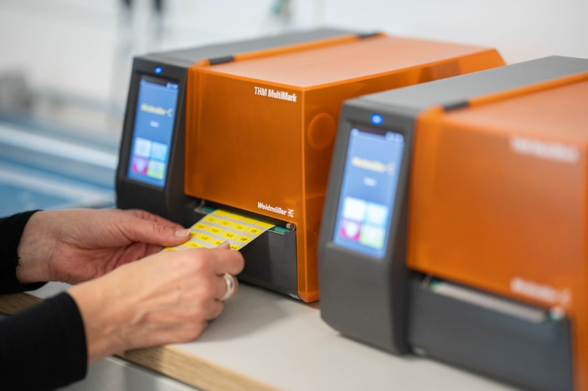
Image caption: No driver installation is required. The THM MultiMark and THM MultiMark Plus are integrated directly via the M-Print® PRO software.

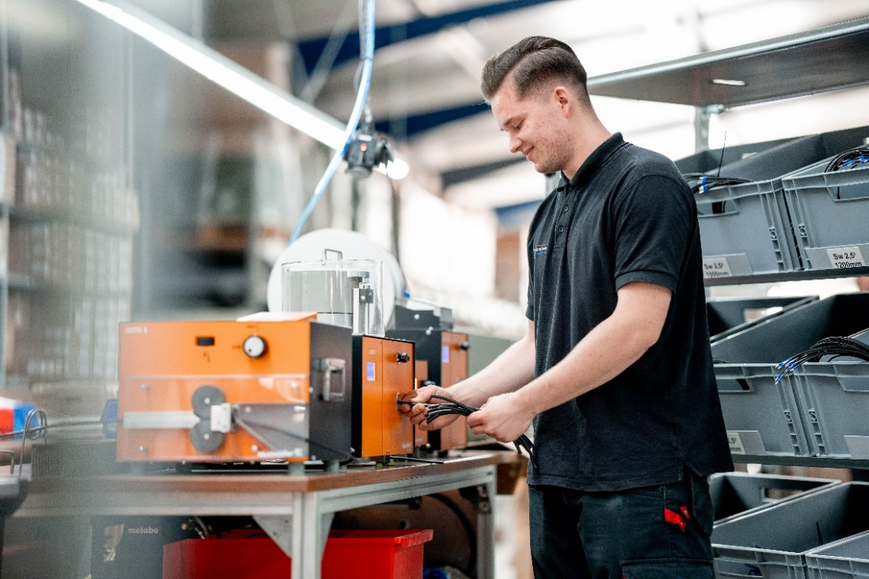
Image caption: Weidmüller machines CUTFIX S, CA 100, Powerstripper 6.0 and CRIMPFIX R VARIO significantly accelerate the production process while ensuring the highest quality standards.
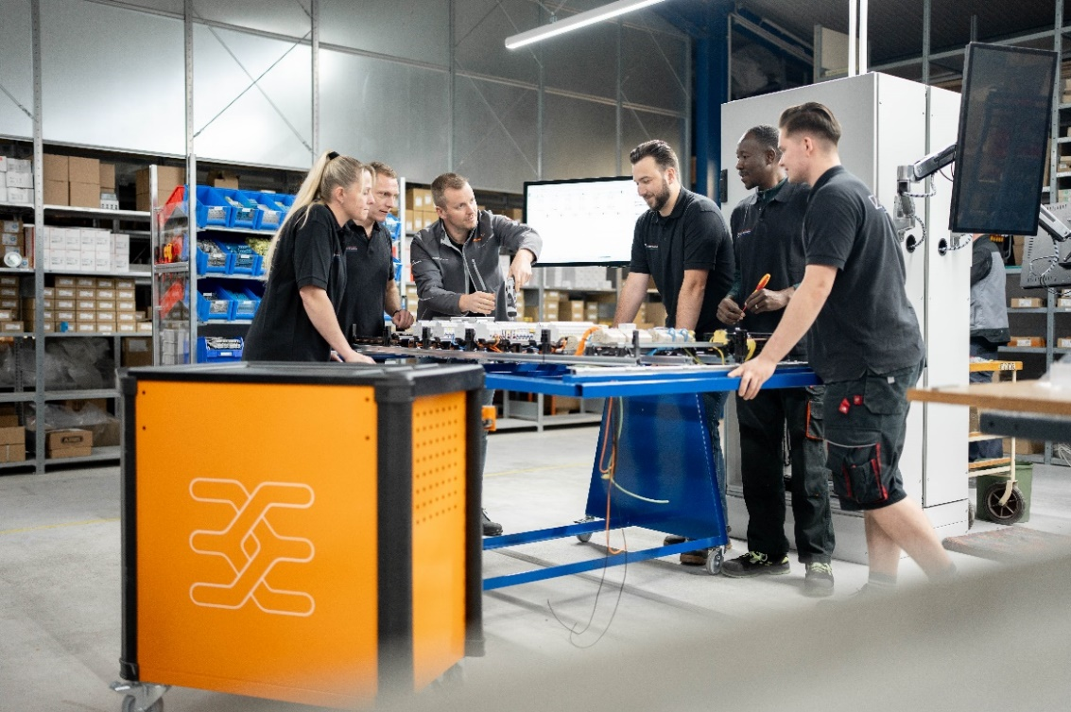
Image caption: Thanks to its collaborative partnership with Weidmüller, B&F has been able to develop new, efficiency-boosting approaches and successfully put them into practice.

You are free to use all images. We request that you cite the image source.

You can download all images in high quality via the following link: Weidmüller Pressemitteilung_Referenz B und F

The Weidmüller Group
Smart Industrial Connectivity: Electrification, automation, digitalisation, electrical connectivity and renewable energies – markets in which Weidmüller feels right at home. The family-owned company established in 1850 has production facilities and sales companies in over 80 countries. As a global player in electric connection technology, Weidmüller achieved a turnover of almost one billion euros in the 2024 financial year with around 5,700 employees worldwide - around 2,000 of whom work at the company's headquarters in Detmold, in the heart of East Westphalia-Lippe, Germany. What Weidmüller lives by: Diversity with respect.
Technologies and engagement for a liveable future - Weidmüller demonstrates how it approaches the topic of sustainability in its interactive sustainability brochure.

Your contact person: Weidmüller Corporate Communications
Marc Ladermann, Head of Corporate Communication
Tel.: +49 5231 14-292322
Email: presse@weidmueller.com

