Cooperation for bird protection: Weidmüller and ProTecBird optimise wind turbines
Weidmüller assembles customised enclosures for ProTecBird's AI-based anti-collision system

The partnership between Weidmüller and ProTecBird sets new standards in the field of bird protection and renewable energies. The focus is on the development and implementation of a customised, AI-based anti-collision system designed specifically for wind turbines. This cooperation shows how technological innovation and environmental awareness can go hand in hand to promote both the expansion of wind energy and the protection of wildlife.

ProTecBird specialises in species and environmental protection. With its AVES systems, the company offers innovative, AI-based solutions. AVES Wind Onshore uses an AI-based camera system to detect birds, track their flight path and, if a collision is imminent, set the rotor blades of the wind turbines into idle mode until the bird leaves the area again. This approach enables an effective reduction in bird strikes and at the same time contributes to accelerating the use of renewable energies.
In the offshore sector, AVES Monitoring offers a powerful tool for collecting and analysing avifaunistic data. This comprehensive data collection enables the creation of precise risk models in order to fulfil official requirements in a correct manner.
Furthermore, ProTecBird contributes to the flight safety of aircraft taking off and landing with AI-based and fully automated deterrence systems and protects industrial buildings, power plants, offshore facilities and football stadiums from pollution and damage caused by birds.

Industrial implementation by Weidmüller

In close cooperation with ProTecBird, Weidmüller is responsible for the industrialisation of the current systems. The specific requirements of the onshore and offshore wind industry are the guiding principles here. Weidmüller is contributing its expertise in mechanical and electrical design to develop a modular system that meets the specific requirements of the wind energy industry.

Customised Weidmüller enclosures for the highest demands

Among other things, the collaboration aims to develop stainless steel enclosures for ProTecBird's camera system and speakers, which are equipped with Weidmüller products according to the individual requirements of ProTecBird. For example, the modular u-control controller for industrial automation and IoT applications is utilised. u-control is one of the most compact and modern control systems on the market.
The powerful I/O system u-remote is also installed in the enclosures. The modular and space-saving system impresses users with its intuitive handling on both the software and hardware level.
Remote maintenance is made possible by Weidmüller's Industrial Security Router u-link. Industrial Ethernet, power supply units and connection technology complete the range of products used.

These customised solutions guarantee a high level of reliability as well as maximum functionality. Extensive tests are carried out to ensure that the enclosures meet the highest standards, including tests for electromagnetic compatibility (EMC) and saltwater resistance as well as IP protection class certifications.

Responsibility and progress for the wind industry

The partnership between Weidmüller and ProTecBird not only promotes the protection of species, but also clears the way for a faster growth of wind energy. This co-operation impressively demonstrates how innovative approaches and strong partnerships can help to master the challenges of the future and at the same time demonstrate ecological responsibility.

Image caption: A DC microgrid is connected to the AC supply network as an independent grid and includes various DC sectors

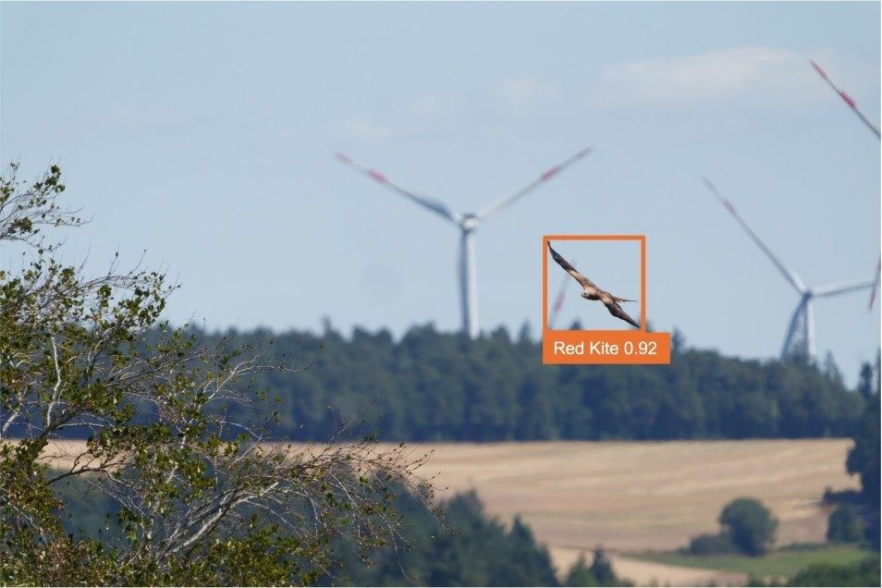
Image caption: Visualisation of bird detection by AVES Wind anti-collision system with species recognition AI with indication of probability
(© Photo: Manfred Stöber; Photomontage ProTecBird)
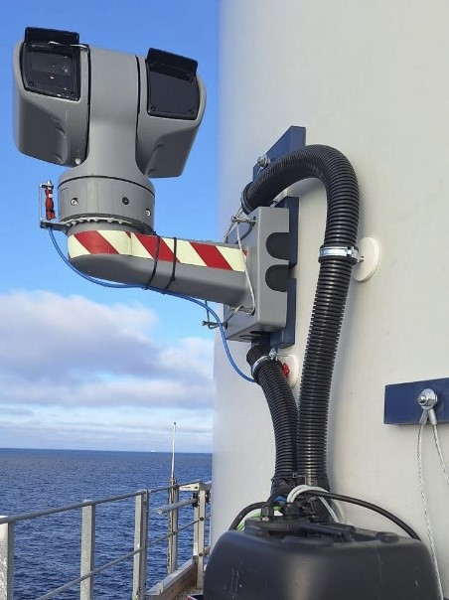
Image caption: AVES Monitoring Offshore enables the detailed monitoring and analysis of bird migration
(© Photo: ProTecBird)

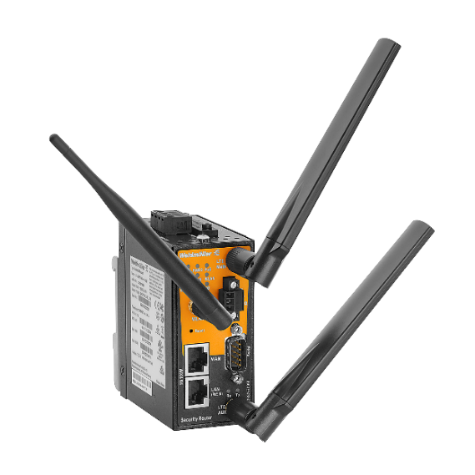
Image caption: The u-link remote access service from Weidmüller enables simple and secure remote maintenance
(© Photo: Weidmüller)

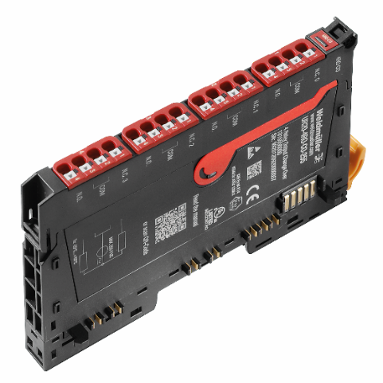
Image caption: Weidmüller's modular, space-saving and powerful I/O system u-remote
(© Photo: Weidmüller)

You are free to use all images. We request that you cite the image source accordingly.

The Weidmüller Group
Smart Industrial Connectivity: Electrification, automation, digitalisation, electrical connectivity, electromobility and renewable energies – markets in which Weidmüller feels right at home. The family-owned company established in 1850 has production facilities and sales companies in over 80 countries. As a global player in electric connection technology, Weidmüller achieved a turnover of more than one billion euros in the 2023 financial year with around 6,000 employees worldwide - around 2,000 of whom work at the company's headquarters in Detmold, in the heart of East Westphalia-Lippe, Germany. What Weidmüller lives by: Diversity with respect
Technologies and engagement for a liveable future - Weidmüller demonstrates how it approaches the topic of sustainability in its interactive sustainability brochure.

Your contact person: Weidmüller Corporate Communications
Tel.: +49 5231 14-292322
Email: presse@weidmueller.com

