Technology partnership for greater customer benefit

Improving production efficiency and quality in control cabinet building is a common pursuit of Weidmüller and Eplan. To achieve this goal, both companies are working on the best possible integration of their interfaces and data models. This has resulted in a technology partnership that was sealed in 2022 as part of the Eplan Partner Network and has now been announced at the Hannover Messe.

Hanover/Detmold/Monheim, 19 April 2023 – For many years, control cabinet and switchgear manufacturers have been confronted with a variety of challenges. In addition to the continuing shortage of trained specialists, cost and time pressure for lead times and tests, customer expectations regarding flexibility and change management as well as the new requirements for climate neutrality, sustainability and the circular economy are areas in which the industry must keep pace. Furthermore, it must meet the demands for increasingly individual solutions and often realise flexible batch-size-1 production.

For many years, Weidmüller has been supporting the industry with proven solutions and innovative engineering concepts, such as the Weidmüller Configurator WMC, in order to meet the diverse requirements. The extended partnership with Eplan as part of the Eplan Partner Network is based on a clear objective: to improve data quality and expand data models for automated and efficient control cabinet building.

Volker Bibelhausen, Spokesman of the Executive Board and Chief Technology Officer at Weidmüller, explains: "The technology partnership with Eplan aims to develop forward-looking data models and interfaces for better digital consistency along the process chain and greater automation of control cabinet building. At the same time, it strengthens the circle of companies that coordinate the core digital technologies for Industry 4.0 in the working groups under the auspices of ZVEI and VDMA."

To achieve this goal, Weidmüller uses the ECLASS Advanced format for its data, converts it to the Eplan Data Standard and makes all data available in the Eplan Data Portal. Weidmüller is also developing connectors to be able to control the company's own software systems, such as the M-Print Pro labelling and marking software, directly from Eplan. The web-based engineering tool WMC will also include wizards to help the user find the right and approved product and components in a solution-oriented manner.

From the planning to the approval of a control cabinet, logistical planning and the control of production processes are of crucial importance. An acceleration of assembly can be achieved if pre-assembled terminal strips are used and the continuous marking of components and conductors is implemented. But also the assembly of cable harnesses and the implementation of a partially or fully automated production line require more precise data models in order to safely control the processes and achieve high product quality. Sebastian Seitz, CEO of Eplan, sums up: "This optimisation of data as well as workflows enables more precise control of production processes and improves production efficiency and quality for the customer."

3,188 characters including spaces

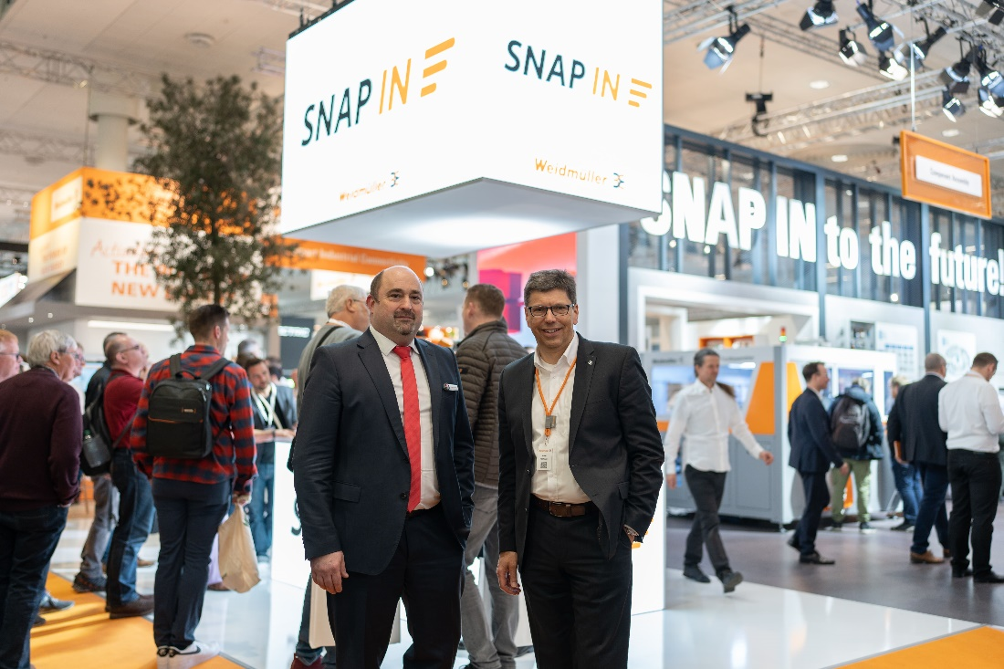

Image caption: Volker Bibelhausen, Spokesman of the Board and Chief Technology Officer at Weidmüller (r.) and Sebastian Seitz, CEO of Eplan (l.) are looking forward to the cooperation as part of the Eplan Partner Network, which will create a synergy of innovation, expertise and experience for greater customer benefit.

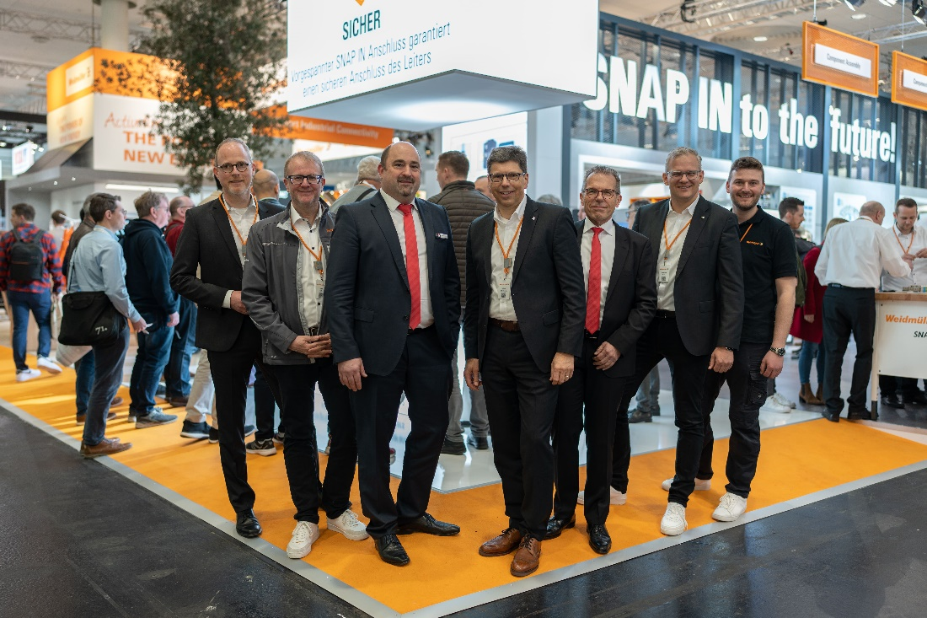

Image caption: Pleased about the cooperation: (f.l.t.r.): Arnd Schepmann, Head of Division Cabinet Products at Weidmüller, Frank Polley, Head of Cabinet Products Business Development at Weidmüller, Sebastian Seitz, CEO of Eplan, Volker Bibelhausen, Vorstandssprecher und Technologievorstand of Weidmüller, Dieter Pesch, Bereichsleiter F&E und Produktmanagement at Eplan, Dr. Sebastian Durst, Vorstand Operations of Weidmüller, Vincent Vossel, Team Leader Business Development Management at Weidmüller

Copyright: Weidmüller and Eplan

Your contact: Weidmüller Corporate Communications
Tel. +49 (0) 5231 / 14-292322
E-Mail: presse@weidmueller.com

Weidmüller - Your Partner in Smart Industrial Connectivity

The Weidmüller Group has production facilities, marketing companies and representative offices in more than 80 countries. With our customers, we shape the digital transformation – with products, solutions and services for Smart Industrial Connectivity and the Industrial Internet of Things. In the fiscal year of 2022, Weidmüller reached sales of more than 1 billion euros with around 6,000 employees.

Responsible for content: Weidmüller Corporate Communications
Corporate Spokesperson, Sybille Hilker

