New partnership for cyber consulting
Orange Cyberdefense and Weidmüller work together for security consulting

The French company Orange Cyberdefense and Weidmüller, the international specialist for electronics and connection technology based in Detmold, Germany, announced their strategic partnership in the field of cybersecurity consulting at the Smart Production Solutions (SPS) 2024 trade fair. The aim of the collaboration is to provide manufacturing companies with easier access to comprehensive cybersecurity consulting services.

The increasing convergence of information technology (IT) and operational technology (OT) is creating new opportunities for the manufacturing industry. By analysing machine data, advanced applications such as machine learning, condition monitoring and predictive maintenance can be implemented. These innovations enable companies to increase the efficiency of their production processes while reducing costs.

However, the growing interconnectedness of the production floor is also creating new challenges. Formerly isolated OT systems are increasingly being connected to the IT infrastructure, which is bringing the issue of cyber security more and more to the fore. As a result, there is a growing need for safeguards to ensure the security of production environments. Regulatory requirements such as NIS2 and the CRA oblige companies to protect their IT and OT networks more effectively and to harden their products against attacks.

Under the guiding principle ‘Enabler from data to value’, Weidmüller supports its customers in realising innovative solutions. The company offers a comprehensive portfolio of hardware and software solutions for the Industrial Internet of Things (IIoT) and automation technology. Weidmüller has entered into a strategic partnership with Orange Cyberdefense to offer its customers the best possible support in the area of cyber security. This cooperation expands the existing portfolio to include security consulting for machines and the IT/OT corporate infrastructure.

As a member of the Weidmüller partner network, Orange Cyberdefense supports customers in implementing security measures in their machines or production facilities and offers comprehensive advice on security lifecycle management. In addition, Orange Cyberdefense’s Security Operation Centres (SOC) offer continuous 24/7 monitoring of systems and facilities.

Orange Cyberdefense is the expert cybersecurity business unit of the Orange Group, providing consulting, solutions and services to organizations around the globe. As Europe’s go-to security provider, Orange Cyberdefense strives to protect freedom and build a safer digital society.
Orange Cyberdefense is specialized in threat research, intelligence-driven, offering unparalleled access to current and emerging threats. With a 25+ year track record in information security, 250+ researchers & analysts and 18 SOCs distributed across the world, Orange Cyberdefense is offering global protection with local expertise.

By partnering with Orange Cyberdefense, Weidmüller is expanding its IIoT partner network with an essential partner in the field of cyber security. Together, the companies aim to support the manufacturing industry in securing their production environments and ensuring compliance with legal requirements such as the EU NIS2 Directive, the Cyber Resilience Act (CRA) and the EU Machinery Regulation (MVO).

3409 characters including spaces

All images are free to use.

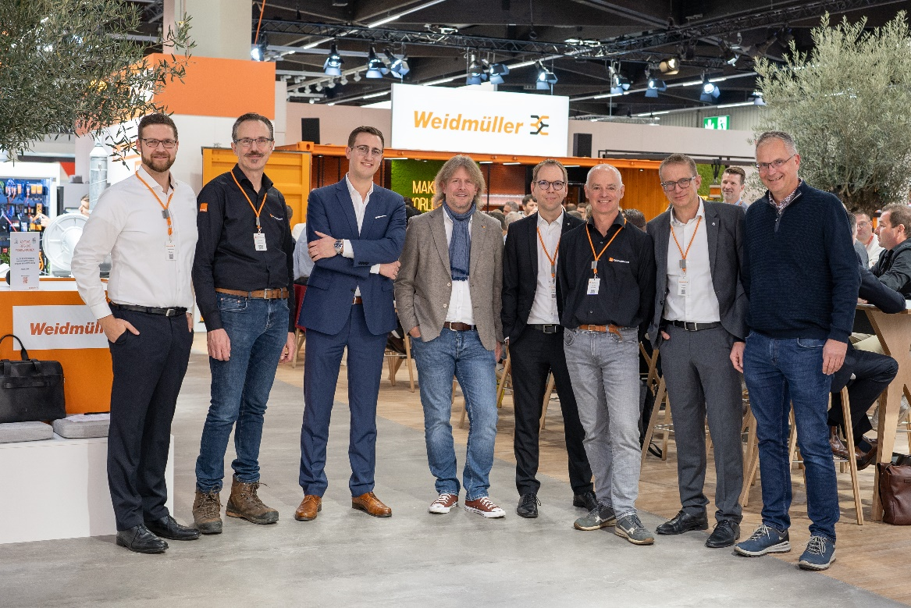
Image caption: f.l.t.r: Sebastian Stelzer, Group Lead Product Management Industrial Ethernet (Weidmüller); Jeroen Wijnands, Manager OT Security Netherlands (Orange Cyberdefense); Leon Theis, Sales Manager (Orange Cyberdefense); Ralf Czekalla, Head of Business Development (Orange Cyberdefense); Dr. Björn Griese, Head of Product Security (Weidmüller); Marcel Hulsen, Enterprise Security Architect (Orange Cyberdefense); Dr. Thomas Bürger, Executive Vice President Automation Products and Solutions (Weidmüller) und Klaas Wijbenga, Automation Sales Engineer (Weidmüller) announce the strategic partnership at SPS trade fair in Nuremberg, Germany

The Weidmüller Group
Smart Industrial Connectivity: Electrification, automation, digitalisation, electrical connectivity, electromobility and renewable energies – markets in which Weidmüller feels right at home. The family-owned company established in 1850 has production facilities and sales companies in over 80 countries. As a global player in electric connection technology, Weidmüller achieved a turnover of more than one billion euros in the 2023 financial year with around 6,000 employees worldwide - around 2,000 of whom work at the company's headquarters in Detmold, in the heart of East Westphalia-Lippe, Germany. What Weidmüller lives by: Diversity with respect.
Technologies and engagement for a liveable future - Weidmüller demonstrates how it approaches the topic of sustainability in its interactive sustainability brochure.

Your contact person: Weidmüller Corporate Communications
Tel.: +49 5231 14-292322
Email: presse@weidmueller.com

