New versions for u-OS

Weidmüller's operating system is being expanded

Weidmüller launched the u-OS operating system for the SPS exhibition last year. When it was launched, it already enabled efficient data pre-processing and precise control directly at the machine. A year later, the company is expanding the functions of the operating system.

Hardware-independent
The boundaries between different classes of devices are disappearing quickly. Controllers, Edge PCs, routers and gateways work together better to operate systems. Weidmüller is expanding the availability of u-OS for the different classes of devices step by step. After starting with the u-control 2000 controller, on which u-OS ran for the launch, the company has followed with the modular controller and Edge systems u-control M3000 and M4000.
Thanks to the open design of the operating system, in the future it will be possible to install u-OS on generic hardware based on ARM© SystemReady and Intel x86. The “Community Edition”, for example, will be available for the single-board computer Raspberry Pi in the future. It will be offered for download from the Weidmüller website. Its simple handling makes it possible to install apps from many different users on the Raspberry Pi.
For machine construction, u-OS means independence. Because u-OS is compatible with generic hardware, in the future machine builders will be able to implement a multi-supplier strategy. This secures delivery capabilities, and saves costs.
Users building on OEM-specific hardware can talk to experts from Weidmüller. Customers can independently adapt u-OS for their hardware using the “Developer Edition”. The Weidmüller team is available to provide support.

Software, cloud, and on-premise
u-OS is designed to be a platform, not another ecosystem. Because of this, it is possible to integrate different kinds of software. Cloud and on-premise solutions can be integrated, in addition to AutoML tools and visualisation software. This is the case for Weidmüller apps as well as applications from Weidmüller’s partners. In addition, the open design of the operating system allows users to integrate their own systems as well. APIs and container technology serve as the basis. The u-OS Data Hub serves as the foundation for interactions between the different applications. The Data Hub makes it possible for users to create their own solution even without programming expertise.
u-OS also offers freedom for developers. Users who want to develop their own software can integrate it into the u-OS via container technology. This also includes on-premise systems, making it possible for users to create their systems to meet their individual needs.

The easy way to Industrial IoT & Automation
Weidmüller sees itself as an enabler, a facilitator on the simple path to industrial IoT and automation. The company’s goal is to enable its customers to take the easiest route to automated production and make the smart factory a reality. In doing so, the company works to preserve the flexibility and independence of its customers.

3057 characters including spaces

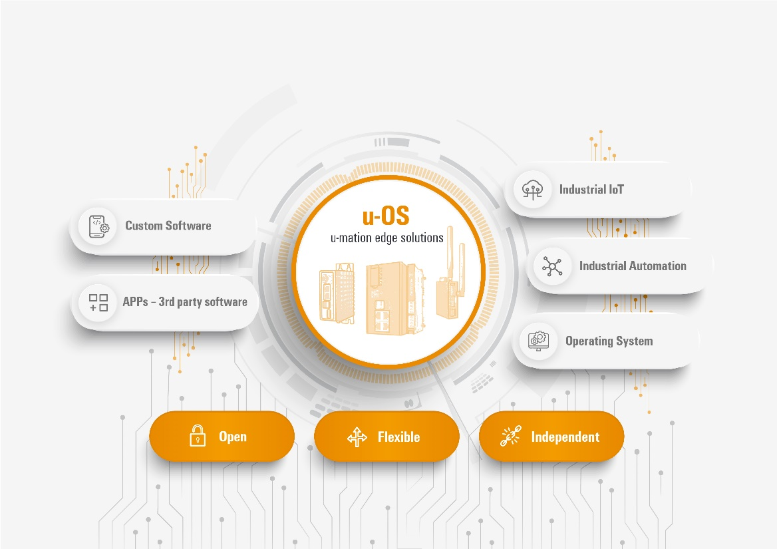
Caption: u-OS combines customised software with industrial IoT and automation technology

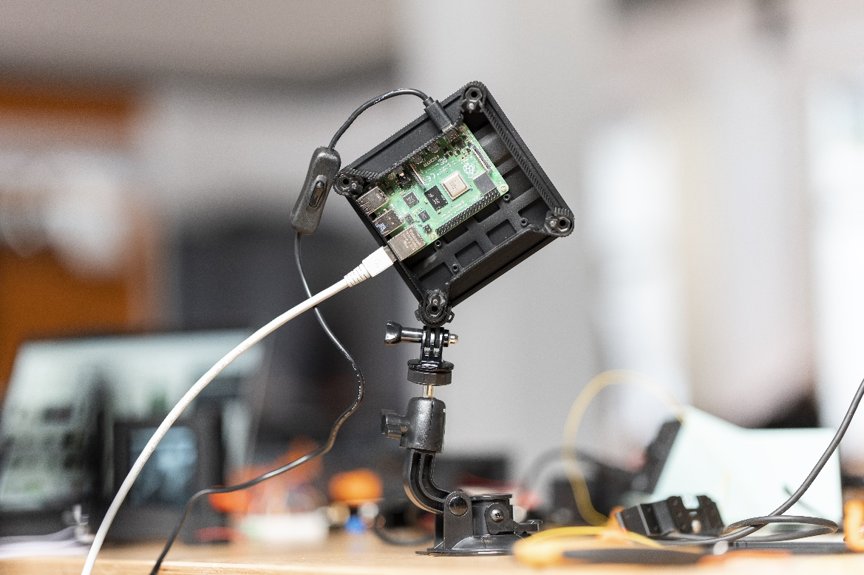
Caption: u-OS will be available for Raspberry Pi, including a Community Edition for private users

You are free to use all images. We request that you cite the image source.

The Weidmüller Group

Smart Industrial Connectivity: Electrification, automation, digitalisation, electrical connectivity, electromobility and renewable energies – markets in which Weidmüller feels right at home. The family-owned company established in 1850 has production facilities and distributors in over 80 countries. As a global player in electrical connectivity, in 2023 Weidmüller reported revenue in excess of one billion euros with around 6,000 employees worldwide – approx. 2,000 of whom are located at the headquarters in Detmold in the heart of Ostwestfalen-Lippe, Germany. What Weidmüller lives by: Diversity with respect.

Technologies and engagement for a liveable future – Weidmüller demonstrates how it approaches the topic of sustainability in its interactive sustainability brochure.

Contact:
Weidmüller Corporate Communications
Company Spokesperson, Sybille Hilker
Tel.: +49 (0)5231 / 14-292322
Email: presse@weidmueller.com

