Weidmüller BOLTcontrol – New monitoring system for detecting bolt breakage in wind turbines
Reliably detect broken bolts on blade bearings and prevent subsequent damage

Efficiency, system availability and profitability are crucial for operating wind turbines. Condition monitoring systems continuously generate turbine data, helping to ensure uninterrupted operation. With BLADEcontrol® (rotor blade monitoring) and TwinCap® (screw monitoring for blade bearings), the electrical engineering and connection technology company Weidmüller already offers two monitoring solutions. Now, they have added another new product innovation: BOLTcontrol bolt breakage detection for wind turbines.

BOLTcontrol is a monitoring system developed for wind turbines. It uses special detection plates to detect broken bolts on blade bearings in real time. Moreover, BOLTcontrol prevents potential damage by holding the bolts in place even if they break. The innovative technology behind the system is the product of intensive research and development work and aims to optimise the safety and operation of wind turbines – both onshore and offshore.

Added value in many areas
Flexibility is a key advantage of BOLTcontrol: the system is available for different turbine types, can be retrofitted quickly and easily and offers various interfaces to alert the operator or operations manager of a broken bolt. Further benefits of BOLTcontrol include:

• Minimisation of downtimes: timely detection of broken bolts minimises downtime by preventing major damage to the turbine.
• Reduction in repair costs: BOLTcontrol prevents subsequent damage, thereby reducing expenditures for repairs.
• Cost-effective further operation of existing turbines: the system fulfils the requirements for blade bolt inspections made in the scope of continued operation reports while eliminating the need for expensive bolt replacements and time-consuming on-site inspections of the bolts.

“Bolt breakage on blade bearings happens more and more often the older a wind turbine gets. Our BOLTcontrol system offers wind farm operators a way to lower the risk of damage to hydraulic or electrical lines caused by a broken bolt flying around in the rotating hub”, says Hans Schlingmann, Head of IIoT & Automation Consulting at Weidmüller, adding: “This simply makes the turbines safer to operate.”

Meet the requirements of continued operation reports with BOLTcontrol
The system also helps to reduce costs for wind turbines operated after the end of their intended service life, which is typically between 20 and 30 years. Once the certified service life has expired, operators have the option of commissioning a continued operation report. This report requires the inspection of components related to the stability of the turbine. The rotor blade bolts are listed as critical components in almost all continued operation reports, as these have usually reached the end of their service life at the time of inspection due to the dynamic loads to which they are exposed. In this case, the operating company has the choice of two options: either have all bolts replaced completely as a preventive measure or commission extensive on-site inspections of the blade bolts in order to detect possible damage. To carry out these measures, the turbine has to be stopped, resulting in a loss of yield. With BOLTcontrol, Weidmüller now offers another way to fulfil the requirements of continued operation reports. The system is both economical and safe, as the blade bolts are continuously monitored without having to stop the wind turbine.

Comprehensive condition monitoring solutions
Weidmüller also offers other solutions for the wind energy industry, including the BLADEcontrol® and TwinCap® condition monitoring systems. BLADEcontrol® continuously monitors rotor blades for changes and detects damage as it occurs, while TwinCap® reliably detects damage to bolted connections and blade bearings and ensures safe operation. “The best choice of condition monitoring system in each case depends on the turbine type and the typical damage. We therefore offer our customers advice based on their individual requirements”, explains Hans Schlingmann. Weidmüller’s condition monitoring solutions reduce unplanned downtimes and contribute to the safe and efficient operation of wind power installations.

4,316 characters including spaces

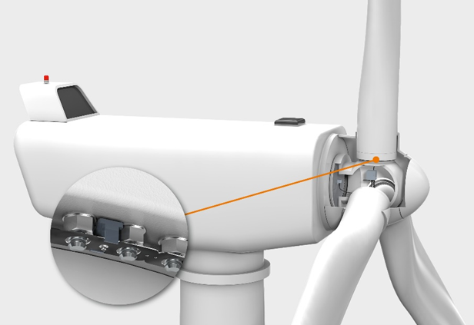
Image caption: Blade bolts act as a bolted connection between the hub and rotor blade and are therefore continuously exposed to dynamic loads. The Weidmüller BOLTcontrol system not only detects a broken bolt, but also offers protection against the consequential damage caused by broken bolts.

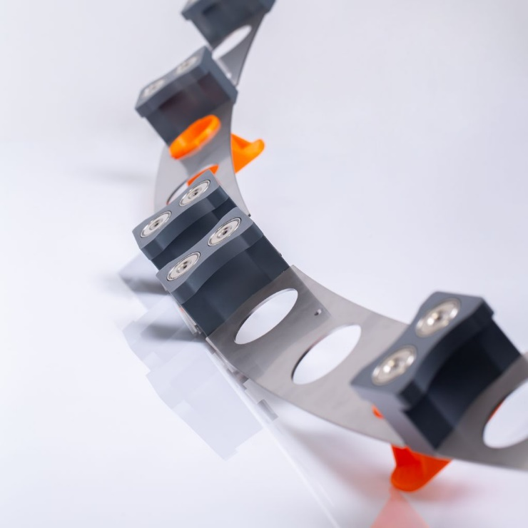
Image caption: The detection plates and their holding magnets can be adapted to different wind turbines for specific applications.

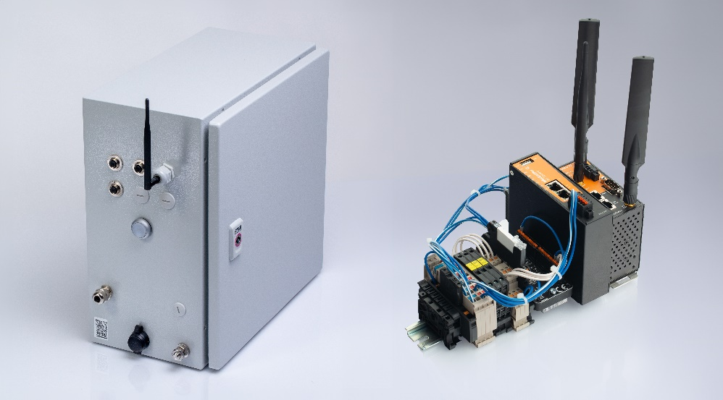
Image caption: The evaluation unit is available as a control cabinet (left) and DIN rail version (right).


Image caption: Hans Schlingmann, Head of IIoT & Automation Consulting at Weidmüller

Image rights: Weidmüller

The Weidmüller Group
Smart Industrial Connectivity: Electrification, automation, digitalisation, electrical connectivity, electromobility and renewable energies – markets in which Weidmüller feels right at home. The family-owned company established in 1850 has production facilities and sales companies in over 80 countries. As a global player in electric connection technology, Weidmüller achieved a turnover of more than one billion euros in the 2023 financial year with around 6,000 employees worldwide - around 2,000 of whom work at the company's headquarters in Detmold, in the heart of East Westphalia-Lippe, Germany. What Weidmüller lives by: Diversity with respect
Technologies and engagement for a liveable future - Weidmüller demonstrates how it approaches the topic of sustainability in its interactive sustainability brochure.

Your contact person: Weidmüller Corporate Communications
Tel.: +49 5231 14-292322
Email: presse@weidmueller.com

Responsible for the content: Weidmüller Corporate Communications
Corporate Spokesperson, Sybille Hilker

