Weidmüller achieves increased sales of EUR 830 million in 2019 despite difficult market environment
- The electrical engineering specialist achieves 1% growth compared with the previous year
- Securing the future through long-term investments with expansion of internal know-how in all areas (production, electronics manufacturing, research and development)
- Position reinforced by breaking into important future markets such as electromobility, and investing in growth markets
- Focus on expanding the IoT portfolio to digitalise processes

Detmold, 20 April 2020. The Weidmüller Group looks back at a mixed financial year in 2019. In a very challenging market environment, which saw a 1.8% decline in sales for the German Electrical and Electronic Manufacturers' Association, the company achieved sales of EUR 830 million, which equates to an increase of almost 1%. "Nevertheless, considering the economic slowdown in the second half of the year and the economic conditions, we are satisfied with the result," emphasises Volker Bibelhausen, Speaker of the Executive Board. While the economic situation remained stable during the first six months of 2019, there was a significant global downturn during the second half of the year. "We are faced with huge challenges, but we are confident that we will not only overcome them but will also grow alongside them. Our entry into future markets such as electromobility will help us here in future, as will continued automation and our IIoT solutions," explains Bibelhausen.

Digital trade fair experience: Weidmüller makes a virtue out of necessity Due to the cancellation of Hannover Messe, this year the figures were announced for the very first time during an online press conference. Chief Marketing and Sales Officer, Dr Timo Berger, emphasises the importance of the trade fair: "Hannover Messe is always a fantastic opportunity to discuss the latest technological developments with our customers." The Detmold-based company had many highlights lined up for this year's trade fair in Hannover, not least the celebration of its 170-year anniversary. So, to present its product innovations, the electrical engineering company has created a digital trade fair experience for its customers. "Beyond the dates of the trade fair period and into the summer, we will continue to present product highlights, offer online training and gradually introduce additional technical features for our customers. In other words, we are making a virtue out of necessity," says Berger.

Growth in core business and with digitalisation solutions
Weidmüller reported 1% growth in particular in the area of terminal rail components, markers, printers, installation and consulting. The area of intelligent components and solutions even saw growth of 6%. "Here, business was supported by the high demand for our latest family of terminal blocks and our automation products from the u-remote range as well as our power supplies," explains Bibelhausen. Only the OEM business and the area of device and field wiring saw a 3% decline in sales compared with the previous year. "This decline is mainly due to the high level of sensitivity and fast response of power electronics customers to economic fluctuations," Bibelhausen continues. The area of field wiring, on the other hand, reported growth and benefited greatly from the uninterrupted trend for decentralisation in automation and electrification.

Investments in research and development, as well as modernisation and expansion of the worldwide production network
Weidmüller invested EUR 53 million or almost 6% of its revenue in research and development in 2019. A total of 408 employees are dedicated to the development of new solutions and products at the company. At the same time, Weidmüller invested almost EUR 60 million in the modernisation and expansion of its global production network. "Here the main focus was on completing the third wing of our customer and technology centre as well as our production locations in China, Thüringen and Romania," explains Chief Financial Officer André Sombecki. Weidmüller opened a new 14,000 m² production facility in China in June, after a construction period of just eight months. And a new production hall was also opened at the Wutha-Farnroda location in Thüringen in June. "The new production facility is another step in the right direction towards the expansion of TWG as Weidmüller's high-tech location for industrial connector and cabling solutions," explains Sombecki. "There are plans to further expand the plant in order to gradually resolve the complex extended workbench structures and for production to be process-optimised and highly automated," adds Bibelhausen.

Digitalisation and automation in the core business for terminal blocks In Weidmüller's core business for terminal blocks, the company is strengthening its position by establishing digital services and further solutions and components for automatic assembly and marking. This involves making the workflows and processes more efficient for panel builders and assemblers by harmonising the production workflows. "With RailAssembler, we offer a solution for the automated assembly of terminal blocks on a terminal rail," highlights Bibelhausen. "This complements our existing Workplace Solutions portfolio to enable greater efficiency in control cabinet building." Weidmüller is pursuing its vision to shape future panel building through the "Smart Cabinet Building" initiative, in cooperation with other companies. "This means that our customers benefit from continuous and harmonised solutions from the respective specialists in the field," explains Berger.

Expansion of the IIoT portfolio to digitalise processes
At the same time, Weidmüller is further expanding its portfolio in the area of the Industrial Internet of Things – with solutions for acquiring, forwarding, processing and visualising data. Last year, the company already announced its intention to invest more heavily in the area of IIoT. "At the largest automation trade fair in Nuremberg in November, we showcased some of our initial products such as the IoT terminal, which enables efficient and cost-effective status monitoring of decentralised machines and plants as well as simple automation controls," continues Bibelhausen. "Sensors for acquiring data are one of the latest additions to our range, which we are continually expanding. The portfolio is rounded off by the Industrial Analytics offering as well as the Automated Machine Learning Tool for evaluating data. Customers can make reliable predictions with regard to the quality of their products on the basis of seamless recordings of sensor, condition and process data.

Investments in charging infrastructure for electric mobility
The topic of electromobility will pick up greater speed over the next few years. "At eMove360 in October, we showcased our AC charging station for the very first time and received a great deal of positive feedback. When developing our charging infrastructure solutions, the experts also take into account intensive factors that play a role in everyday use: installation, availability, reliability and acceptance of charging stations – and of course economic efficiency," explains Bibelhausen. The electronics specialist attaches particular importance to simple installation and a high level of user-friendliness – such as the way in which the connector is attached to the charging station and the way in which the cable is wound up. This is why Weidmüller acquired a 25.1% share in Paderborn-based company wallbe GmbH in 2019, in order to develop innovative solutions together for the charging infrastructure in Europe.

Cautiously positive outlook for 2020
The outlook for 2020 is challenging due to the current situation. "There were many elements of uncertainty even at the start of the year, causing us to look towards the future with caution," says Sombecki. During the first quarter, Weidmüller recorded orders that equalled the level of the previous year. However, in April things slowed down considerably. "Therefore we are satisfied that, despite all the uncertainties, we have so far been able to reasonably navigate our way through this crisis. We are experiencing the slowdown and must continue to act with caution. For this reason, we are continuing to consider all options in order to be able to respond quickly to a changed situation. Shorttime work will also be applied again in May for the administration area. We are proceeding 'cautiously' here and carefully considering all further steps," continues Sombecki. "We were faced with the impacts of the coronavirus crisis right at the very start in China. However, the situation in China recovered relatively quickly. We have seen that the economy can quickly pick up after a crisis situation and can gather pace again. This is what we are assuming for the second half of 2020," adds Berger. "This is why we are setting the course in order for business to really take off again in 2021. In any case, our planning and investments in locations and technologies are oriented towards the long term. We are continuing along this path together with our shareholders and our employees, who we know we can rely on even during these challenging times. These conditions give us confidence that we as a company and a society will emerge from this crisis even stronger," says Bibelhausen positively. "We have the right products and solutions as well as the right workforce to achieve this."

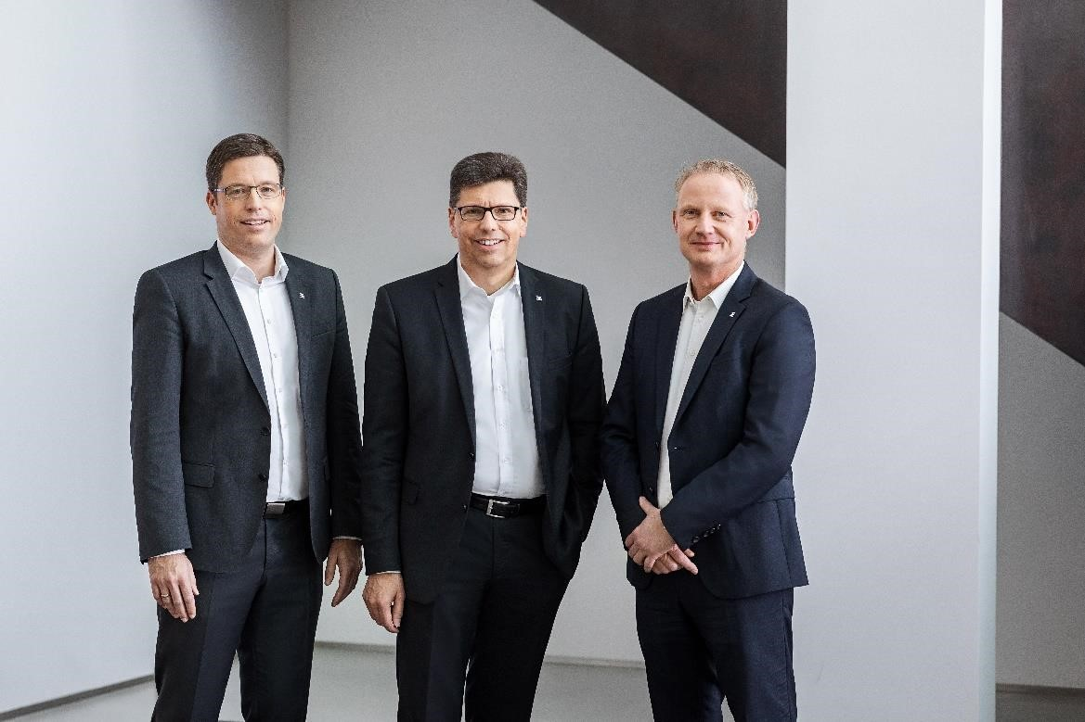
Image caption: The Executive Board of the Weidmüller Group looks back at a mixed year overall in 2019 and is confident that in 2020 the company and society will emerge from the crisis even stronger.

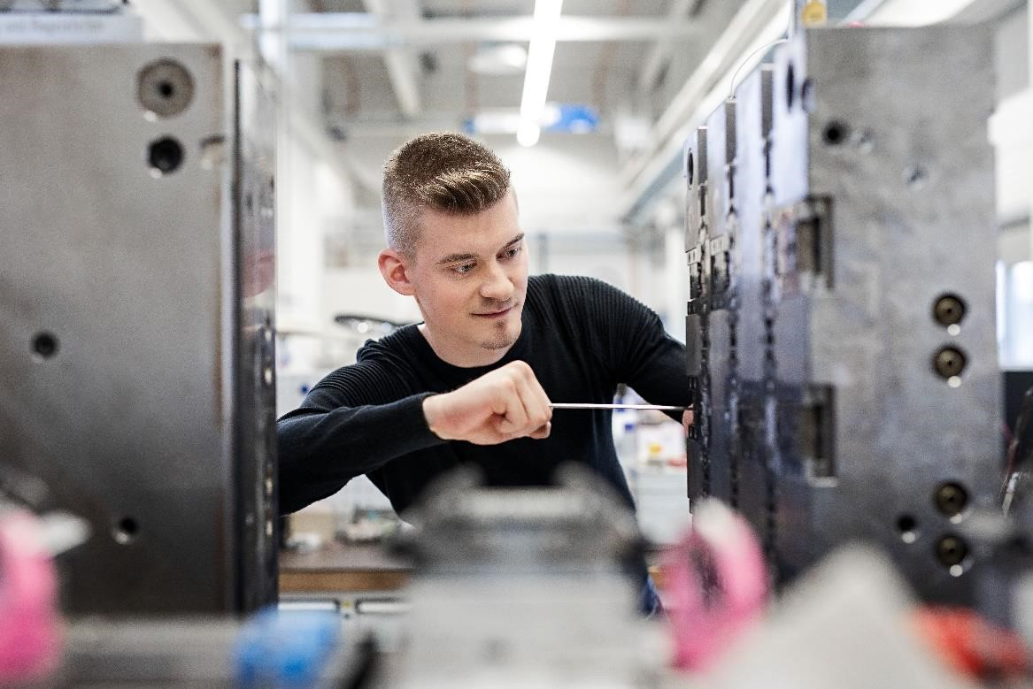
Image caption 2: Weidmüller makes long-term investments in the training of young people. There are more than 100 apprentices at the company.

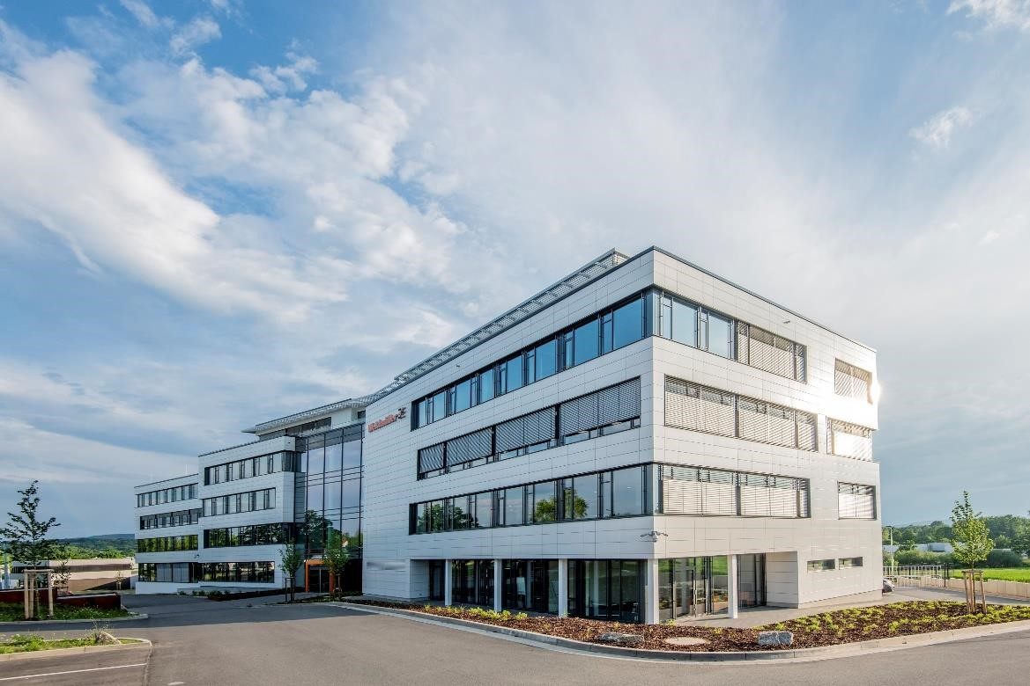
Image caption 3: Slight growth in employee headcount, not just at the Detmold location.

Weidmüller – your partner in industrial connectivity.
As experienced experts we support our customers and partners around the world with products, solutions and services in the industrial environment of power, signal and data. We are at home in their industries and markets and know the technological challenges of tomorrow. We are therefore continuously developing innovative, sustainable and useful solutions for their individual needs. Together we set standards in Industrial Connectivity.
The Weidmüller Group owns manufacturing plants, sales companies and representatives in more than 80 countries.
In its fiscal year 2019, Weidmüller achieved sales of EUR 830 million with around 5,000 employees.

Contact:
Sybille Hilker and the Corporate Communications team
Phone: +49 (0)5231 / 14-292322
E-mail: presse@weidmueller.com

