Full Programme for the Charging Infrastructure
Weidmüller offers future-proof charging points for residential and commercial buildings

On 25 March 2021, the Act on the Construction of Charging and Wiring Infra-structure for Electromobility in Buildings (GEIG) came into force. It applies to new residential and commercial buildings as well as in the case of renovations. The law requires the installation of charging points and pre-equipment for elec-tric vehicle charging infrastructure. With the AC Wallbox HOME and the AC Wallbox BUSINESS, Weidmüller already has two legally compliant and future-proof charging points in its range, which impress with many advantages and a wide range of accessories for individual installation.

The charging infrastructure is the backbone of the traffic turnaround. Only if there are enough charging points will more people opt for an electric vehicle. In order to accelerate the expansion of the charging infrastructure, the legislator has passed the Building Electric Mobility Infrastructure Act (GEIG). At the same time, this brings into force part of the EU Buildings Directive 2018/844, which stipulates certain minimum standards for the provision of charging points.

Politics sets the course for the transport turnaround

In order to achieve the goals of the climate protection programme, seven to ten million electric vehicles must have been registered by 2030. The German Association of Energy and Water Industries (BdEW) estimates that this would require at least 500,000 standard charging points and 50,000 fast charging points nationwide. This means that a large number of charging points will be needed very soon – especially on private drives in front of residential buildings. The law is intended to accelerate the expansion considerably. In addition, the federal government wants to provide financial support for the expansion of charging points.

Mandatory pre-fitting for new buildings: The key points of the GEIG

Among other things, the GEIG stipulates that in new residential buildings with more than ten parking spaces, each parking space must be pre-equipped to be compatible with the network infrastructure. For non-residential buildings, this applies to every fifth parking space. If the building has more than 20 parking spaces, at least one functional charging point must be provided as of 2025. Exceptions to the GEIG only apply to owner-occupied buildings of small and medium-sized companies and to isolated existing buildings where the pre-fitting costs would amount to more than seven percent of the refurbishment costs.

High demands placed on the charging infrastructure

In order to successfully promote e-mobility, the charging infrastructure must meet several requirements. It must be available nationwide, must be expandable to meet demand and finally it must be user-friendly. Furthermore, depending on the location, it must be decided whether normal, fast or intermediate charging is primarily used and whether charging takes place at home, at work or in public areas. This is just as important for potential e-vehicle users as it is for planners, operators and energy providers.

Future-proof wallboxes from Weidmüller

Weidmüller offers two attractive product lines for those who want to install fu-ture-proof charging points: The AC Wallbox HOME and the AC Wallbox BUSINESS. The AC Wallbox HOME is designed for use simple in residential and commercial environments. It looks good, offers good charging speeds and is reasonably priced. The AC Wallbox BUSINESS is designed to meet the needs of companies, cities and municipalities and has all the technical features for commercial use. These include, above all, the MID-compliant energy meter as well as the secure and convenient authentication via RFID.

AC Wallbox HOME

The AC Wallbox HOME combines economy and functionality in a striking de-sign. It is available with a fixed cable or socket. A DC fault current protection circuit is also already integrated. The wallbox is characterised by simple installation and handling. Commissioning, control and maintenance are carried out via a web-based configuration tool. The integrated cable rewind avoids cable tangles and is protected against overheating in case of improper unwinding. The round design covers can be customised, and the attractive LED ring serves as a status indicator. All HOME Wallboxes have an easily accessible switch with which the entire charging station can be switched off. This saves costs in standby operation. The AC Wallbox HOME is available with 11 and 22 kW.

Sophisticated accessories for individual installation

There is an extensive range of accessories for all AC Wallboxes from Weidmüller. These include various charging cables and sockets, a matching plug holder and an NFC unit. The components come with everything needed for installation – from pre-assembled cables and connectors to mounting materials and adapters for wall or rail mounting. Thanks to the convenient PUSH IN connection technology, flexible conductors can be connected easily and without tools. All core components for the charging point control are produced in Germany in compliance with the highest quality standards.

AC charging cable
The Mode 3 charging cables have ergonomic handles and are designed for tough continuous outdoor use. They are available in different lengths and de-signs – in smooth or spiral form, with type 2 plug or with open cable end for direct connection to the charging station.

Type 2 sockets
The particularly robust sockets are easy to install and have a cover to protect against dust and water. A bistable actuator for plug locking is already integrated. Wired charging points have a pre-assembled LED status indicator in the plug holder.

NFC unit
The NFC unit is used for secure authentication. It supports the MIFARE standard and can be perfectly integrated into charging solutions with Weidmüller components via Modbus RTU.

Type 2 plug-in holder
For charging solutions with a permanently attached cable, the type 2 plug holder is available with integrated LEDs for status display. A spring-loaded pressure piece ensures that the plug is held securely in the parked position and enables convenient one-handed operation.

6,303 characters (including space characters)
(5,196 not including the optional paragraph)

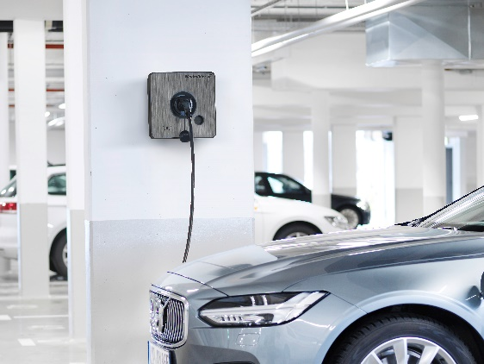
Image caption:
The Weidmüller AC Wallbox BUSINESS has all the technical features for pro-fessional, commercial use.
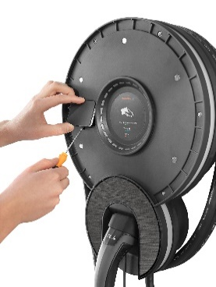

Image caption:
The AC Wallbox HOME is characterised by easy installation and handling.

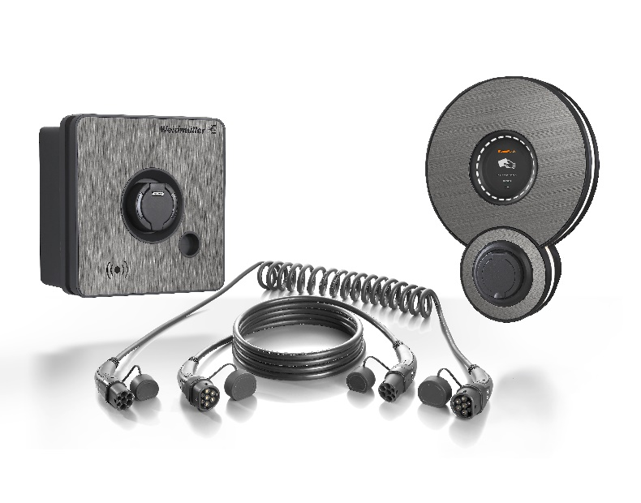
Image caption:
Future-proof charging points: The AC Wallbox HOME and the AC Wallbox BUSINESS from Weidmüller.

5811 Zeichen inklusive Leerzeichen

Your contact person: Weidmüller Corporate Communications
Tel. +49 (0) 5231 / 14-292322
Email: presse@weidmueller.com

Weidmüller – your partner in industrial connectivity.
The Weidmüller Group has production facilities, marketing companies and representative offices in more than 80 countries. Together with our customers, we shape the digital transformation – with products, solutions and services for Smart Industrial Connectivity and the Industrial Internet of Things. In the fiscal year of 2021, Weidmüller reached sales of 960 million euros with around 5,300 employees.

Responsible for the content: Weidmüller Corporate Communications
Corporate Spokesperson, Sybille Hilker

